Status Report from Stanford University Center for Design Research for the Tampere/Stanford project on Research on the Use of Sense of Touch With Mobile Devices for All Users Including Disabled People

Period: September 1 – December 31, 2006
Principal Investigator: Prof. Mark R. Cutkosky
Consulting Professor: Dr. Machiel Van der Loos
Research Assistants: Karlin Bark (visiting researcher at Tampere during this reporting period), Li Jiang, Jason Wheeler

Overview of activities
The work at Stanford University, in collaboration with the TAUCHI group at the University of Tampere, for the research project on “Research on the Use of Sense of Touch With Mobile Devices for All Users Including Disabled People,” has focused on three tasks: Wireless Mobile Haptic Displays for Active People, Haptic Ball for Physical Interaction and Rehabilitationand Skin Stretch Haptic Display for Portable Haptic Devices. The status and activities of the work on each task are discussed briefly in the following pages.

Expenditures
Expenditures during the period from September – December 2006 have been on schedule with the following 12 month budget:

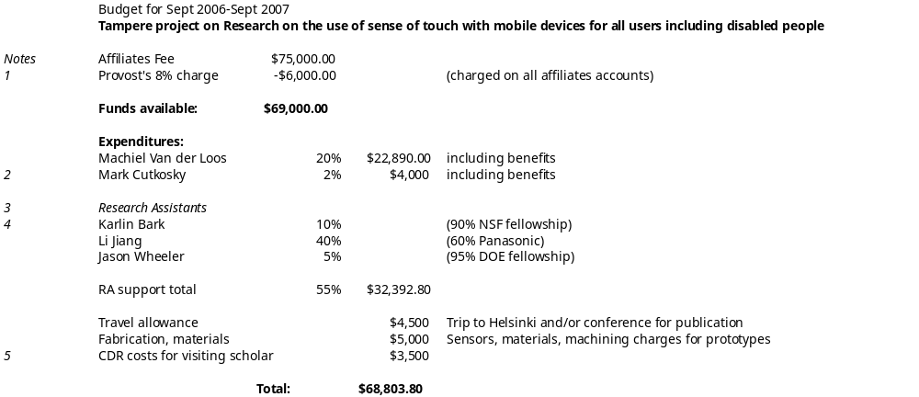
Explanations:
1. Stanford Provost assesses an 8% charge on all Affiliates accounts in lieu of 60% overhead.
2. 2% = minimum charge; 90% of Cutkosky AY salary paid directly by Stanford School of Engineering
3. Research Assistant rates are for a nominal 20 hours of instruction and 20 hours of direct labor per week.
4. K. Bark is funded 90% by a fellowship from the National Science Foundation; Li Jiang is funded 60% by a CDR affiliates project from Panasonic Inc.; J. Wheeler is funded 95% by a DOE fellowship from Sandia National Labs.
5. CDR costs for visiting scholar from Tampere for computer and networking services, telecommunications, laboratory charges, etc.

Task area 1: Haptic display for active people
Research Assistant: Jason Wheeler

The work in this area concerns haptic display for active people. Our hypothesis, based on preliminary observations, is that the perception of vibration feedback is affected by accelerations that accompany rapid movements during walking, jogging, etc.

Status: A test apparatus and protocol have been developed and preliminary equipment tests have begun (Figure 1). A modified human testing protocol has been submitted to the Stanford Internal Review Board and experiments will be conducted once it is approved (within a few weeks).
In a first set of experiments, two kinds of vibrational haptic displays will be evaluated: The first is a small voice-coil motor attached to a compliant mechanism. It is adapted from the commercial Logitech “Feel-It” mouse, designed by Immersion Corp., San Jose CA. The device produces vibrations over a range between 10-200 Hz and stimulates a large receptive field of approximately 100 cm². The second device is a small “C2 tactor” from EAI Inc., Winter Park, FL, consisting of a probe attached to a short-stroke linear motor. In comparison to the first display, it produces a more localized stimulus and has a working frequency range of 20-300 Hz. Both stimulators are attached using an adjustable Velcro strap.

A computer running a realtime operating system (Matlab xPC) has been set up to control the stimulators with various waveforms, using a digital/analog output card and linear current amplifiers. The computer may also monitor and control the speed of the treadmill during the experiments. Accelerations near the sites of stimulation will be monitored using commercial accelerometers and an analog/digital input card for the computer. In future experiments, the motions of markers on the subjects may be tracked with a high speed vision system.

Procedure: In initial experiments, vibration waveforms, durations and frequencies will be determined empirically for each device and held constant. The amplitude will be varied and the subjects will be asked to press a button when they detect a stimulus. The tests will be conducted for standing, walking and jogging. Amplitudes and activity levels will be randomized to compensate for learning effects and fatigue.

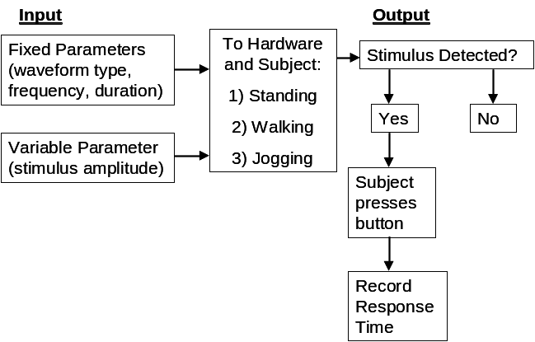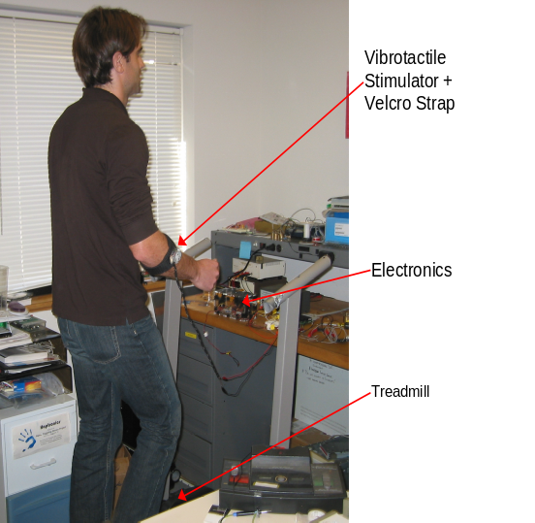
Figure 1: Mobile haptic display apparatus and experiment design

The next phase of experiments will take place after discussion with researchers at the TAUCHI group to compare results obtained with a similarly instrumented stationary bicycle platform.
Task area2: Haptic Ball for Physical Interaction and Rehabilitation
Research Assistant: Li Jiang

The goal of research in this area is to design a portable, configurable device that can provide haptic feedback to enhance the experience of elderly and possibly disabled individuals. Based on joint discussions and a design concept originally developed by the TAUCHI group in Tampere, it was agreed that the team at Stanford would develop some first prototypes of a “haptic ball” that could be shown to such individuals for a preliminary evaluation. Interviews at Stanford Medical Center and the Palo Alto Veteran’s Hospital revealed that therapy for stroke and spinal trauma patients could represent a particularly promising application area. To explore this area further, a series of interviews with patients and staff (10 doctors and 50 patients) were conducted at the Stanford Hand Clinic, Neural Clinic, and Rehabilitation Center, as well as the Palo Alto VA Rehabilitation Center and the Foothill College Rehabilitation Program. Detailed results are posted on the Stanford Haptics wiki.
Some of the findings were as follows:
- A lack of motivation is one of the biggest obstacles for patient recovery, due to difficulty in seeing evidence of clear and steady improvement.
- For stroke patients to voluntarily open the hand is difficult and requires much practice.
- To use patients’ unaffected hand to teach the affected hand is a useful approach.
- Approximately 20% patients have little or no sensation on the affected hand and >50% have a distorted touch sensation; therefore haptic feedback may need to be channeled to the unaffected side as well as the affected side.
Based on the results of interviews and surveys, two initial prototypes were constructed. Fig. 1 shows a passive linkage with a symmetric motion for the left and right hand. Fig. 2 shows a hydraulic system that can be configured for symmetric of opposing motions.
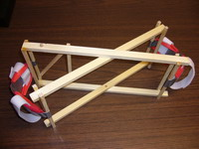  Fig. 1.  Prototype linkage and finger pads | 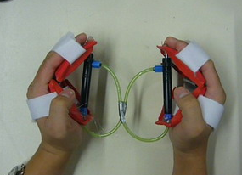  Fig. 2.  Prototype with hydraulic system.
In preliminary tests, three stroke patients indicated that the second prototype was more comfortable and pleasant to use, confirming the initial impressions of the researchers. Based on these early tests, a third prototype has been designed and will be fabricated, as shown in Figs 3a, 3b. This prototype will be suitable for instrumentation and for the possible addition of vibration feedback, pending discussions with researchers at the TAUCHI group.
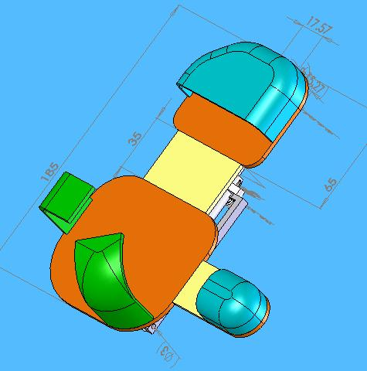  Figure 3a.  Front view of prototype III (left-hand config.) | 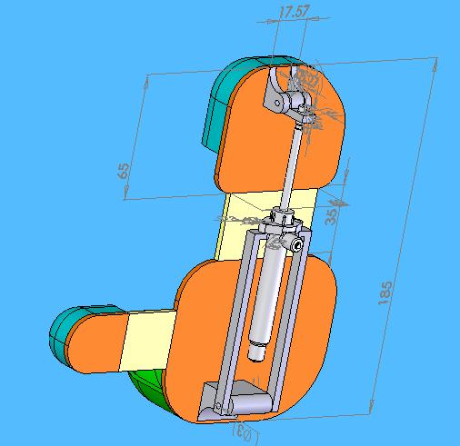  Figure 3b:  Rear view of prototype III (left-hand config.)

Task area 3: Skin Stretch Haptic Display for Portable Haptic Devices
Research Assistant: Karlin Bark

Tests with a new benchtop apparatus are being conducted to characterize skin stretch as a tactile display method suitable for wireless applications such as wearable medical or activity monitors. Tests to date indicate that skin stretch may be less sensitive to “masking” effects from rapid human motion (e.g. when walking or jogging on a treadmill) than vibrations, which are commonly used for portable devices. The work completed thus far focuses on studying how skin-stretch stimulators can be used to enhance a user’s experience in a virtual environment. This work consists of testing skin stretch perception on limbs and determining suitable methods for inducing skin stretch.

Status: A simple experiment was conducted, while K. Bark was a visiting researcher at the TAUCHI group in Tampere, to start to answer questions about how variations in skin stretch application affect human response. For example, does human perception of, and response to, skin stretch depend on the velocity of stimulus application? Does varying the magnitude of a rotational displacement have a simiar effect? A desktop skin stretch application device was used to apply varying magnitudes and rates of rotational skin stretch to a user’s arm (Fig. 1). Ultimately, the results of these experiments will guide the design of a small, wireless skin stretch displayl.

Procedure: Six different stimuli were applied to a subject’s left forearm, consisting of three different magnitudes (10, 20 and 30 degrees) and two velocities (ramps varying from 50-80 degrees/second and from 190-220 degrees per second). The subject was instructed to push a button with the right hand as soon as the skin stretch stimulus was detected. Each stimulus was presented 30-40 times in random order using EPrime software from Psychology Software Tools, Inc, and reaction times were recorded using LabView 7.0, from National Instruments Inc. Subjects were blindfolded and wore sound isolation headphones to prevent detection of the stimulus by sight or sound (Fig. 2). The duration of the button presses, as well as torque applied to the subject’s forearm were also recorded. A total of 13 users were tested. We are currently completing statistical analysis of the data.

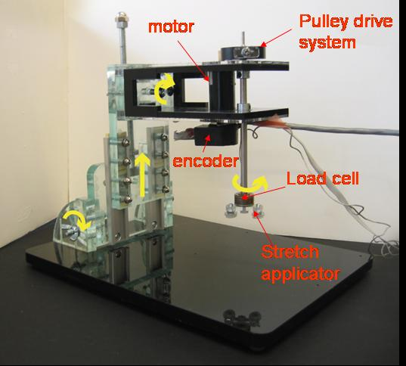
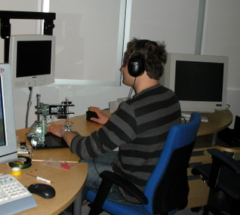
Skin stretch applied to forearm
Headphones and blindfold
Button press

Fig. 1: Benchtop skin stretch device Fig. 2: Test subject completing reaction time experiments

