Shape Deposition Manufacturing of Biologically Inspired Hierarchical Microstructures
Annals of the CIRP Vol. 57/1/2008

M. Lanzetta¹ (2), M. R. Cutkosky²
¹Department of Mechanical, Nuclear and Production Engineering, University of Pisa, Italy
²Department of Mechanical Engineering, Stanford University, California, USA

Abstract
The applications of dry adhesives range from part handling in manufacturing to aids for human and robotic climbing. Nature provides inspiration in the hierarchical structures used by geckos and spiders to attach using Van der Waals forces. Among the challenges faced in creating synthetic dry adhesives are the need to conform to surfaces at length scales from centimeters to tens of nanometers and the need to create arrays of compliant asymmetric structures at the micro scale. Initial attempts from the literature are reviewed and a new approach based on a hybrid additive/subtractive prototyping technique called Shape Deposition Manufacturing (SDM) is proposed.

Keywords:
Prototyping, Surface, Design

Introduction

Figure 1: Scheme of a hierarchical adhesive patch, definitions and nomenclature of a hierarchical structure.
hair / smaller structure
LAYER i+1
LAYER i
LAYER i-1
main building direction
BASE
transverse building directions
lamellae
stalks
larger structure
stacks (layered manufacturing)
Originally developed for climbing robots (e.g. [] []), synthetic dry adhesives are a promising alternative to mechanical gripping and suction for handling delicate materials such as glass, LCD panels and fine leather in manufacturing applications.
This paper briefly reviews the mechanisms needed to achieve dry adhesion and presents a new prototyping method for fabricating hierarchical compliant structures that help adhesives to conform to surfaces to achieve large areas of contact.

Motivation
The principle underlying dry adhesion in geckos and spiders is based on Van der Waals forces and requires large areas of intimate contact between the animals’ compliant structures and the surfaces to which they attach []. The adhesive structures of geckos are also directional: they stick only when pulled in a particular direction and their adhesive force is directly proportional to the applied tangential force. This characteristic makes gecko adhesion controllable, a desirable property for climbing animals and robots, but also for manufacturing applications that involve repeatedly grasping and releasing fragile objects.
The theory and application of dry adhesion draw upon tribology and the modeling of micro scale hierarchical compliant structures [Error: Reference source not found] [] []. Researchers have developed synthetic dry adhesives using a variety of methods, including micro-molding, filters that are infiltrated with polymers and subsequently dissolved and arrays of aligned carbon nanotubes (e.g., [] [] [] [] []). As noted in [Error: Reference source not found], synthetic arrays have achieved high levels of adhesion when small (<< 1 cm²) areas are tested but have not produced useful levels of adhesion for patches of several square centimeters, as required for a climbing robot or for materials-handling applications in industry. One reason for the disappointing performance when scaling to larger areas is that they lack the hierarchical compliance system consisting of spatulae, setae and lamellae [Error: Reference source not found] that the gecko employs to ensure intimate contact with smooth and rough surfaces.
The need to provide a hierarchical compliant structure poses a formidable manufacturing challenge. The feature sizes range from micrometers to millimeters and the structure is fully three-dimensional, making it difficult to use standard lithographic methods. Moreover, sharp features are required at the tips to prevent premature peeling and pull-off due to stress concentrations at the edges of the microscopic contact regions (more generally, shape sensitivity is a function of the material stiffness and feature sizes [Error: Reference source not found]).
Shape Deposition Manufacturing (SDM) provides a promising approach to overcoming the challenges of creating hierarchical, compliant substructures for dry adhesives. The theory and process planning of SDM for multi-material polymer parts are covered elsewhere [] but the most relevant attributes for the current application are summarized here with reference to Figure 1 and Figure 2.
Like most rapid-prototyping methods [], SDM assumes a primary building, or growth, direction, as shown in Figure 1. For purely additive processes, the resolution in the building direction is limited, leading to a “stair stepping” approximation to sculpted 3D shapes. A similar limitation applies to lithographic processes used for creating micromechanical structures and molds. However, for a process like SDM, material deposition is followed by shaping or removal (e.g. by CNC micromachining []), so that smooth, sculpted 3D contours are possible. As shown in Figure 2, the cycle can also be interrupted to place prefabricated components into the part or sacrificial supporting material. Despite these advantages, it is generally easier with SDM, as with other layered processes, to create arrays of complex shapes in the transverse plane, orthogonal to the build direction.
This work explores the benefits of applying SDM using two alternative methods in the transverse building direction for creating and assembling complex hierarchical structures.
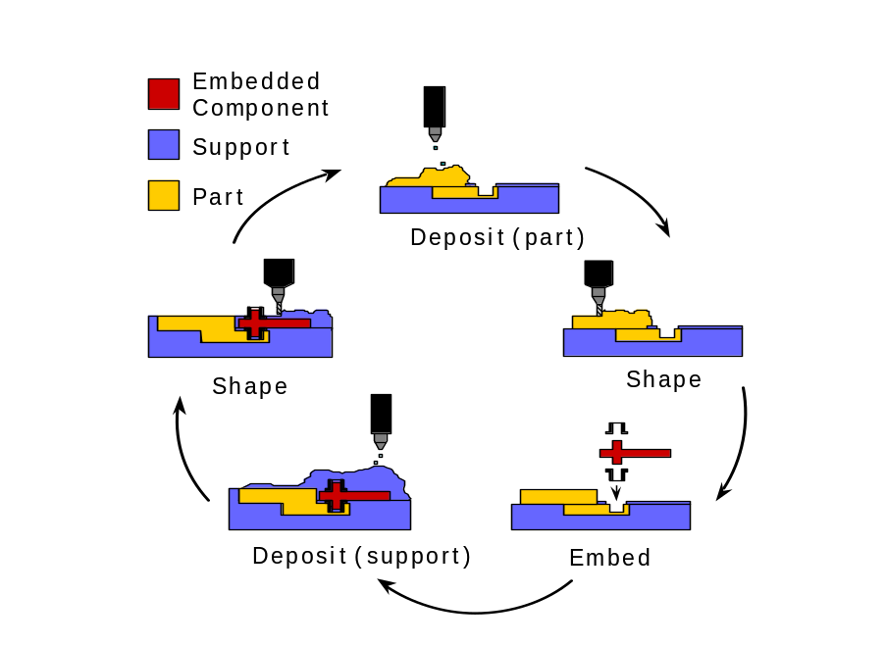

Process design input
Figure 2: Shape Deposition Manufacturing (SDM) cycle with addition and removal of part and support materials.
The conceptual design of the required hierarchical structure is shown in Figure 1. Each layer has a different set of characteristic geometries and a different material. The layers can be created in situ by a sequence of operations, or assembled after creation by different processes. The top layer has the primary adhesion function; subsidiary layers provide conformability to surfaces at different roughness scales.
Among the essential design constraints are:
- The tips of the features should be angled and end in sharp tips to prevent stress concentrations and premature lift-off when the structure is loaded in a combination of pull-off and shear.
- The features should be asymmetric so that they conform and adhere only when pulled in a particular direction.
- The features should avoid self-adhesion, or “clumping.” This is a function of the material stiffness in bending and of the curvature and material surface energy on the vertical and undercut faces.
- The number of layers, and the feature sizes for each layer, should promote conformation to rough surfaces over a range of length scales from micrometers to millimeters. This behavior depends on the relative compliance at each scale [Error: Reference source not found].

Current part design
Figure 3 shows a solid model of a prototype hierarchical structure with the necessary design features. The structure is meant to be brought into contact with a surface by moving it simultaneously upward (+Z) and along the +X direction so that the compliant structures bend, leaving the top faces parallel with the surface. Subsequently, the structure can be pulled in a combination of normal (-Z) and shear (+X) loading. The tip features of the design in Figure 3 are derived from the directional polymer stalks used for climbing robots [Error: Reference source not found]; the supporting cantilever beam structures are inspired by gecko lamellae [Error: Reference source not found].
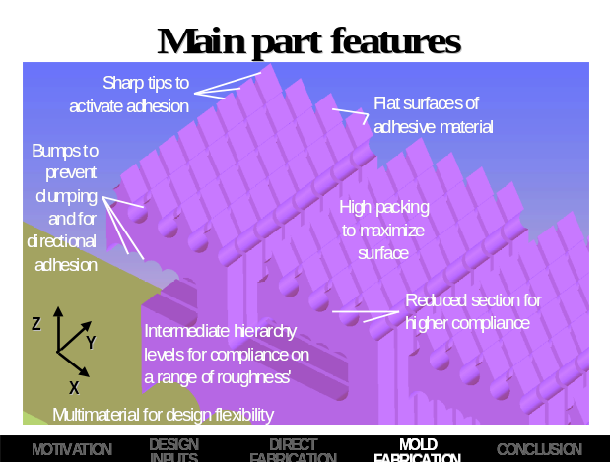
Figure 3: CAD model of the hierarchical structure used to compare the proposed manufacturing methods. Major design features are labeled.A three level hierarchical structure is considered representative of the manufacturing difficulties that can be found when dealing with more layers. A size ratio of 1:4 has been chosen for both length and section of structures of successive layers. The slopes of distal features and lamellae are respectively 45º and 20º.

Process description
The main contribution of this paper is to use the transverse building direction to create a series of flat multi-material structures that are assembled, as shown in Figure 3, to create a three-dimensional hierarchical compliant structure. The process planning takes advantage of the ability to assemble prefabricated components or structures into mold cavities during the SDM process. Two process variations have been tested: the Direct SDM method and the Mold SDM method. Both methods utilize sacrificial support materials (machinists wax and hard urethane) to define the geometry because the elastomers used for the final parts are too soft to be machined directly.

Direct SDM
The Direct SDM method uses temporary inserts of a hard, machinable urethane to support the compliant parts and to circumvent a limitation on the sharpest interior mold corners that one can obtain with an end mill of a given radius. The exterior corners of the urethane inserts can cut be quite sharp because they are fully supported in a bed of hard wax. These exterior features become the interior features of the mold cavities into which the final part material is cast.
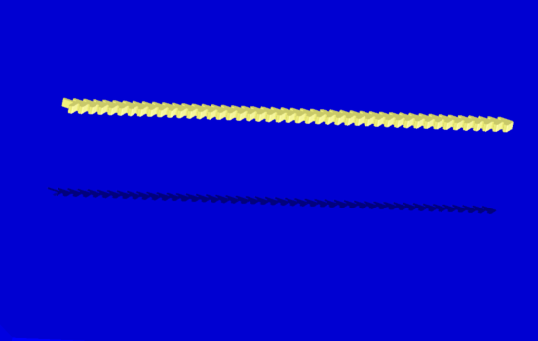
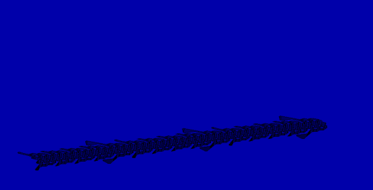
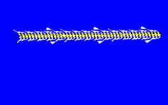
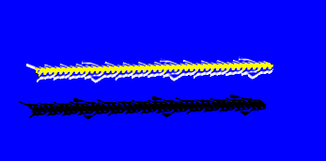
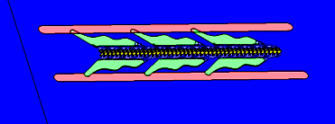
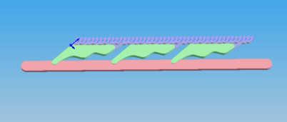
Re
Machine cavities
for small features
step 3.
Remove cast
urethane inserts
step 4.
Cast 1st silicone
around inserts
Remove, with inserts
step 5.
step 6.
Remove, detach inserts and split
step 8.
step 10.
Cast 2nd silicone in
molds for large features

The sequence of operations proceeds as follows (key steps are illustrated in Figure 4):
Figure 4: Key steps in the process plan for the Direct SDM method.
- Machine cavities in hard machinist’s wax to create thin inserts for use as temporary supporting structures.
- Cast a stiff polymer (Task 9, two-part urethane, Shore 85D hardness, from Smooth-On Polymers, Inc.) into the mold to create the inserts.
- Remove the urethane inserts from the molds.
- Machine new mold cavities in machinist’s wax that will hold the inserts and provide additional spaces for molding the smallest features.
- Assemble the urethane inserts (light press fit) into the cavities and cast a silicone (P-20, Platinum catalyst, Shore 20A, Innovative Polymers, Inc.) into the remaining spaces.
- Remove the inserts, with silicone features attached.
- Machine new mold cavities for the largest features and press the inserts into them.
- Cast a second, stiffer, silicone (P-100, two-component platinum cure, Shore 60A hardness, Innovative Polymers Inc.) into the remaining cavities to create the large features. (To reduce the number of molds, two sets of hierarchical structures are created as conjoined twins, sharing a common insert.)
- Remove the inserts, with attached large and small silicone features. Steps 4.-9. can be repeated for each additional layer and part material.
- Detach the silicone parts from the urethane inserts. Split the conjoined symmetrical pairs and assemble them into a structure resembling the model shown in Figure 3.
The assembly of the inserts into new cavities in step 5. creates a negative geometry, allowing sharp distal features with tip radii of tens of micrometers.
A drawback to the Direct SDM method is that it requires multiple assembly steps, each of which involves a tight fit between an insert and a mold cavity to achieve precise definition of the features.

Mold SDM
Mold SDM is an alternative approach in which urethane frames are first created through casting and machining, as in steps 1.-3. of the Direct SDM method. Next, the frames are assembled as shown in Figure 5, with thin films of polyethylene plastic as spacers to keep the distal features separated. A silicone polymer is then cast directly into the resulting three-dimensional mold. If desired, the mold can be filled in two (or more) stages using different silicone polymers for each layer.
The urethane frames are finally removed leaving a completed silicone structure. Although this process avoids the multiple assembly operations of the direct method, it is sensitive to achieving a tight seal between the frames and the polyethylene spacers to avoid molding flash. It can also be tedious to demold the silicone structure without damaging it.
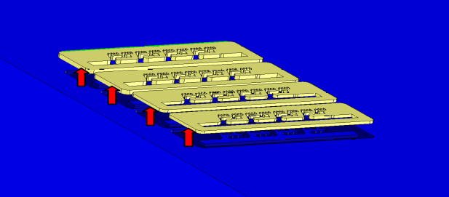
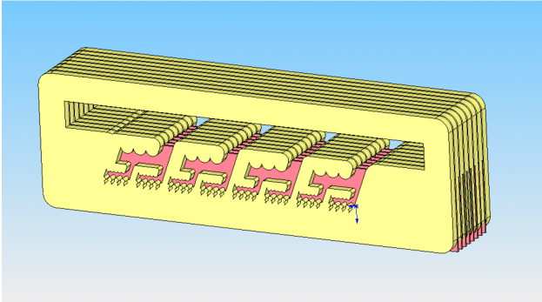
Figure 5: Mold SDM. Cast and machined urethane frames (top) are assembled with polyethylene spacers to create a complete mold (bottom).

Results and Discussion
Using the Direct SDM method, batches of hierarchical compliant structures were fabricated with thicknesses of 0.1, 0.2 and 0.4 mm prior to assembly. The cavities were machined with a ∅ 0.25 mm end mill. To reduce burrs (some are visible in Figure 6 and Figure 7) it is necessary for the inserts to fit precisely into the mold cavities.
In Direct SDM it is difficult to maintain uniform thickness during deposition and the thinnest structures are also more difficult to handle and assemble.
The tip radii of the smallest features (see Figure 6) are less than 20 μm. Based on experience with the Stickybot robot [Error: Reference source not found], using directional polymer stalks of the same silicone material and similar dimensions and tip radii, we anticipate similar adhesion properties.
As seen in Figure 7, similar results are obtained using the Mold SDM method, with frames of thickness 0.4 and 0.7 mm. As with the Direct SDM method, the overall accuracy is approximately ± 20 μm.
Although a certain amount of flash is visible along the underside of the structure, it is easily trimmed using a sharp blade. The scalloped bump features, visible on the back sides of hierarchical structures at each level, were successful at preventing self-sticking.
Functional testing on Stickybot awaits the fabrication of approximately 100 cm² of structures. However, preliminary tests are encouraging:
- compliance. The sharp tips demonstrate adhesion and the entire structure is able to follow surface undulations;
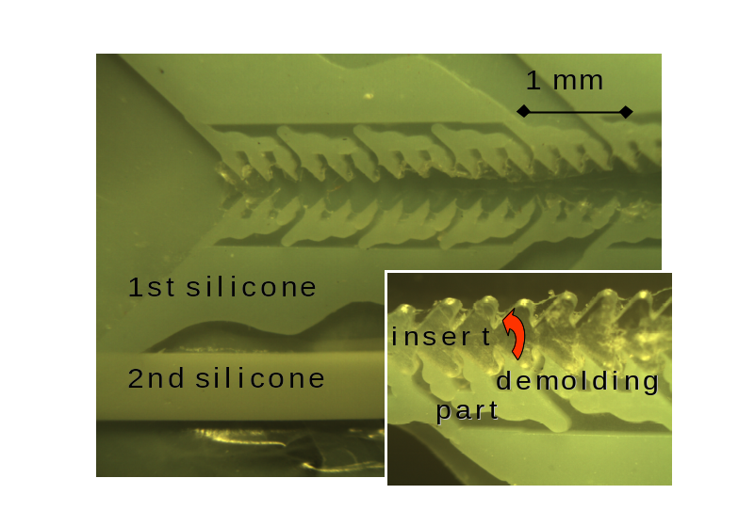
- Figure 6: Results of Direct SDM process, prior to removing clear urethane inserts and splitting. Inset shows detail of sharp tip features.directionality (anisotropic structures). The structures bend more easily and bring the angled tip faces into contact when loaded in the desired direction (loading direction in Figure 7);
- no clumping or matting. After releasing a load, stalks and structures return to their initial shape without self-adhesion.
As expected, the transverse building direction allows complete flexibility in the shape design of hierarchical structures. In addition, all the stacks are manufactured in parallel and then assembled, reducing the risk of failures found in lengthier processes where each new layer is grown atop the previous one.
Of the two processes described, Direct SDM is more labor intensive and presents more difficulties with respect to handling cast materials and inserts.
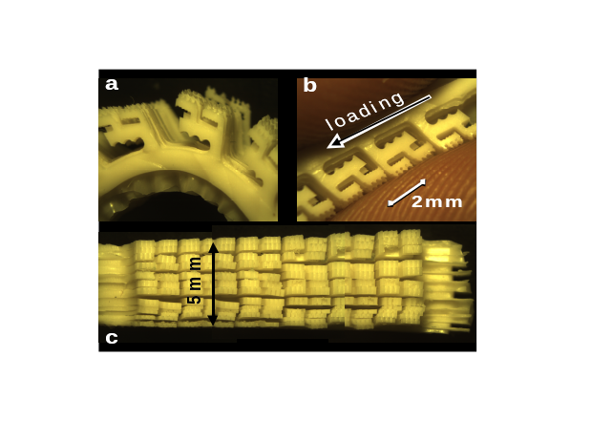
Figure 7: (a) Bending a three level Mold SDM microstructure; (b) applying a load in the preferred direction using two fingers; (c) top view of structure.
For mass production, an attractive evolution of the Mold SDM method is to use micro injection molding. Injection molding would permit experimentation with a wider range of part materials.

acknowledgments
Thanks are due to J. Grillo and the staff of the Biomimetic Robotics Lab (Stanford University) for their many suggestions and assistance in creating the models and molds described in this paper. Prof. M. Santochi's invaluable advice on the first draft is also acknowledged. The Italian CNR provided a STM (2007) fellowship for Prof. M. Lanzetta. Prof. M. R. Cutkosky’s work was supported in part by the DARPA BioDynotics program.

References

[?] Santos, D., Spenko, M., Parness, A., Kim, S. Cutkosky, M.R., 2007, Directional adhesion for climbing: theoretical and practical considerations, Journal of Adhesion Science and Technology, 21/12-13:1317-1341.
[?] Unver, O., Uneri, A., Aydemir, A., Sitti, M., 2006, Proceedings of the IEEE International Conference on Robotics and Automation, Orlando, FL, 2329–2335.
[?] Autumn, K, 2006, Properties, principles, and parameters of the gecko adhesive system, in A. Smith and J. Callow, editors, Biological Adhesives, Springer-Verlag, Berlin, 225-256.
[?] Kim, T.W., Bhushan, B., 2007, Adhesion analysis of multi-level hierarchical attachment system contacting with a rough surface, Journal of Adhesion Science and Technology, 21/1:1–20.
[?] Spolenak, R., Gorb, S., Gao, H., Arzt, E., 2005, Effects of contact shape on the scaling of biological attachments. Proceedings of the Royal Society A: Mathematical, Physical and Engineering Sciences, 461/2054:305–319.
[?] Geim, A.K., Dubunos, S.V., Grigorieva, I.V., Novoselov, K.S. Zhukov, A.A., Shapoval, Y.U., 2003, Microfabricated adhesive mimicking gecko foot-hair. Nature Materials, 2:461–463.
[?] Kim, S., Sitti. M., 2006, Biologically inspired polymer microfibers with spatulae tips as repeatable fibrillar adhesives. Applied Physics Letters, 89(26):261911.
[?] Majidi, C., Groff, R.E., Maeno, Y., Schubert, B., Baek, S., Bush, B., Maboudian, R., Gravish, N., Wilkinson, M., Autumn, K., Fearing, R.S., 2006, High Friction from a Stiff Polymer Using Microfiber Arrays, Physical Review Letters, 97:076103.
[?] Northen, M.T., Turner, K.L., 2005, A batch fabricated biomimetic dry adhesive. Nanotechnology, 16:1159–1166.
[?] Zhao, Y., Tong, T., Delzet, L., Kashani, A., Meyyappan, M., 2006, Interfacial energy and strength of multiwalled-carbon-nanotube-based dry adhesive, Journal of Vacuum Science and Technology B, 24:331.
[?] Xu, X., Cheng, W., Dudek, D., Cutkosky, M.R., Full, R.J., Hatanaka, M., 2000, Material Modeling for Shape Deposition Manufacturing of Biomimetic Components, DETC2000/DFM-14022, Proceedings of the ASME DETC/DFM Conference, Baltimore, MD, USA, Sept. 13-16, 2000.
[?] Levy, G.N., Schindel, R., Kruth, J.P., 2003, Rapid manufacturing and rapid tooling with layer manufacturing (LM) technologies, state of the art and future perspectives, Annals of the CIRP, 52/2:589-609.
[?] Dornfeld, D., Min, S., and Takeuchi, Y., 2006, Recent Advances in Mechanical Micromachining, Annals of the CIRP, 55/2:745:768.

