4 Technical Potiential Review on Future Communication device
In this topic, we intend to make a sound and complete investigation on the current cutting edge researches among world leading universities and institutes. To land the investigation on cell phone’s potential application, we design our web surfing and literature reading into three titles: sensor technology, initiative mechanism and expression pool. Such three titles can almost cover the inner and external functions of such communication device, from the information absorbance, to main body movement, to expression styles. With the relative broad and deep investigation, we conclude the technical roadmap and its trend of future development, and based on this dynamic technical database, together with the cell phone’s development, we give some suggestions and portraits of what the 10 years later communication device should be like. Guess or probably future truth, it’s up to your imagination and the technology development. No matter what, the investigation and topic illustration here will surely make an applicable technical probe for future. For more detail, please keep reading in the following passages.

4.1 Sensor technology

4.1.1 Image Sensor
With eyes, human can observe the world, the people, living things and beautiful scene, enjoying colorful lives. Color-detecting, in some sense, is up-most and straightforward requirement for learning and communication. With this special function acquired thoroughly, the future communication device will exhibit far-reaching influence in people’s daily life. Then the image sensor technology is introduced. The CCD (Charge Coupled Device) and CMOS (Complementary Metal Oxide Semiconductor) are two kinds of widely used image sensors nowadays, both of which carry out the conversion of photo electricity using photo-diode.

4.1.1.1 Brief Introduction of CCD & CMOS
CCD was invented by W .S .Boyle and G .E .Smith of Bell Laboratories. The performance of CCD has been improved a lot after the development over thirty years and it is a very important technology in photons detection and video collection. Many countries devote a lot of funds and manpower to the research of CCD such Japan and America, both of which keep ahead in this field.
CCD sensors made by the USA have advantages on definition, large target size, low illumination, super dynamic range and infrared band. However the core technology of civil CCD is held by several Japanese companies such as SONY.
The main body of CCD chip is an array formed by many light-sensitive diodes, which convert the light to electric charges when exposed. The electric charges are first stored in well corresponding to each pixel. Then the electric charges are transferred line by line to serial shift register by outer vertical displacement signals and transferred out in order by outer horizontal displacement signals.
Electric charge signals would be converted to voltage signals by drift pervasion amplifier. The voltage signals are amplified by source track amplifier to be put out. Figure 1 shows the typical image collection system.
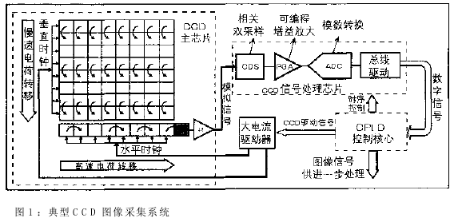
Fig 1 the typical CCD image sensor system

CMOS image sensor was first developed in early 1970s. For the obvious disadvantages compared with CCD such as image quality and performances, no great progress was achieved in the first twenty years. However the development of CMOS has been very fast since 1990s because the advantage of CMOS imaged such as miniaturization, low energy cost and low cost. And now CMOS image sensors can be find almost everywhere, digital cameras, mobile phones, videos and monitors.
The structure of CMOS is showed as below. The Pixel Array converts the light image to electrical signals. Row Select Logic selects a row of pixels and electrical signals are read out to vertical line can. Then the signals will be dealt with in Analog-Signal Processors (ASP). At last the signals will be integrated and be converted to digital signals.
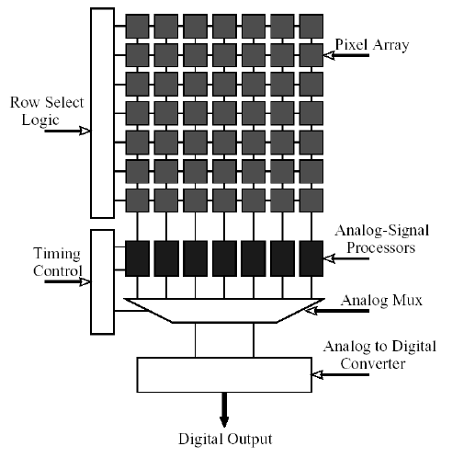
Fig 2 the typical CMOS image sensor system

The differences between CCD and CMOS
Both of the two image sensors use optical diode to carry out photoelectric conversion. The difference is the way by which the digital signals are transferred.
As it is showed below, the electron charge data of each pixel in CCD will be transferred to next pixel to be put out by the pixel at the bottom and then will be amplified by the amplifier at the edge of the sensor. However in CMOS there is an amplifier and an A/D conversion circuit attached to each pixel. The data is put out in a way just like EMS memory. The reason of that is as following. The data will not be distorted during transmission owning to the special techniques of CCD so that data can be amplified until collected to the edge. But in CMOS noises will come out in long-way transmission so being amplified first is necessary.
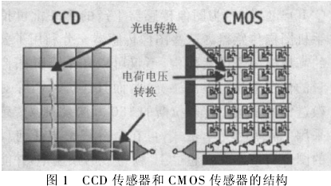
Fig 3 architectural difference between CCD and CMOS

The advantages of CMOS compared with CCD：
- System-integrated. CMOS sensor is able to integrate many kinds of signal and image processing modules in one chip, such as operational amplifier, A/D converter and so on.
- Low energy cost. CMOS sensor can be powered by single voltage and static power cost is negligible, which is as much as only one eighth of that of CCD. So that CMOS sensor can be carried for a long time and can be applied in planes and satellites.
- High-imaging-speed. CCD carries out serial continuous scanning and the whole line or row data should be read out once, while CMOS can amplify the signals after each pixel is scanned.
- Wide responding-range. CMOS sensor is sensitive to infrared ray other to visible light. The sensitivity is much higher than CCD in the wave-length range of 890nm to 980nm. And the attenuation velocity corresponding to the increasing of wave-length is slow.
- Mightily radiation-resistant. The pixels of CCD are formed by MOS capacitances and quantum effect inspired by electron charges can be easily influenced by radials. However the pixels of CMOS are formed by photo electricity diode or optical grating so that CMOS is almost immune to radials.
- Low cost. CMOS sensors cost less and the structure is simpler. The rate of finished product is higher.

4.1.1.2 Technical Roadmap of CCD
There are only six companies in the world which can produce CCD sensors in batch size because of its complex produce techniques. They are Sony, Fuji, Kodak, Philips, Panasonic and Sharp. Sony is the leader company in this field which owns a half of the market share. Sony began to investigate CCD in 1970s and has produced over 100 million chips since then.
The history of CCD of Sony
Sony had made great efforts on CCD investigation since 1973 and at last in March 1978 a circuit board was produced with 110 thousand elements integrated, which was considered to be impossible before. They spend two more years to improve image quality to produce the first CCD colorized vidicon and CCD colorized vidicon has become a kind of commodity since then though the rate of finished products was very low.
In 8th January 1985, a commemorable product of Sony namely CCD-V8 was put into market. It was a vidicon with 250 thousand pixels.
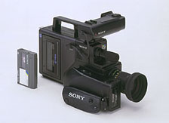
Fig 4 CCD-V8 of Sony

But the development from CCD investigation to digital vidicon is just a threshold and there is still a long way to go to compare with optical vidicon in image quality. Further more efforts have been made since then by Sony.
HAD (hole-accumulation diode) CCD sensor was invented by Sony in the middle of 1980s, which could help to catch clear-cut image even if the object was moving in a high speed.
As we know we must minish the size of each pixel to integrate more pixels in a chip, while the sensitization area and light sensitivity reduces at the same time. Sony equipped each diode with special micro lens to solve the problem. ON-CHIP MICOR LENS CCD sensor was invented then by Sony in late 1980s.
CCD pixel integration techniques had made great progress when middle 1990s and the micro lens technique could not help to induce the sensitivity any more. To solve the problem Sony change the shape of lens and super HAD CCD technique came out.
In 1998 new structure CCD came out. With the rise of F size of the optical lens, more and more diagonal rays of light came into the vidicon, which usually could not arrive at CCD absolutely. So the sensitivity of CCD was restricted. Sony put one more internal lens between colorized filter lens and shade film to improve internal beam path so that the diagonal rays of light could arrive at CCD absolutely.
Infrared rays could be converted to electric charges by semiconductor chips while how to collect the electric charges effectively was a problem then. EXVIEW HAD CCD invent by Sony in 1999 could convert infrared rays to materials that could be used by imaging. That is to say we could get high lightness image even in dark.
In 16th July 2003, Sony declared that four-color filter technique was applied to Sony CCD products. The new four-color filter technique criterion wan named RGBE. Thereinto E was considered to be a criterion of bright blue. Sony said four-color filter technique helped to get closer to the natural color identity of human being and color revivification would be more real. Further more a special image processing module was put out to help.
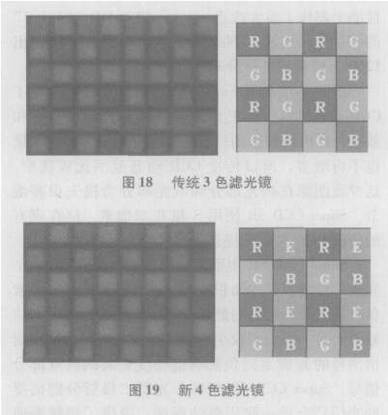
Fig 5 four-color filter technique
The history of CCD of Fuji
Fuji could not compare beauty with Sony in investigation strength and history but its super CCD does have some characteristics.
In 1999 Fuji invented their first generation super CCD. The photo electricity was octagonal and pixels arrange was alveolate. So that the absorbing of light was more efficient and its sensitivity, signal-to-noise performance and dynamic range were all enhanced. The light absorbing area size is twice of the size of ordinary CCD.
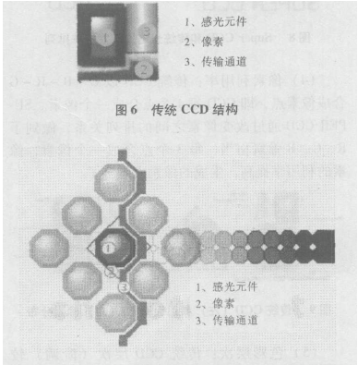
Fig 6 the structure of super CCD
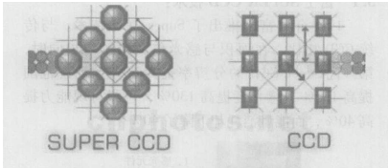
Fig 7 the arrangement of pixels

The second generation super CCD came out in 2001. Its amount of pixels was much larger and noise was much smaller. Some achievements had been made in image quality and details such as image sharpness.
The third generation super CCD came out in 2002. IOS1600 had come true and VGA movie screen velocity could be 30 fps. Besides, new image processing arithmetic and chip technique were adopted.
The forth generation super CCD or super CCD SR came out in 2003. SR meant super dynamic range, which helped to get clear-cut image no matter the light was very strong or very faint. Super CCD meant there were two light sensation diode in each micro lens. One is aimed to black and signals below normal light ray while the other is aimed to signals above normal light ray. The two signals from two diodes were composed to one integrated photograph. The dynamic range of super CCD SR is four times as that of the third generation.
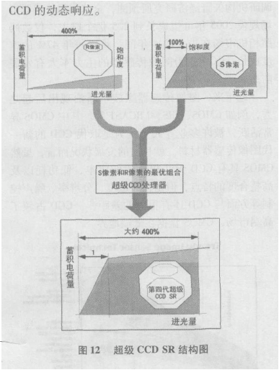
Fig 8 the principle of super CCD

EMCCD
EMCCD technology, sometimes known as ‘on-chip multiplication’, is an innovation first introduced to the digital scientific imaging community by Andor Technology in 2001, with the launch of our dedicated, high-end iXon platform of ultra-sensitive cameras. Essentially, the EMCCD is an image sensor that is capable of detecting single photon events without an image intensifier, achievable by way of a unique electron multiplying structure built into the chip.
If you are interested in EMCCD technology, there are some more details at http://www.andor.com/library/digital_cameras/?app=325.
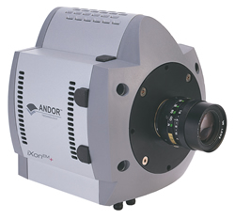
Fig 9 the EMCCD product of Andor Technology

ITO-CCD
ITO-CCD (Indium Tin Oxide CCD) was invented by Kodak. For ITO is absolutely transparent to blue light ray, the light transferring efficiency of CCD sensor is much higher. So is the sensitivity and signal to noise performance.
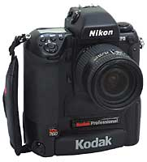
Fig 10 Kodak DCS 760 using ITO-CCD of Kodak

ISIS CCD
ISIS CCD was invented by Kinki University of Japan. ISIS means In Situ Storage Image Sensor. It is a new kind of high-speed vidicon, whose speed can reach one million fps. Besides, the size of photo electricity diode is ten times the ordinary CCD and it is not necessary to enhance lighting strength when taking photos.

X3 integrated color CCD of Foveon
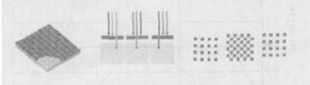
X3 integrated color CCD was invented by a company named Foveon from California, the USA. The structure of ordinary CCD is something like 0beehives with photoreceptors, with whose help CCD recognize the color is red, green or blue. That is to say only one kind of color can be got by each pixel. However the pixels in X3 integrated color CCD are different. A technique named multi-layer sensitization is applied. Each pixel can absorb three colors according to the wave length just like film fiche.
Fig 11 ordinary CCD Green Color-Sensing

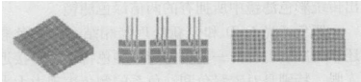
Fig 12 11 X3 integrated color CCD of Foveon

4.1.1.3 Technical Roadmap of CMOS
Before CCD and CMOS devices came out, there were MOS image sensors. Some reports about solid image sensor manufacturing using NMOS and PMOS techniques came out in 1960s. In 1966 WestHouse invented 50×50 one-chip light sensation transistor array. In 1967 FairChild improved the size to 100×100. In 1968 Noble from the Britain suggested a light sensation diode manufacturing technique using superficial light sensation and integrating amplifier used to read out electron charges. And in 1970 Fry Noble and Ryceoft discussed solid model noise form and restraining.
In 1970s CCD image sensors came out, which had many advantages. People continued the study of CMOS and even vidicon used MOS image sensors were put out by Hitachi and Mitsubishi. But CMOS sensors were not widely used because of the disadvantage in image quality. In late 1980s CCD was widely used in visible light while CMOS was used in some mixed infrared focal plane array.
The research on CMOS has been hot since 1990s with the development of VLSI technique and the need of miniaturization, low energy cost and low money cost. The USA, Japan and many countries from Europe expended a lot on that. And as a result, great progress has been achieved. In the field of low resolution, the examples are the image system from Pinkhill and one chip camera from Marshall. In the field of middle and high resolution, CMOS are more widely used. Many companies such as VLSI Vision and Canon put out their products. The details will be formulated in the following paragraphs.

The development actuality of CMOS
Kodak
In 2005 Kodak put out CMOS image sensor KAC-3100 with 3.1million pixels and KAC-5000 with 5million pixels. KAC-3100 is aimed at mobile phone with high resolution and perfect imaging performance, while KAC-5000 is aimed at digital camera and vidicon. PLXELUX technique was applied in the two sensors. And in 2006 Kodak put out 1/4 inches, 1.3million pixel CMOS image sensor KAC-01301. PLXELUX and 4T4S techniques are applied to it .It has the ability of night viewing and image quality is perfect. The performance parameters are as follows table 4.1.
Table 4.1 Performance Parameter of KAC-3100
device | resolution |  | Pixel size  Μm | Optical format | Frame frequency
KAC-01301 | 1.3MP | 1284×1028 | 2.7 | 1/4’’
KAC-3100 | 3.1MP | 2048×1536 | 2.7 | 1/2.7’’ | 10
KAC-5000 | 5.0MP | 2592×1944 | 2.7 | 1/1.8’’ | 6
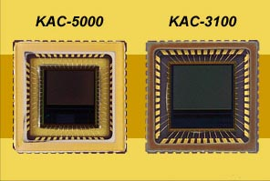
Fig 13 KAC-5000 and KAC-3100

Proware Technology
In August 2005, a kind of VGA CMOS image sensor OV7670 was put out by Proware Technology, whose size was 1/6 inches. New optical format was applied in this device and the pixel size was reduced to 3.6μm, which was used to reduce the height of the module. OV7670 used the special sensor frame of the company and signal-to-noise was enhanced while the performance in faint light was improved. In April 2006 their new product of automobile CameraChip family was put out named OV7949, which is a new kind of high-performance and high integrated CMOS image sensor. The performance parameter is shown below.
Table 4.2 Performance Parameter of OV7670
Size of array | PAL:628×586
Size of array | NTCS:510×496
Electric source | Analog/ADC/IO: 3.3VDC±5%
Electric source | Digital core: 1.8VDC±5%
Power consumption | 250mW
Image size | 5.961mm×4.276mm
Exposal time | 1/60s-12μs(NTSC)
Exposal time | 1/50s-12.5μs(PAL)
sensitivity | 2.26V/Lux-s@5600K
Signal-to-noise performance | 48dB(Max)
dynamic | 50dB
Pixel size | 9.2μs×7.2μs
Packaging size | 14.22mm×14.22mm
Working temperature | -40℃~+105℃ in CLCC

Avago Technologies

In May 2006, Avago Technologies put out a kind of CMOS image sensor with 1/4 inches size and two million pixels, named ADCC-4050. It is applied in ultrathin vidicon mobile phones to enable the cameras in phones to zoom automatically. Thirty frames could be got with resolution of 800×600 pixels. The quality of the images is almost the same with the digital camera. ADCC-4050 image sensor is the few 2 million pixels image sensor which can be easily put into thin and small image modules.
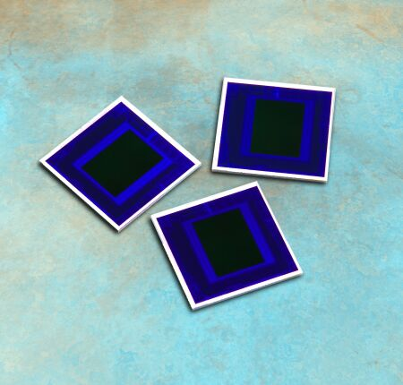
Fig 14 ADCC-4050
Cypress Semiconductor
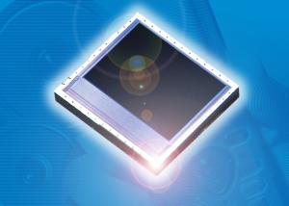
Fig 15 Cypress CMOS
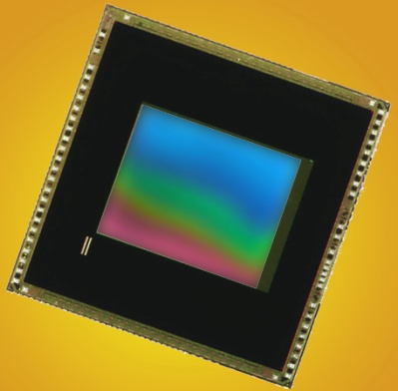
Fig 16 Micron MT9M112

In September 2005, Cypress Semiconductor declared a percept of CMOS image sensor with 1.3 million pixels and 1/4 inches size, which could be used to take place the 1/4 inches VGA image sensors used in mobile phones. 0. 13μm CMOS technology was used in CYIWOSC1300AA 1.3 million pixels image sensor and CYIWCSC1300AA 1.3 million pixels image sensor. They were designed to camera used in mobile phones.

Micron Technology
In August 2005, Digital Clarity technology was put out by Micron Technology with 1/4 inches and 1.3million pixels CMOS image sensor, which is able to get vivid image in poor lighting, named MT9M112. MT9M112 is provide with senior image processing ability including brightness correcting and color correcting. Its frame frequency is 30f/s in preview and 15f/s at highest speed. The size is 2.8μm×2.8μm，including 1280×1024 valid pixels.
Le CMOS Micron MT9M112 : 1.3 Mpixels de 2.8 microns rassemblés dans 1 cm2 !
MagnaChip from Korea
MagnaChip came into CMOS image sensor market in 2003 and purchased IC Media in 2005. In December 2005 a 3.2million pixels CMOS image sensor MC532MA was put into market, which was designed specially to mobile phones. Newest technology was adopted and newest image filter was applied. The performance parameters are as following.
Table 4.3 Performance Parameter of MagnaChip
resolution | 2048×1536
Pixel size | 2.575μm
Optical format | 1/2.7’’
Frame frequency | 12f/s@full resolution;30f/s@VGA
Power voltage | Analog:2.7-2.9V
Power voltage | Digital /O: 2.5-3.1
Power voltage | Digital core: 1.62-1.98
Output format | Bayer RGB,RGB,YUV
Packaging | Die(in wafer form)48- CLCC4
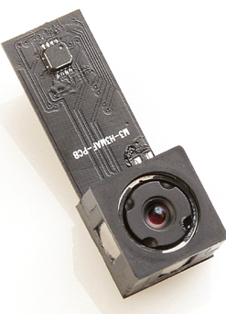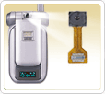
Fig 17 MC532MA

4.1.1.4 Trend of CCD & CMOS technologies
Based on the above detailed-technical portrait, we could find both CCD and CMOS have been underwent great improvements in many aspects, in which some promising influential developing trends are:
- High distinguish ability. The amount of CCD pixels has been enhanced from one million to twenty million. And 8192×8192 pixels CCD has been invented by EG& G. Retion of America. And CMOS also follows closely with CCD in this attribute.
- High speed. It is very critical to enhance the efficiency of electric charges transferring and the frequency characteristic of the equipment.
- Micromation. The current CMOS has been made relative small (Cypress Semiconductor invented concept CMOS with1.3 million pixels and 1/4 inches in size). Still, this trend is undergoing to the future Nanoscale pixel.
- Special application conditions. Current CCD and CMOS sensors have already fulfill the requirement of our daily lives. However, under certain special circumstances (harsh or dangerous area), special image sensor are under research, like Dim light CCD, Multispectral CCD, and Super CCD.

4.1.1.5 Possible application in Cellphone
Current cell phone already adopts CCD or CMOS sensor as its image-absorbing tool, and the concerning development is more on its pixel high density, sensor size minimization and high processing speed. Such is only one direction to consider. Still, when we pay much attention on the actual advantage of image sensor, we may find some other potential applicable circumstances.
1) 3-D environmental info absorbance
If we planted more than 2 image sensors in cell phone and put them in different position to get panorama, then the image is constructed into a vivid environment with field-depth. Not only the direct phone-to-phone communication becomes very live and real, but also this technology enhances the realization of communication in Virtual Reality world.
2) image recognition
We have found that cell phone could recognize ID card and get personal info from the image, just by image sensor. Still, if such technique would improve to multi-info recognition, many applications would be created like: cell phone personalization by face identification; bad food test by color; emotion detection by face info-recognition; and so on.

4.1.2 Speech recognition
People once had a dream that machine can one day understand the voice of our human beings just like pets. From the first phone created by Alekander Graham Bell in 1876, people have experienced and been experiencing the far-open vivid communication between people via lifeless phone machine. In the last century, SR (speech recognition) was proposed and cleaved a brand-new vivid communication zone.

4.1.2.1 Brief Introduction
Speech recognition is an integrated subject, which convert voice signals to corresponding texts or orders. The process of computer speech recognition and human speech recognition is almost the same. Nowadays, usual speech recognition technology is based on statistical pattern recognition. There are three parts in an integrated speech recognition system.
- Speech characteristics pick-up
- Acoustic module and pattern matching
- Content understanding
Speech recognition is a kind of understanding process. Just as we don’t dispatch speech, phraseological structure and semantic structure, machine need this knowledge, too. However there is still a long distance between machine and human brain because of the polytrope, dynamic character and instantaneity. So professional design and debugging is need in speech recognition.

4.1.2.2 Technical Roadmap
In September 1996, Charles Schwab opened the first large-scale commercial speech recognition system, namely stocks quoting system. The system effectively enhanced the service quality and the customers’ contentment. And the cost of calling center was reduced. Later speech stocks business system was opened, too.
The main telecom business company namely Sprint opened speech drive system in 2000, which provided customer service, speech dialing, number lookup and address change. And in September 2001 an inquiring system was put out to which the customer could talk freely.
Bell Canada is the largest telecom business company of Canada, which owes many speech drive system providing customer service, increment business and inquiring. And as s result, customers’ complains reduce and sources of income increase.
Speech recognition has broken through the threshold, while there is still a long way to go. Now the focuses of speech recognition technique and application are as follows.
- Recognition of speech with accent
- Recognition of speech with noises in background
- Recognition of speech with tongue
Now in the world, the application of speech recognition is very high. In western countries, many speech recognition products came into market and the speech recognition of other countries are forming. Nuance is the leader company in this field owning mature technique, application model and business systems in all over the world. Nuance provides developing and optimizing tools, which enhance the speed of system development and upgrading.

4.1.2.3 Trend of SR technologies
From early years’ basic signal transmission and treatment, to nowadays intelligent speech recognition, voice transmission is much advance. And the most distinctive directions are: Integration percept, speech base, developing tool, optimizing tools.

4.1.2.4 Possible application in Cellphone
Current cell phone has made it possible to recognize user’s voice and locate intended caller’s name in telephone directory. It’s true that when connecting with people’s daily need and intentions, there are so many software developments in this sensor’s applications, such as: realize dangerous environment by sound recognition; emotional info recognition by speaker’s voice; and so on.

4.1.3 Olfactory sensor
We may not notice such a fact: just like ear, our noses work permanently once we live. We’ve used to it and never pay attention on its far-reaching influence: our noses not only keeps our breath system, but also enables us with tasty world. Delicious food, sweet flower, smelly clothes, and stingy dirty water…with our noses we taste our world and experience the acerbity, sweetness, hardness, and spiciness in life.
The sense of smell is the least understood of all the mammalian senses. An odour is an organoleptic attribute perceptible by the human olfactory organ upon sniffing air containing certain odorants.
A brief summary that compares the characteristics of the biological nose and the electronic nose is shown in table 4.4.

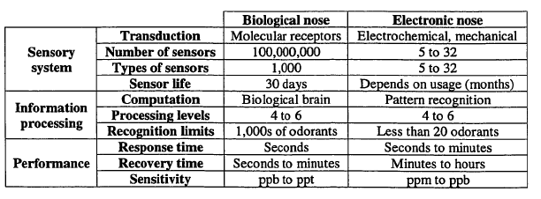
Table 4.4 Comparison between biological nose and current e-nose

4.1.3.1 Brief Introduction
According to Gardner, “an electronic nose is an instrument, which combines an array of electronic chemical sensors with partial specificity and an appropriate pattern, recognition system, capable of recognizing simple or complex odours”. The cross-sensitivity of the array and the pattern recognition module provide the electronic nose with a wider range for odor detection than the individual sensors themselves.
Two types of materials are commonly used for the sensors inorganic semiconductors (metal oxides) and conducting polymers. Their detection mechanism is based on a surface-level change in resistance (chemo resistors) when the material is exposed to odorants. Besides these primary types, there is a myriad of chemical sensing devices. It is worth mentioning quartz resonators, SAW devices and langmuir-Blodgett films. The transducer mechanism of each particular sensor is describes elsewhere.
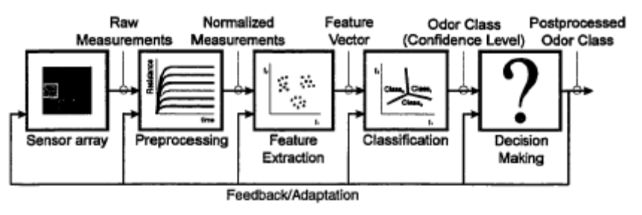
Fig 18 block diagram of the different components in an electronic nose

A block diagram of the different components in an electronic nose is shown in Figure. The architecture is subdivided into five blocks: sensor array, preprocessing, feature extraction, classification and decision-making. Signal preprocessing algorithms are used to compensate for sensor drift, compress the sensor array transient response and reduce sample to sample variations. Typical preprocessing techniques include: (1) manipulation of sensor baselines. (2) Normalization of sensors ranges. (3) use of sensor steady state and window time slicing to compress the sensor transients and (4) modeling the sensor transient with a family of exponential decays defined by amplitude and time constants. The purpose of feature extraction is twofold: (2) reduce the dimensionality of the measurement space and (2) extract information relevant for classification purposes. Typically, feature extraction is performed with a linear transformation, lt. multiplying the measurement vector with a projection matrix. Principal Components Analysis (PCA) is the most widely used linear feature extraction technique, but it is sub-optimal for classification since it only finds projections of maximum variance, regardless of class labels. Linear Discriminant Analysis (LDA), a second well-known linear feature extraction technique, has been shown to be more appropriate for classification purposes since it finds projections that maximize class separability. Some non-linear transforms have been recently adopted, such as Sammon’s non-linear mapping and Kohonen self-organizing maps (neither of them makes use of class labels and are sub-optimal for classification). The pattern classification module assigns a class label to an unknown sample by comparing its fingerprint with previously recorded and labeled odor prototypes. The classical methods to perform the classification task are K nearest Neighbors, Bayesian classifiers and, more recently, back propagation neural networks. The classifier produces a class assignment for an unknown sample, along with an estimate of the confidence placed on the class assignment. A final decision-making module can be used if any application specific knowledge is available, such as risk associated with different classifications errors. The decision-making module may modify the classifier assignment and even determine that the unknown sample does not belong any of the classes in the database.

4.1.3.2 Technical Roadmap
The earliest work on odor sensing can be traced back to Moncrieff in 1961. It was actually a mechanical nose. The concepts of early electronic noses were reported by Wilkens and Hatman back in 1964, Buck in 1965, and Dravnieks in 1965, but the concept of an electronic nose as an intelligent chemical sensors array system of odor classification was introduced 20 years later by Persaud at Warwick University in UK in 1982 and Ikegami at Hitachi in Japan in 1985 and 1987. The term “electronic nose” appeared around the late 1980s as it was sued at a conference in 1987. In 1989, during a session at a NATO Advanced Workshop on Chemosensory Information processing, artificial olfaction was discussed and design of an artificial olfactory system was further established. The first conference dedicated to the topic of electronic nose was held in 1990.
Since 1990, many researches on a sensor array system for odor classification have been done. Several kinds of electronic nose sensors have been investigated. They fall into five main categories: conductivity sensors, piezoelectric sensors, MOSFETs, optical sensors, and spectrometry-based sensing methods. There are two different types of conductivity sensors; metal oxide and conducting polymer. Both of them exhibit a conductance change when exposed to odors. Metal oxide has been used extensively and available commercially in electronic nose applications. Oxides of tin, zinc, titanium, tungsten, and iridium doped on platinum or palladium are usually used. Sensor sensitivity ranges from 5 to 500 parts per million. One severe drawback is that its operation temperature is usually very high. On the other hand, conducting polymer sensors usually operate at ambient temperature, so they do not need a special heater. The electronic interface for conducting polymer sensors is very straightforward, making them very suitable for portable instruments. Sensor sensitivity ranges from 0.1 to 100 parts per million. The main drawback of conducting polymer sensors is their high sensitivity to humidity. Thus some ways to tune out the background humidity and sensor drift are necessary.
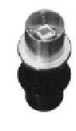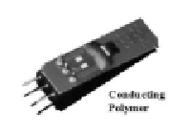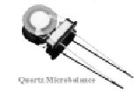
MOS
CP
QCM
Fig 19 MOS, CP and QCM

There are two types of piezoelectric sensors: quartz crystal microbalance and surface acoustic-wave device. For the electronic nose applications, they are both configured as mass-change-sensing devices. The QCM device is a resonating polymer-coated disk with metal electrodes on each side connected to a lead wire. In operation, the device resonated as a characteristic frequency when excited with an oscillating signal. When the odor is adsorbed by the polymer, the mass of the device increased, thus the resonance frequency is reduced. The reduction of frequency is inversely proportional to odorant mass adsorbed by the polymer. QCM usually has sensitivity up to 1ng mass change. One of the disadvantages of QCM is when the dimensions are scaled down; the device becomes noisier because of the instability due to larger surface-to-volume ratio. Another type of piezoelectric sensor is SAW device. Different from QCM, a Rayleigh wave travels over the surface of the device instead of its volume. SAW sensors operate at much higher frequencies than QCM; hence the frequency change is larger. So the sensitivity of a SAW device can be up to 1pg mass change. Both SAW and QCM devices need more complicated interface electronics.
When the volatile organic compounds come in contact with a catalytic metal, there is a reaction in the metal. By using a MOSFET odor-sensing device this reaction diffuses through its gate and changes the electrical properties of the device. Therefore, the sensitivity and selectivity of the device can be optimized by adjusting the type and thickness of the metal catalyst. Usually several parts per million sensitivity can be achieved. One of the advantages of using a MOSFET odor-sensing device is its excellent compatibility with IC fabrication processes. So the device can be integrated with electronic interface circuits and batch-to-batch variations can be minimized. But remember the catalyzed reaction products have to penetrate the catalytic metal layer for the device to change its electrical properties. Thus the device needs a window to allow reaction productions to interact with the gate structures.
Another type of odor-sensing device is optical-fiber sensors. Glass fibers with a thin chemically active material coating on the sides are configured as the sensing devices. The active material contains chemically active fluorescent dyes immobilized in an organic polymer matrix. A light source at a single frequency is used to interrogate the active material. When an odor is applied to sensor, a change in color is detected and measured. By forming an array of these optical-fiber devices an electronic nose can be built. Their sensitivity is usually very high, up to low parts per billion. The disadvantages of the device are the complexity of the instrumentation and control system and the limited lifetime due to photobleaching. Dickinson and Kauer at Tufts University have reported convergent, self-encoded bead sensor array in the design of an artificial nose.
Gas chromatography, mass spectrometry, and light spectrum are the three different types of spectrometry-based sensing methods. The idea is to inject the odor into a spectrometer which generates a spectral response characteristic of odor, such as separated molecular constituents (gas chromatography), atomic mass profile (mass spectrometry), or transmitted light frequencies (light spectrum). A sensor at the output of the spectrometer detects the characteristic profile. When sampled at various instants, a unique pattern can be obtained as coming from an array of different parallel sensors. The sensitivity is usually parts per billion and good analytical accuracy can be achieved. But such types of odor-sensing devices require complex interface electronics, and they seldom perform in real time in the field.
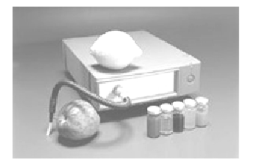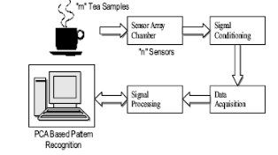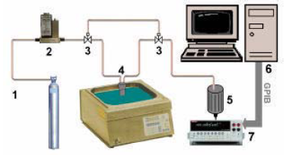
Fig 20 Research among Univ.s (India, Spanish, Germain)
Table 1.1 summaries different technologies for electronic nose sensors, including the principle of operation, their fabrication methods, availability, sensitivity of the sensors, advantages and disadvantages.
Table 4.6 Different electronic nose sensor technologies
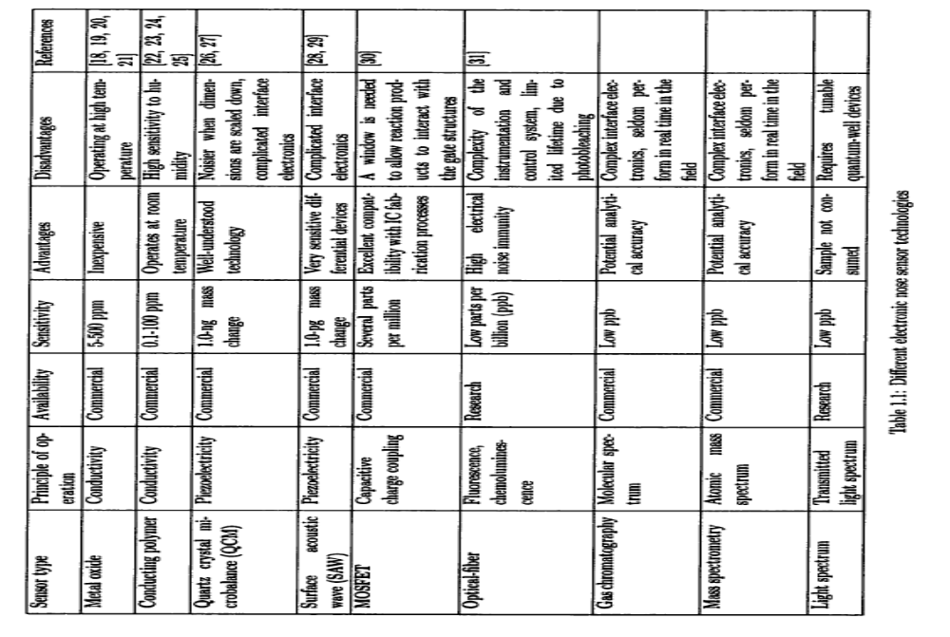
Several manufacturers have already commercialized different “electronic noses”. They are instruments that are mostly desktop or laptop in size, depending on their features. Since much of the early work of electronic nose technology has been done in Britain, there are many companies such as AromaScan, Bloodhound Sensors, and EEV chemical Sensor Systems in Britain. There are several other companies in Europe that commercialize electronic nose instruments such as Airsense and Lennartz in German, Alpha M.O.S. in France, and Nordic Sensor Technologies in Sweden. In the United States several companies have joined the electronic nose business, including Cyrano, Electronic Sensor Technologies, Hewlett-Packeard and Sawtek. Table is a summary of some available electronic nose instruments today in the market, including their sensor type, number of sensors, size of the instrument, and their cost.
Table 4.7 available electronic nose instruments
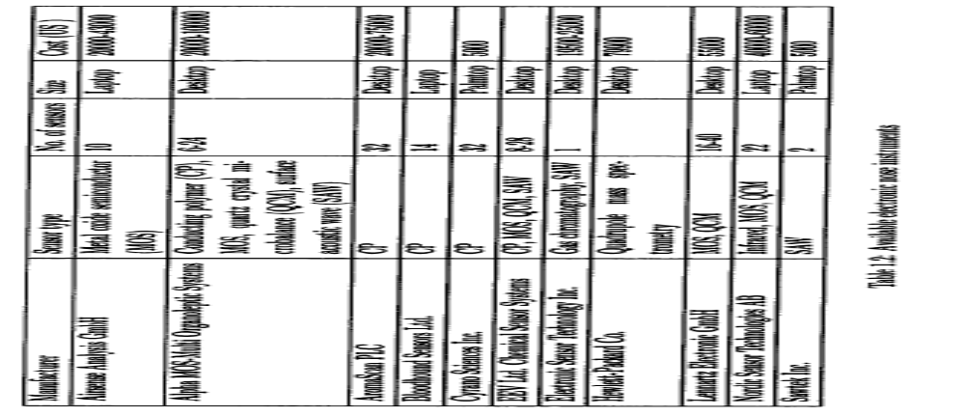
Although these “electronic nose” instruments have the ability to mimic the biological nose to some extent so that they can be applied to many industrial uses, they are large in volume with high cost and high operating power. For the applications such as landmine detection in the military use and food freshness examination in the supermarket, it is impractical to bring a desktop or laptop alongside. Today, electronic nose instruments available in the market are either in size of desktop or laptop, with very few companies researching on palmtop size electronic nose.
In California Institute of Technology, VLSI circuits’ integrated sensor has been researched by Jeff Dickson And later Kea- Tiong Tang in that institute built the other blocks of the electronic nose chip, and interface.
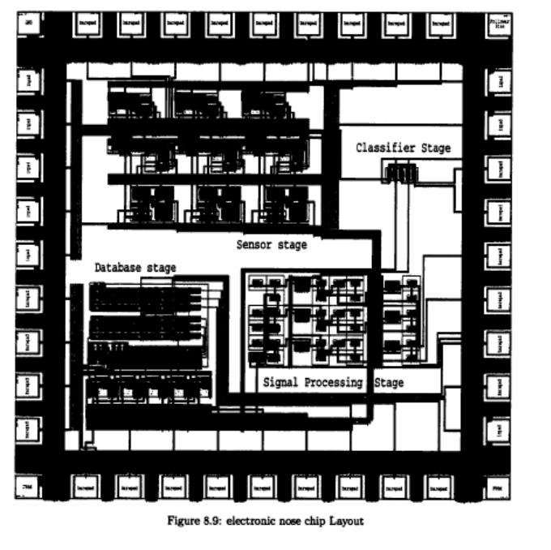
Fig 21 electronic nose chip layout

Summary of technology roadmap
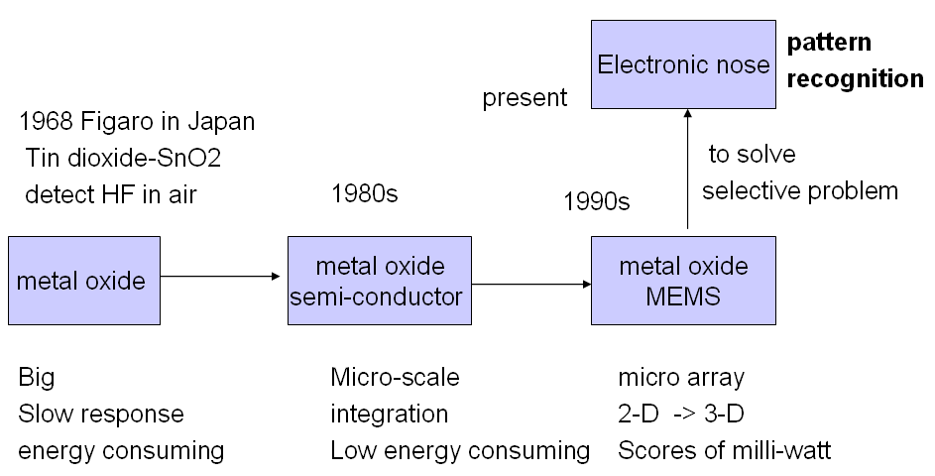
Fig 22 the road map

4.1.3.3 Development Trend
Although the commercial electronic nose instruments have the ability to mimic the biological nose to some extent so that they can be applied to many industrial uses, they are large in volume with high cost and high operating power. For the applications such as landmine detection in the military use, food freshness examination in the supermarket, or even the extreme use in cell phone, it is impractical to bring a desktop or laptop alongside. Today, electronic nose instruments available in the market are either in size of desktop or laptop, with very few companies researching on palmtop size electronic nose. As portable and even wearable like ring or watch is the prospective instrument portrait, the electronic nose should also minimize its size. Therefore, innovative methods should be made to build up a low cost, low power, small size and versatile sensing platform.
For the size aspect, electronic nose should be developed into portable in size and later to nose on chip, while relatively amount of odors could be detected.
For the detecting precision aspect, electronic nose should be made with more sensor arrays and exceed the current 10s per cm2 to 10k per cm2.

4.1.3.4 Possible application in Cellphone
Simens has long declared to research to explore the possible use of olfactory sensor in cell phone, ever since Sep., 2004. However, about 3 years passed with no following new published about its research. On the other hand, LG created an wine-sensing cell phone (LP4100) in Jul. 2006. Such is the only found application of olfactory sensor in cell phone.
Yet, when we make a thorough consideration, we may find there are still many interesting topics that olfactory sensor can implement the powerful cell phone. Such like:
1) Share of flavor
If a boy wonder in rose garden and get fascinated by marvelous sweet smell, he deeply wants to share his feeling to his beloved girlfriend. Photo may not indicate much, explanation may also vague, but with an olfactory sensor planted cell phone, he needs no worry of feeling faded. Such phone can locate the rosy smell and transmit the info to his lover, at whose place expression way could be as colorful, tasty, or vivid as possible. Such is also true for delicious food or disgusting smell. Also share of favor also expedient patient’s diagnosis process, which means that patient could stay at home and be looked over by doctors remotely with this olfactory sensor cell phone.
2) Gas alarms.
For those working in harsh environments like leakages, mining & oil rigs, for those health-concerning people considering carbon monoxide level in closed car parks and ferries, for drunk drivers, for fire conditions, gas alarms sent by olfactory-sensor cell phone could have prominent effect.

4.1.4 Tactile sensor
We, human being, can feel each other and show our kindness, gentleness, love, anger, and so on. Human skin, though very slice, let us touch the life vividly, offering much information: size, shape, position, temperature, or force distribution of a contacting object.
To gain such rich tactile information in real time, the human tactile skin has a variety of specialized structures (Fig ) such as fast responding Meissner’s and Pacinian corpuscles for sensing vibration and touch, slow Ruffini endings and Merkel’s discs for sensing deformation and touch, Kraus’ end bulb thermoreceptors for temperature sensing, and hair follicles for sensing flow, proximity, and touch.
As shown in the figure 26, schematic cross-section of biological skin, showing Meissner’s, Pacinian, and Ruffini corpuscles as well as Merkel’s discs for sensing deformation and touch, thermoreceptors for sensing temperature, as well as hair cilia and follicles for sensing flow and touch.
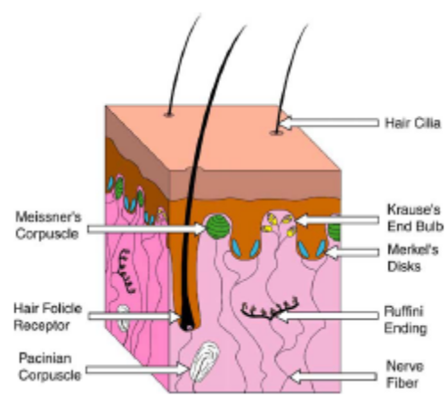
Fig 26 Schematic Cross-section of Biological Skin

Tactile sensor is aimed to mimic the human skin and realize the basic function.

4.1.4.1 Brief Introduction
A tactile sensor is defined as a device that measures parameters of a contact interaction of the device in response to a physical stimulus. Tactile sensors are used to sense a variety of properties concerning both the attributes of a contacting stimulus and the relationship between the stimulus and the sensor. A simple tactile sensor may only detect the presence or absence of touch, whereas a complex sensor can provide information about the size, shape, position, temperature, or force distribution of a contacting object.
In order to develop an artificial tactile sensing device, one needs to know the fundamentals of human tactile sensing. The human upper extremity is an exquisite example of a tactile sensing system that can sense delicate touch and precisely adjust coordinated movements. The sensory receptors are located both in the outmost layer of skin and deep within the muscular and connective tissues. Tactile perception is the combination of cutaneous, propriceptive and kinesthetic response. Touch, force, slip and temperature are conveyed by the cutaneous response. At larger forces the cutaneous response saturates and propriceptors in the tendons and muscles provide force information. Kinesthesia is the sensing of limb position and movements via an array of proprioceptors in and around the joints and the muscle together with the exteroceptors. Mechanoreceptors are low-threshold sensory nerve terminals that are involved in the transduction of mechanical energy to electrical energy. Most are highly specialized and encapsulated structures. Their dynamic responses to stimuli are determined not only by the properties of their receptor membranes, but also by the properties of their capsules and their relationship to the surrounding issues. Quantitative data concerning the distribution and densities of the various mechanoreceptors in the skin are very limited. Some investigations found that fingertips have the highest densities of all the mechanoreceptors.
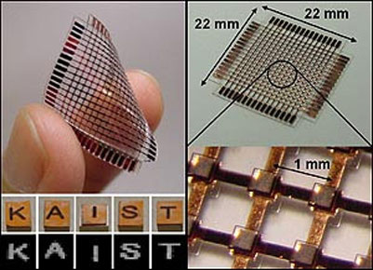
Fig 23 A typical tactile sensor
An ideal tactile sensor should possess the following attributes for human-object interface studies.
Sensing component:
- Ability to sense both normal force and shear force.
- Sensitive to a wide range of force, 0-100N.
- Tolerance to over-range force with no damage.
- Fast response time, less than 25ms.
- Low hysteresis, low creep.
- Small in size, should not interfere with ability to perform normal tasks.
- Accurate force transmission.
Sensor system
- Multiple sensing elements arranged in an array or a matrix.
- Close spacing of sensing elements, in the order of mm center-to-center.
- Flexible, ability to conform to various surfaces.
- Robust packaging.
- ‘Graceful’ failure, survival of the remaining portion when some elements are damaged.
Other specifications
- Local signal processing capability.
- Low power consumption for portable applications.
- High noise immunity.
- Temperature variation immunity.
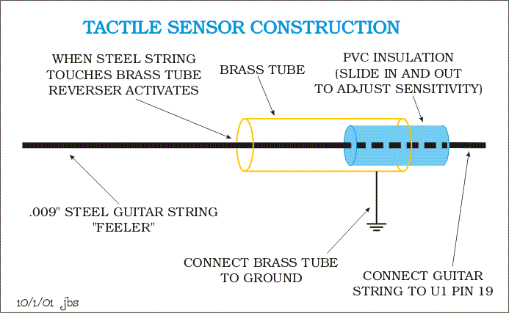
Fig 24 The construction of a typical tactile sensor
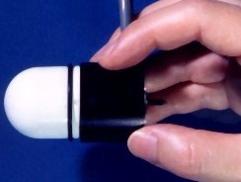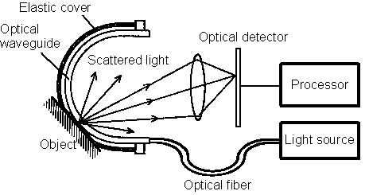
Fig 25 Finger-Shaped Tactile Sensor Detecting contact location on 3D hemispherical surface

4.1.4.2 Technical Roadmap
Some tactile sensors and small force sensors using micro-electro mechanical systems (MEMS) technology have been introduced. MEMS tactile sensing work has mainly focused on silicon-based sensors that use piezoresistive or capacitive sensing. These sensors have been realized with bulk and surface micromachining methods. Polymer-based devices that use piezoelectric polymer films such as polyvinylidene fluoride (PVDF) for sensing have also been demonstrated.
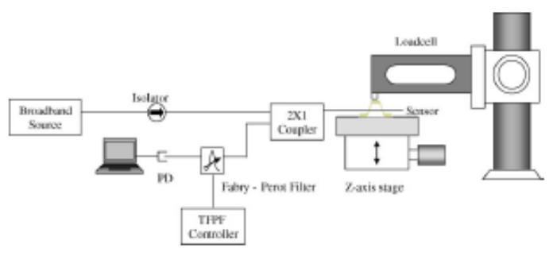
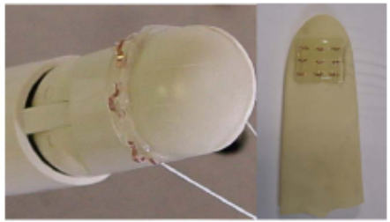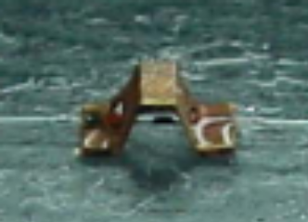
Fig 1 Calibration System of Prototype Sensor
Scientist in Daejeon University Korea developed an optical fiber force sensor and 3×3 sensor arrays, which are the first step toward realizing a tactile sensor using optical fiber sensors (FBG), as well as two kinds of transducers. The two types of transducers have different size and structure. One is applied to a large size force sensor and the other is applied to a small size force sensor.
Researchers in University of Illinois at Urbana-Champaign created a kind of polymer-based sensor skin with multiple independent sensing modalities, including the ability to sense the hardness, the thermal conductivity, the temperature, and the surface profile of an object. Unlike previous multimodal approaches based on FSRs, the presented multimodal polymer skin uses specialized sensing structures to perform various sensing functions, similar to the design of the human skin. The polymer MEMS skin offers the following combination of characteristics:
- 1. Mechanical flexibility and robustness.
- 2. Low fabrication complexity with the potential for continuous roll-to-roll fabrication.
- 3. Specialized sensing elements for sensing multiple physical phenomena grouped in sensor nodes.
- 4. Relatively low processing temperature (<350 ◦C).
- 5. Improved strain transfer from membrane to strain gauges due to direct deposition of sensors on polymer skin rather than on intermediate adhesive layers.
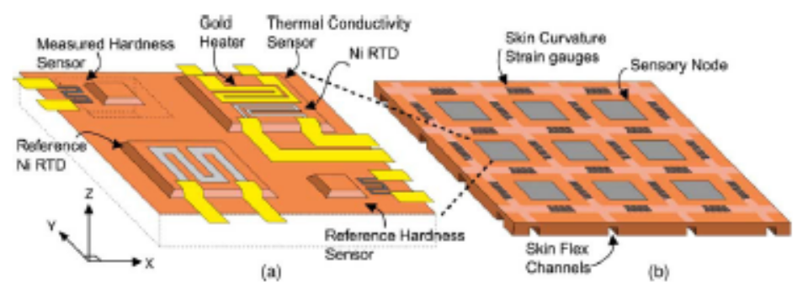
Fig 28 sensory node incorporates four distinct sensors and in the Skin Array
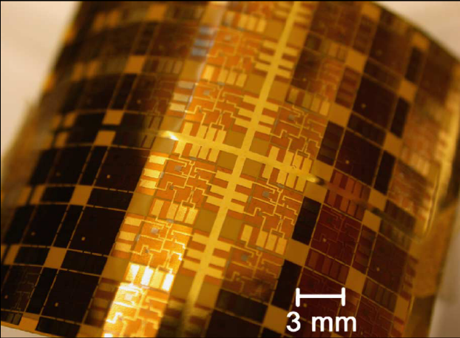
Fig 2 Photograph of Completed Skin in Flexed State

Institutes——Nagoya U: Fukuda Lab
Tactile Sensor for Robot with High Sensitivity and Wide Measurement Range :
We propose a new tactile sensor utilizing piezoelectric vibration. This tactile sensor has a high sensitivity, wide measurement range, pressure resistance, flexibility, and self-sensing function. This tactile sensor comprises two piezoelectric materials. One is used for the vibration of the sensor element and the other is used for the measurement of the change in mechanical impedance induced by an external force. We achieved the wide measurement range by implementing two ideas. One was to apply the external force to the sensor element through an elastic body and the other was to use two or more modes of vibration. Moreover, for the elastic body, it is preferable to use a material whose elasticity and viscosity are easily changed by an external force, such as a gel. In this study, first, this tactile sensor was analyzed, and then its characteristics were derived. The analytical results qualitatively corresponded to the experimental results. Next, a prototype tactile sensor was fabricated and evaluated. The evaluation results showed that this tactile sensor can measure a pressure of 2.5 Pa or less and a pressure of 10 kPa or more and its pressure resistance is 1 MPa or more. Additionally, the integration of the piezoelectric vibration-type tactile sensor and the application to the object grasping were done.
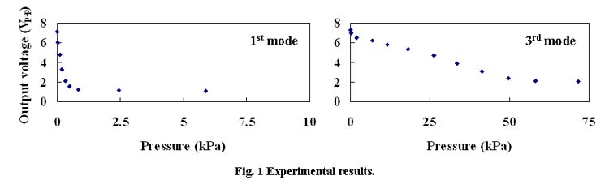
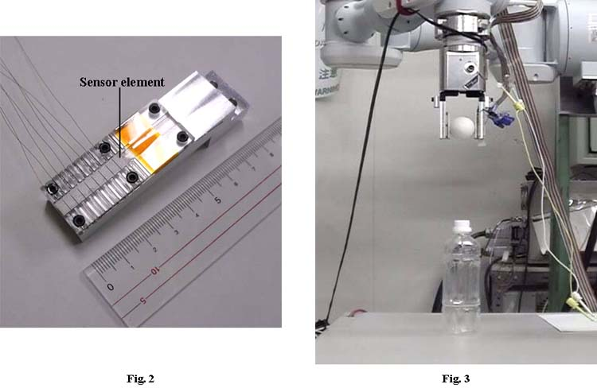
Fig 30 Tactile Sensor for Robot with High Sensitivity and Wide Measurement Range

Institutes——Tadokoro Laboratory of Tohoku University
Representation of artificial tactile feeling has been placed emphasis as new technology to augment virtual reality technology, also as new communication media for remote robotic manipulation or Internet shopping.
We have been studying presentation methods for qualitative surface textures of objects, such as clothes. Our major strategy for tactile presentation is applying vibratory stimuli to fingers.
We also have been studying tactile information processing of humans in psychophysics, engineering and numerical computation methods.
Synthesizing Tactile Feelings by Selectively Stimulating Mechanoreceptor Classes
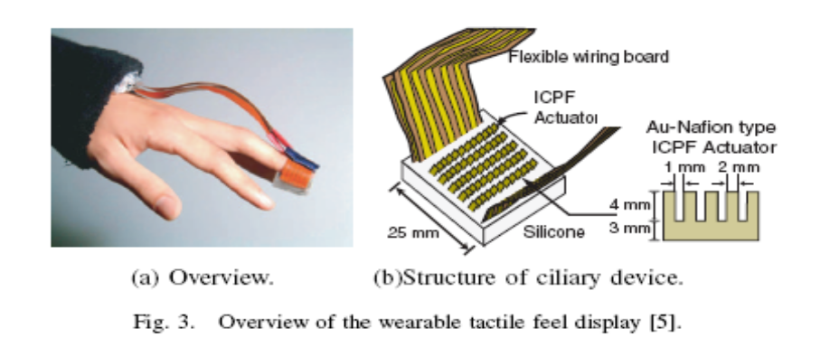
Fig 31 Overview of the wearable tactile feeling display

Multiple tactile feelings, such as pressure, roughness and friction feelings can be synthesized by ICPF tactile display. Which we have developed and studied effective displaying methods.
A device in left pictures replicates surface textures of objects including qualitative information by mechanically stimulating three receptor classes selectively. Activation of each class can be controlled using the device. Because each class has different frequency response characteristics and ICPF tactile display can produce superposed vibrations, each vibration activates each class.
Tactile Displaying Method in Response to Rubbing Motion
We are studying the relationships between rubbing motions and tactile represented. Rubbing motion cannot be ignored, discussing humans' natural touch. Therefore we are proposing tactile display methods in syncronization with hand motions.
The left figure illustrates our experimental setup, in which subjects virtually touch clothes.
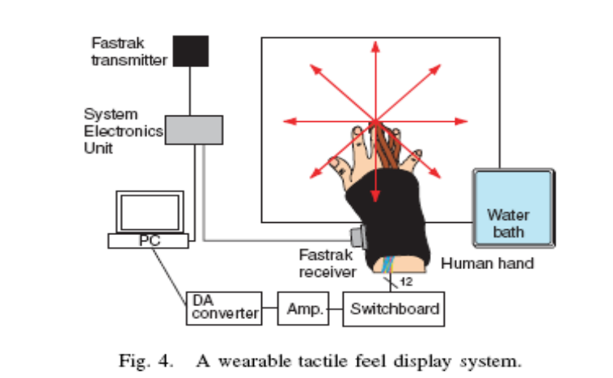
Fig 32 A wearable tactile feeling display system

Touch a 3D Staffed Pig in a Computer
As a demonstration of integrated technology studied in our laboratory, we developed a "touch a virtual pig" system. You can feel differences of clothes and rub it along its spherical nose or ears.
The system presents roughness, softness and friction feelings to fingers just by mechanically vibratory stimuli, which are controlled according to rubbing motions.
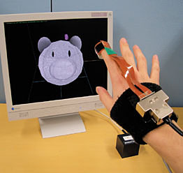
Fig 33 Tactile display of virtual touch with 3D objects

4.1.4.3 Possible application in Cellphone
As have stated on the above, Tactile sensor in the bionic skin material has good performance of detecting the hardness, the thermal conductivity, the temperature, and the surface profile of an object. If such material could be applied on the crust or screen of cell phone, the information detected from human finger or other resource could be used for special functions.
- Once user grasp cell phone with great strength, phone may send out funny voice or flash lights for entertainment.
- If phone drops to the ground or is pressed, this sensor may detect the abnormal pressure and shut down phone.
- The blind could sense the phone’s crust to send or receive information from cell phone; hence, one unique space or market of communication with the disabled, is cleaved.

4.2 Initiative mechanism Expressing info
All living animals have face and body language to express their feeling, which is called emotional expression. To show our feeling, we can smile, swing our arms, or jump. We can see this topic as two aspects: facial movement and body language. Customarily, emotion is generated by movement of facial muscular. However, due to the limitation of technical development in biological and medical area, current artificial facial or body language are more realized by rigid body movement, which is called classic rigid mechanism. Still, there are many testing research on other soft mechanism like artificial muscle. Here, I would like to stress this idea in two ways: facial movement, body movement, special movement, and muscle movement.

4.2.1 facial movement
Current research in this area mainly is the right facial emotional expression of human. Waseda University’s TAkanishi Lab creates WE-4RII have the unprecedented emotional robot prototype. As shown in figure xx, this robot could display 13 different facial expressions.
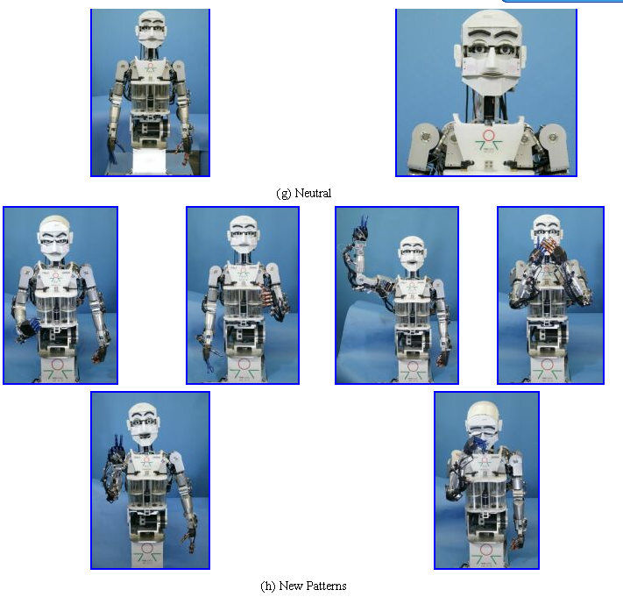

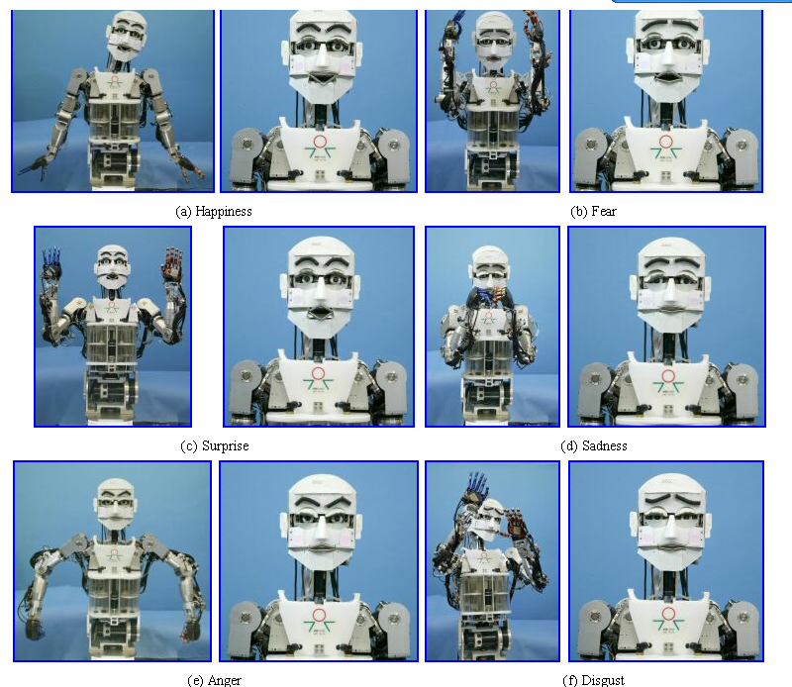
Fig 34 the expression of WE-4RII

Fig 35 the expression of WE-4RII

Another developing trend is to use artificial muscles based on conducting polymers. Hanson Robotics Corp made one unprecedentedly mimetic emotional robot “Hanson Head K-Bot”. The head’s got 24 servomotors, covering the major muscles in the human face. It’s got digital cameras in its eyes, to watch the people watching it. As it looks like, a smiling urethane self-portrait, a tan bot named Andy-roid, a pirate robot with an earring and eye patch. Technically, all 24 servomotors drive soft flesh-toned polymer skin to display 28 facial appearances.
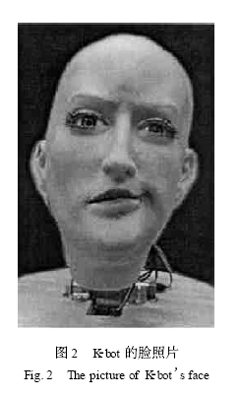
Fig 36 the picture of K-bot’s face

Our The Robopal out of our design also includes such facial variance mechanism. Besides mechanically mimetic human facial movement, our Robopal could also change emotion by artificial muscle.

4.2.2 Body movement
People employ body languages to show their feeling when speech or facial could not satisfy the expected expression. And body language as a vivid art, also adds various and colorful interests during intimate talks.
Current researches within universities are mainly on the upper body movement just like the WE-4RII in Waseda University’s TAkanishi Lab. It nods head to indicate agree
And sway it to show disagree. Implemented with two arms, WE-4RII can express much more information while talking.
The typical achievements of Japanese universities and institutes are ASIMO, a kind of practical humanoid robot, and QRIO, a kind of entertainment robot, see Fig 3. Humanoid research trends in Japan are how humanoid robots avoid obstacles, move flexibly, cooperate with people and express themselves.
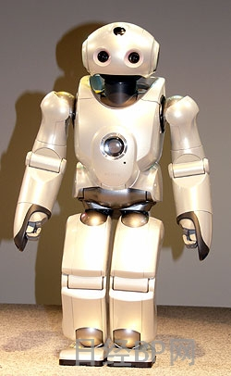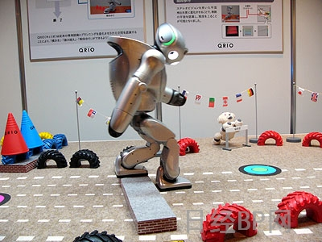
Fig 3 ASIMO and QRIO
The walking bug robot with 6 or 4 legs, designed by Fischertechnik with bionics technology, is controlled by computer using the software LLWin, and Intelligent Interface, see Fig 4. It is driven by power motors, enabling the walking robot to move forwards and backwards as well as to the left and right. The mobile walking robots perceive their surroundings via various sensors. Additional requirements: Intelligent Interface, software and the power supply.
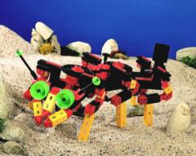
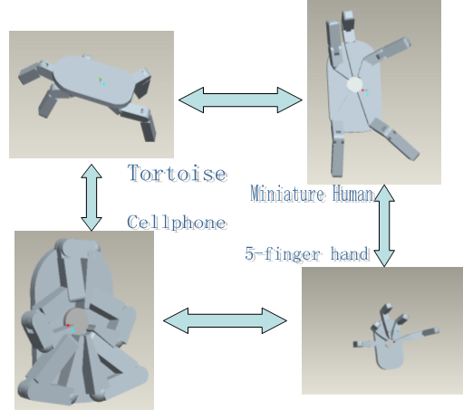
Fig 4 bug robot

Fig 37 meta-morphase

The research in this area is already very complete and relatively deep. However, the TV series “transformer”, once world-widely popular in 80th last century, gives us inspirations. What should we design on Robopal? Why not add some interesting elements, some changeable mechanism? With this design intention, we propose this 4-configuration-changeable mechanism. When five limbs shrink under its crust, it is a standard box-shape cell phone. When five limbs all cluster at one side, Robopal functions like an hand, and could act “Budaixi” drama. It can stand on its two legs, and walk on its four legs. When standing on two legs, it just looks like miniature human; when crawling on four legs, it acts as tortoise or crab. With these several configurations to change, our Robopal can not only use its arm or leg or hand to display, but also change to various types of animals. What’s more, several Robopal could even act a drama.
In the above stated mechanism, Robopal has 15 joints and 25 degrees of freedom. Each leg has three joints. The rear joint is the same as inner joint, both pin joints. However, the different and also difficult joint is the second-level one, a spherical joint with 3 degrees of freedom. Current research on this special joint is still in relatively large scale (75 inches in diameter), which is driven by electro-magnetic poles, functioning like step motor. Because of this working situation, it is very difficult to scale down the joint’s geometry.
Another difficult problem is the control of geometrical transformation. With 25 degrees of freedom to drive to make a complete configuration change, the central processing computer should afford the great calculation amount of each joint’s gait on-line planning and adjustment.
Our Robopal should be designed as a small, portable doll. Therefore, its size is utmost fundamental element to take into account. With upcoming MEMS technology and biomechanics engineering, molecular scaled motion driven may be realized.

4.2.3 New movement control style
Researchers in tadocoro Lab in Tohoku Univ. invented a new movement control-- Ciliary vibration mechanism (actuation of active flexible cables)

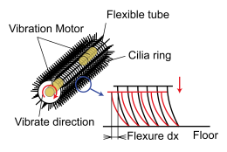
Fig 38 Ciliary vibration mechanism
Ciliary vibration mechanisms were focused and examined for the following two advantages: 1) those having distributional driving force; 2) those that are attachable easily to existing cables. The Ciliary vibration mechanism has plastic or metal thin wires called cilia and achieve driving power through cilia vibration. As the cilia are angled and planted, by adding vibration to the cables, bending and rapid recovery occurs at the front edge of the cilia, which touch the running surface. Using energy stored by bending the cilia, the body can move very short lengths as the cilia recover their original shape. Repeating this bending and recovery motion very rapidly, a body can move forward through a falling-down and standing-up motion. Changing the angle of planted cilia can control the object's velocity and climbing ability. The active cable with this mechanism is covered with cilia all around. Therefore, it has distributive mobility throughout its body and it can generate driving forces in all directions around its body.
Prototypes with ciliary vibration mechanism
Prototypes with ciliary vibration mechanism were produced to examine the capability of this mechanism.
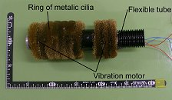 | Fig 39 A first prototype  using brass cilia  73 mm diameter  130 mm/s of driving speed
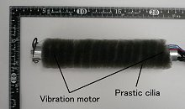 | Fig 40 A second prototype  using nylon cilia  38 mm diameter  40 mm/s of driving speed  can be bent by about 30degrees in four directions
Fig 39 Numerical analysis using model
To elucidate the actuation mechanism and optimize the designing, the actuation mechanism is analyzed using modeling.
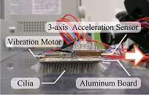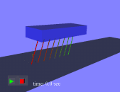
Fig 41 Numerical analysis using model
Active scope camera developed
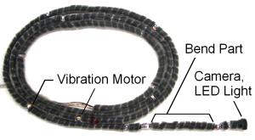
Fig 42 Active scope camera developed
A prototype of an active scope camera was produced. The ciliary vibration mechanism was attached to a general industrial scope camera. The dimensions of the active scope camera are 30 mm diameter and 5 m in length. The driving speed is 11 mm/s and the maximum grad ability was 11.5 degrees.

4.2.3 muscile movement
This area is more on topic 1 (from Zhaodanpu’s work). So, here I just live it blank here. More information could be referred to chapters in topic 1.

4.3 Expression pool
In this chapter, various expression ways are illustrated based on author’s investigation. Due to investigations’ scope and author’s potency limit, the content may be coarse and not complete. More information could be followed in later report.

4.3.1 Visual expression
There are two tools to exhibit visual image: digital screen and digital projector. Digital screen could be divided into TFT, LED, LCD, and so on. Digital projector is to caste an image on opaque walls.
This topic related literature review is still undergoing and should be expected in the next milestone.

4.3.2 Scented expression
Scented expression, as words mean, utilizes various flavor to spread intended smell.
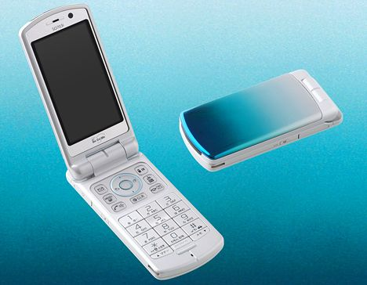
There are many cell phone manufacturers who have made scented cell phone, like NTT Docomo and Sony Ericsson united and made one scented phone early in 2007.
Fig 44 scented phone by NTT & Sony Ericsson
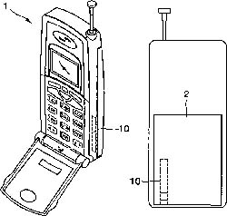
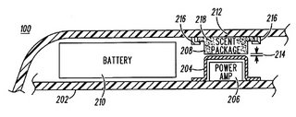
Other institutes like Motorola and Samsung also applied patents on such related cell phone design.
Fig 45 scented phone patent by Motorola Fig 46 scented phone by Samsung

4.3.3 Virtual Reality
The VR research in Japan is very cutting edge and world leading. There are many institutes paid effort to built VR station, such as Watanabe Lab in Nagoya University, Virtual Kyoto city work done by Symbiotic Media Group in Osaka university, Virtual interaction research done by Human Interface Eng. Lab in Osaka university, virtual co-existing space building by Miwa Lab in Waseda university, remote operation research in Fujie Lab of Waseda university and VR & gloves research in ruri lab of Waseda university.
However, due to limited time, I have not completed the literature review work and could only display certain pictures in related institutes.
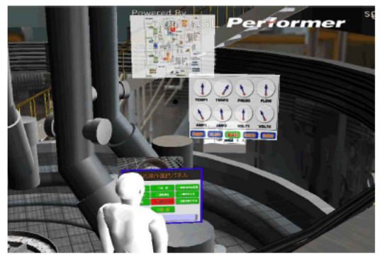
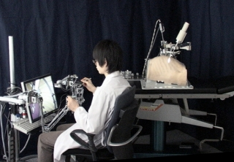
Fig 47 VR & gloves research in Ruri lab of Waseda university
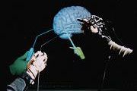
Fig 48 remote operation research in Fujie Lab of Waseda university
Fig 49 Virtual interaction by Human Interface Eng. Lab in Osaka univ.

4.3.4 others
In my Japanese universities investigation, I also found several interesting research which has certain potential application in cell phone, such as body pigment research done by Evolutionary Genetics Group in Nagoya University, and the Color research done by Jinsoken Professor in Waseda University.
Later report will stress the related literature review.

