Concept
In nature, the ability to reconfigure body shape can mean the difference between eating and starving – or between escaping and being eaten. Octopi, cockroaches and mice are diverse examples of creatures that force themselves through holes or gaps whose least dimension is small compared to the normal dimensions of their bodies. The techniques used by these exemplars vary, from the ability of invertebrates like the octopus to extrude through narrow apertures to the ability of arthropods or mice to flatten their exoskeletal or vertebrate structures when squeezing into cracks. In each case, principles are suggested by which a new class of mobile robots could greatly increase their operational performance. In the flattened or extruded state they could pass through slits or holes to gain access to locations otherwise denied or to evade detection. In the normal state they could use extended limbs for rapid locomotion over obstacles and for manipulating objects. With this combination of capabilities they could undertake missions that no current legged, wheeled or serpentine robots can accomplish.
The creation of such robots requires a combination of advances in design, materials, actuation, sensing and control as described in the following sections. The work builds upon recent advances in chemically powered actuation and control, in bio-inspired compliant robotics and in integrative biology that seeks to uncover the principles that underlie successful strategies in animals. The team that we have assembled consists of experts in each of these areas, with a track record of successful collaboration on running and climbing robots and chemical actuation.

Vision
We envision selectively compliant chemically powered robots that undergo dramatic changes in dimensions and shape, according to changing task requirements. In open terrain, they proceed comparatively rapidly, crawling along on appendages, aided by skin and spines with directional adhesion and friction. Tuned passive compliance and damping ensure dynamic stability with an open-loop motor pattern, following principles established in biomimetic running robots such as RHex and the Sprawl robots [Cham02]. Additional appendages can be used for manipulating objects (e.g. to place or remove a payload) or to help the robot climb over obstacles.
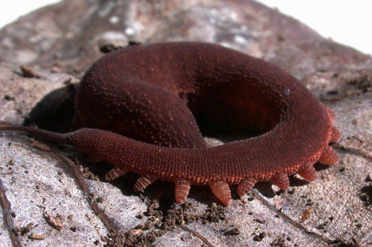
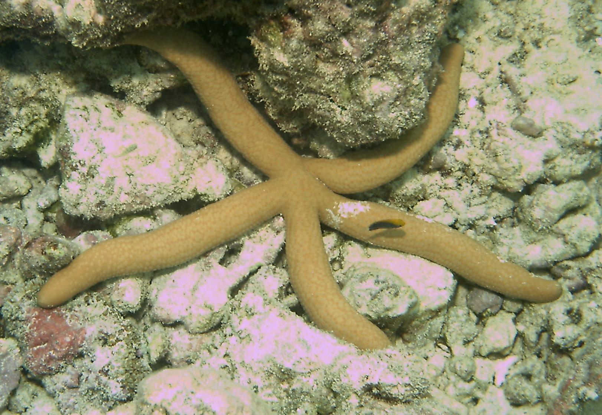
Figure 1. Peripatus (top) and Guilding’s Sea Star (bottom) are two examples of selectively compliant animials that penetrate small areas in proportion to normal body size.
Upon encountering a barrier, the robots search, using their antennae, and possibly additional non-contact visual or proximity sensors, for cracks or holes into which they can force themselves.
The fundamental unit of each robot is a worm-like tentacle, powered consisting of highly elastic chambers, selectively reinforced with embedded fibers. The units are powered by 70% hydrogen peroxide (H₂O₂), an inherently deformable power source with high specific energy. The peroxide mixture is catalyzed directly in the actuating chambers for simplicity, efficiency, and ease of control. Operating at low pressures and with low flow rates, the robots are quiet and can passively conform to the shapes of obstacles around them.
To enter an aperture, each unit establishes a firm grip with using the directional adhesive patches [Kim07] and spines [Asbeck06] and deflates its distal end. A sequence of open-loop motions then forces the unit into the aperature. Locomotion proceeds slowly within the aperture, aided by directional friction/adhesion skin and spines. Upon exiting, the tentacle unit re-expands, segment by segment, to recover its original shape.
Multiple segments can be joined end-to-end, or assembled at their midpoints to create more complex configurations with additional capabilities. The simplest version, which will be explored at the end of Phase I, is to latch a multi-segment tentacle chembot so that it forms a “Y” or three-legged star shape (Figure 3). This is the simplest “branched” configuration that can demonstrate the potential to grasp objects or climb.
Figure 2. Compliant Chembot tentacle approaching and traversing a narrow aperture (replace with new figure showing sequence of tentacle approaching and traversing a hole)

Technical Challenges and Solutions

Figure 3. Figure of multiple segments being bunched or assembled to create a new, more interesting morphology.
To traverse a small opening, a robot can decompose itself into constituent parts or it can change shape. We adopt the latter approach and, taking a cue from primitive animals such as arthropods (e.g. Scutigera) and onycophorans (e.g. Peripatus), we emphasize a primarily passive approach to shape change, in which the geometry of the aperture governs the deformation of the body. This approach simplifies control but it requires (1) a highly deformable elastic body and limbs that can flatten, (2) the ability to sense when apertures are sufficiently large for entry, (3) adequate traction and motive force to propel the body into the aperture, and (4) the ability to recover normal shape on exiting the aperture. These primary requirements lead to technical challenges and solutions, addressed in the following sections.

Bio-Inspiration
Rewrite and perhaps move to later in the Tech section.
Drawing on the successes of previous running and climbing robots, we will ascertain and adapt principles from animals such as Scutigera and Peripatus. These primitive predators have numerous features that make them particularly well suited to robotic emulation. For example, Peripatus are soft-bodied, but have limbs, tipped with chitinous claws that they can move and extend with variations in blood pressure, as do some spiders. With their soft bodies, they excel at hiding “… in incredibly tight crevices” [Cuevas 07] which they locate with anterior antennae. In addition, their relatively primitive neural systems and numerous external sensors including antennae, bristles, and simple visual sensors make them an ideal source of inspiration when seeking to construct and control a monopropellant-powered soft robot. A much faster, although less deformable, solution with an exoskeletal segmented body and more sophisticated legs is seen in Scutigera. Solutions inspired by Scutigera will be investigated as an extension of the pneumatic Sprawl robots [Cham02]. In parallel, we will review the methods adopted by other animals that excel at entering tight spaces including octopi, and certain vertebrates. However, the Peripatus is the initial focus of our biological investigations.

Power and energy conversion
The main power source for the robot will be a hydrogen peroxide monopropellant, which has been demonstrated in previous work [Shields06, Fite06, Goldfarb03] as a compact energy source for robot actuation. Unlike electric motors or internal combustion engines, the monopropellant does not require rigid structures for energy conversion and power transmission. Consequently, it is particularly well suited for integration with compliant, under-actuated structures. With miniature valves and a granular catalyst integrated into the actuators, the entire energy storage, conversion and transmission system is capable of being reconfigured from one shape to another while remaining operational.
A 70% concentration of hydrogen peroxide (H₂O₂) is a clear, stable liquid at temperatures between -40 and +125 C. On contact with a catalyst it decomposes exothermically to water vapor and oxygen. Based on the conservative assumption of isothermal expansion, 70% peroxide will produce 210 kJ/kg of propellant (or 275 kJ/L) of mechanical energy. 70% peroxide robot actuation systems have been shown to provide an energetic figure of merit [Goldfarb03] an order of magnitude greater than (secondary) battery and electric motor actuation systems [Shields06, Fite06]. Under adiabatic conditions, the maximum temperature of the vapor is 232 C (450 F), which is within the range of operating temperatures for several plastics and elastomers, such as Teflon and PEEK (polyetheretherketone) plastics, and silicone and Viton elastomers.
Goldfarb has considerable experience with the design and control of peroxide-powered conventional (hard component) robots and has also tested peroxide-powered Viton-based elastomeric actuators to over 100,000 cycles of loaded actuation.
Fig. 4. Deformable monopropellant and actuator system
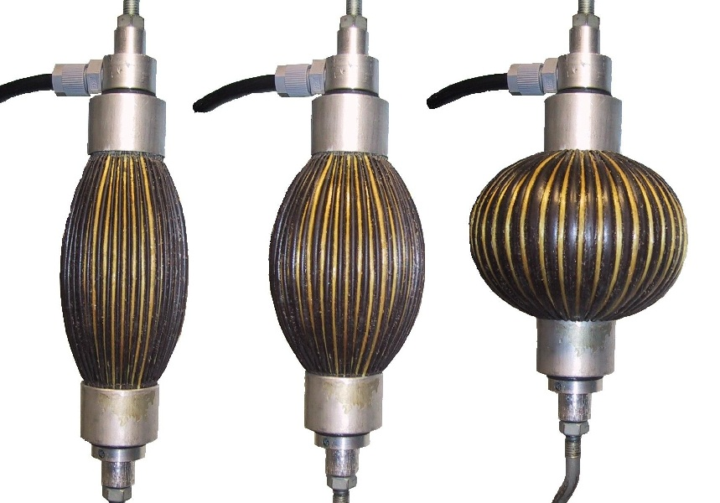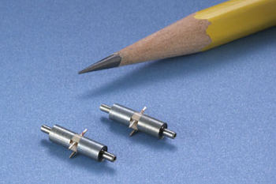
Fig. 3. Examples of (conventional scale) Kevlar-reinforced artifical muscle actuators and micro-dispensing valve (Lee series 120)
Though the elastomeric actuators can take several forms, perhaps the simplest is that shown in Fig. 3. In this form, an elastomeric tube contains longitudinal embedded fibers so that, when pressurized, the fibers remain at constant length and the tube contracts, much like a biological muscle, producing rectilinear actuation. In other configurations, the actuation can be multi-directional, as determined by the shape of the actuator and the direction and orientation of the inextensible fibers. For example, a star-shaped actuator with radially-oriented inextensible fibers would contract radially inward; a tubular actuator with spirally-oriented fibers would simultaneously twist and contract [Shinichi01].
In the schematic power and actuation system in Fig. 4, the peroxide is stored in and pressurized by the elastomer bladder, fabricated from a Silastic elastomer or Viton (depending on desired durometer), both of which are fully compatible with peroxide. Actuation is initiated by pulsing open the micro-dispensing valve, thus passing a shot of liquid peroxide into the muscle actuator. The actuator is filled with a granular catalyst (iridium-coated alumina granules, 18-20 mesh, with sub-millimeter diameters). Muscle relaxation is forced by the elasticity of the skeletal system, and in its simplest form results from a bleed orifice at the far end of the actuator. In this configuration, muscle contraction decays at a predetermined rate. Use of a pin-hole bleed valve assumes that isometric contractions are generally not necessary, since compliance in the skeletal structure will accommodate postural loads, such that the muscles will generally be utilized for locomotion (including squeezing through openings), which is a dynamic activity. An alternative is to use a powered exhaust valve. Our preference in this case is to concatenate exhaust valves along a single spool, with fixed phasing corresponding to a fixed motor pattern.
In the system shown in Fig. 4, the only rigid component is the micro-dispensing valve, which can have dimensions of 3.0 mm (0.11 in) in diameter and 9.6 mm (0.38 in) in length (see Fig. 4). Each valve actuates a muscle group rather than a single actuator. The complete set of non-deformable parts consists of several micro-dispensing valves, a microcontroller, and a small battery to power the controller and valves. All have characteristic dimensions below the 1cm opening described in the BAA.
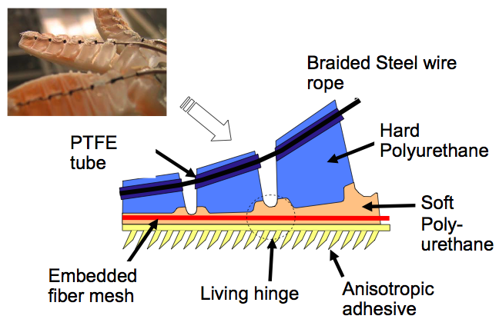
Fig. 5. Stickybot toe – replace with view than shows toe linkage plus
Softbot Body design and locomotion
While H2O2 offers particular advantages in terms of high energy density, controllability and inherent deformability, there are also particular challenges in terms of harnessing it to a soft robot that can propel itself over terrain, squeeze through narrow apertures and reconfigure itself. When we examine the anatomy and physiology of invertebrates that excel at these behaviors, we find that in most cases they rely on muscular hydrostats in which annular rings of muscles contract against a constant fluid volume to produce axial extension; conversely, axial contraction produces radial expansion. Keeping the two sets of muscles in opposition allows for local stiffening, which provides the strength required for an animal to raise itself above the ground (e.g. to enter a hole that is not at ground level, or to climb over obstacles) and to force itself into narrow openings. In the present case, we harness the liquid/gas phase transition of catalyzed H2O2 to produce a volumetric expansion accompanied by a rise in pressure. This mechanical energy must be harnessed to produce a periodic combination of axial extension and radial contraction. We present two variations on a “tentacle” or “annelid” (worm-like) concept for achieving the desired effect. Following a brief description of the two concepts we discuss some of the primary technical challenges and risks and the steps taken to address them.
Softbot concept variant 1:
<brief description and picture(s)>
Softbot concept variant 2:
<brief description and picture(s)>
Common features of both variants include:
* a modular body with multiple, segmented interior chambers of highly elastic silicone and urethane materials, reinforced selectively with high strength tensile fibers, for liquid H2O2 and for expanded water vapor. The initial body shape is an elongated worm or tentacle, but these bodies can be composed into different morphologies (e.g. branched like a sea star) for greatly diversified functional capabilities
* Catalyzation takes place directly in the actuation chambers for efficiency, simplicity and noise reduction.
* The primary actuation cycle is open-loop, following a gait fixed by a microprocessor acting as a central pattern generator.
* regions of the other skin are covered with directional adhesive materials (pioneered by Cutkosky’s group for Stickybot [cite]) and the bodies are equipped with directional spines that bend easily in one direction but are stiffer when loaded in the opposite direction.
* low-power latching mechanisms can be used to join multiple sections together
Key challenges and steps taken to address them
The two softbot variations employ many of the same technologies and present many of the same fabrication and control challenges. Both concepts will be explored during the first several months of the project, conducting tests of locomotion efficiency and assessing fabrication challenges before converging on a single design for the second generation prototype. In the following paragraphs we discuss materials, fabrication and operational challenges and the steps taken to address them.
Locomotion efficiency
Although several annelid robots have been reported in the literature [cite] the locomotion efficiency has generally been disappointing both in terms of body-lengths per locomotion cycle and in terms of meters per Joule. These previously developed devices have focused on reproducing authentic worm-like motion, rather than achieving very high values of deformation, which is of greater concern in the present case. The efficiency of locomotion is also directly related to the amount of deformation achieved per cycle. In open terrain, we anticipate expansion ratios of XX/1. With appropriate elastomeric materials, this translates to localized axial strains of XX percent strain and to changes in radial dimension of YY percent. Consequently, we anticipate efficient open-air locomotion with up to YY body-lengths/locomotion cycle and up to ZZ meters per cubic centimeter of H2O2 consumed.
Inside a narrow aperture or tube, locomotion efficiency and speed will be significantly reduced because maximum strains will also be reduced. However, with the addition of directional adhesive materials and directional spines, we anticipate the ability to travel at 0.5 cm/second.
Aperture penetration and locomotion
The ability to traverse narrow spaces involves more than the ability to assume a narrow or flattened shape. It is also necessary to forcefully penetrate narrow openings, particularly if relying on the geometry of the opening to passively govern the deformed shape. For example, earthworms achieve substantial axial and radial forces – forces several times greater than the normal forces required for locomotion – in comparison to their body weight in order to penetrate soil [cite Quillan2000]. Other animals such as arthropods use directional spines to help them push forcefully into tight spaces [cite Full]. In the present case, we believe that it is necessary to use directional adhesive skin and directional spines to ensure that the body can anchor itself and push the distal end into an aperture. With these aids, longitudinal forces of several times the body weight can be achieved [Sangbaekim07] and, because the materials are directional, detachment or disengagement is easily accomplished when the loading direction is reversed.
The directional skin and spines will also permit locomotion through extended apertures or tubes. The net amount of axial expansion and contraction will be much smaller than in open air, but little backward sliding will take place. Therefore (slow) forward locomotion will be possible. The price we pay for this capability is that backward motion through tubes will be difficult of impossible. If the ability to move equally forward and backward through tubes is important, we will experiment with patches of opposite directionality on alternating segments which are selectively actuated, or not. The net locomotion efficiency will be reduced but bidirectional locomotion will be possible.
Materials and device fabrication
The robot structures will be fabricated by casting from elastomers capable of very high strains. The method of fabrication will be adapted from the Shape Deposition Manufacturing (SDM) process used to create Sprawl, Spinybot and Stickybot robots over the last several years [Cham02, Asbeck06, Kim07]. Carbon fiber fabric will be embedded where highest stiffness and strength are required. A silk mesh can be used where a flexible but inextensible membrane is desired for shear transfer (as in Stickybot toes, Fig. stickybot foot). Discrete bands of Kevlar can be embedded for flexibility with high strength in a particular direction. Superelastic Nitinol wires can be embedded for a combination of moderate stiffness and large bending strains without plastic deformation.
SDM techniques for embedding fibers across material boundaries in heterogeneous structures are described in [Hatanaka03]. Using these methods, elastic strains of over 300% and a high fatigue life can be achieved if a smooth surface finish is maintained. The resulting structures have properties similar to tents or kites, in that the entire structure is capable of sustaining high loads and is surprisingly stiff, despite being made primarily of flexible and elastic materials. And like a tent, they can be collapsed as soon as the primary tension members are made slack.
Recently, the SDM process has been applied to complex, three dimensional hollow mesh structures of polymer, reinforce with a metal mesh and containing embedded fiber optic sensors [Park et al.] (Fig XX) a diagram of the manufacturing sequence is shown in Fig YY. This process can be adapted to create hollow fiber-reinforced chambers for the current proposal.
Tendons, using steel or Vectran in Teflon sleeves, provide the possibility for remote actuation (Fig. 6). Finally, in addition to the stiffening effects of fibers and tendons, narrow chambers can be filled with electro-rheological (ER) or magneto-rheological (MR) fluid for controllable resistance to deformation. These fluids have been used by Cutkosky [Akella95] to control soft robotic fingertips. In the energized state, the chambers become rigid up to the Bingham plastic flow stress; in the de-energized state they deform easily and provide damping. However, a drawback with ER fluids is the need for high voltages to achieve adequate field strength. For MR fluids, power must be supplied through electromagnetic coils or a mechanism must be devised to bring permanent magnets into proximity with the fluid on demand. Consequently, ER and MR fluids are not proposed as a primary enabling technology for this Phase I proposal.
Fig. 7. Embedded sensors using SDM. Top: Sprawl robot with antenna for following walls. Bottom: hexagonal mesh exoskeletal robot finger with embedded fiber Bragg grating sensors.
SDM also supports the fabrication of directional dry adhesive patches, as demonstrated in Stickybot [Kim07]. When a tangential force is applied to these patches in the preferred direction, they adhere to smooth surfaces and exhibit high friction on rough surfaces. This capability will allow the robot to climb slopes and to anchor itself for pushing its body into narrow cracks.

Sensing

Control
The robot will leverage underactuation, with fewer controlled actuators than degrees of freedom, as a strategy to achieve functionality with minimum complexity. With proper constraints and dynamic tuning, underactuated systems can exhibit force/motion behaviors close to the biological “templates” from which they are derived, over a restricted range of conditions. A good example is the foot design in Stickybot (Fig. Stickybotfoot) that uses a single motor to actuate four toes that peel and curl around objects. The actuator is connected to the toes through a set of push-pull tendons connected via a double rocker-bogie linkage [Kim07].

Noise
(address here or under actuation or both?) – Pneumatic equipment is often noisy as a consequence of releasing highly compressed gas at high flow rates, through small orifices. In the present case, we will be using low pressures and low flow rates. We will not be exhausting gas through small, rigid orifices. Consequently, we anticipate that the robot will operate more quietly than conventional small robots with RC servomotors and gearboxes. To further reduce noise we have the option to use elastomers such as urethanes, which have excellent sound dampening properties, for the outer skin.

Sensing and Control
The soft robot will use a largely open-loop control scheme, which will enhance actuation efficiency, reduce the number of required sensors, and reduce computational load on the microcontroller. A sequence of pulses commanded to the valves will generate one gait cycle. Variations in locomotion are enabled by varying the pulse widths and frequency, while entirely different modes of locomotion are enabled by varying the relative phasing of pulses. As in the Sprawl robots, a fixed motor pattern will determine the normal gait, and will be tuned in combination with the mechanical properties to achieve speed and dynamic stability [Cham02] (when creeping into cracks, stability is less of a concern because of the geometric constraint provided by the crack itself).
High level control involves behaviors using signals obtained from antennae and simple optical sensors to guide the robot across open spaces, detect small apertures, assess whether they can be entered, and monitor the progress of the robot into the aperture. The research tasks will include sensor interpretation for a combination of simple mechanoreceptors (antennae and force sensors on the limbs), pressure transducers, body deflection sensors, and simple optical sensors. This work will build upon prior results with the Sprawl robots [Cowan03] using antennae for guiding cockroach inspired robots along walls. We anticipate augmenting the antennae with other mechanical body sensors and with non-contact proximity sensors or specialized vision (e.g., simple optical flow or modified optical mouse technology). In prior work we have embedded such sensors into soft robotic fingertips [Howe93, Park07].

3. Proposed Plan of Work and Milestones

Phase I (18 months)
0-6 months: Design and build preliminary body and appendage structures for testing with monopropellant actuation and control – emphasis on valving, timing and motion trajectory generation. Tests conducted to establish performance (speed, efficiency, leakage).
Develop initial manufacturing process for 3D fiber reinforced body structure.
Begin high speed video investigations of arthropods and onycophorans entering apertures.
Ship first appendage structures from Stanford to Vanderbilt and monopropellant components from Vanderbilt to Stanford so that both sites have equivalent first-generation hardware.
6-month milestone: Tethered demonstration of peroxide-powered locomotion in partial soft robot (e.g. body segment and 2 appendages).
6-12 months: Perform detailed experiments on first-generation structures to quantify terrestrial locomotive speed, endurance, terrain capability, and payload capacity.
Characterize range of achievable shape change.
Characterize traction between appendages and surfaces, and force available for insertion into apertures. Characterize lower bounds on aperture geometry for traversal.
Develop and test first generation sensors for crack detection and assessment.
12-month milestone: Tethered non-autonomous demonstration of peroxide-powered soft robot and preliminary tests of aperture traversal.
12-18 months: Incorporate findings from bio-experiments to guide initial integration of antennae sensory information into semi-autonomous locomotion and shape change control.
Develop on-board electronics and microcontroller for untethered operation, and integrate into soft robot platform.
Develop behavioral specifications for fully autonomous operation (in Phase II)
18-month (Phase I) milestone/deliverable: Untethered demonstration of peroxide-powered locomotion in a ~10cm soft robot, including demonstration of terrestrial locomotion, detection of an opening and traversal of an arbitrarily shaped aperture with a least dimension of ~1cm.
Phase II (24 months): Work in Phase II will focus on refining the proof-of-concept from Phase I into a working robot with: (i) refinements in the design to increase performance, durability and reliability, (ii) a larger number of sensors and algorithms for interpreting sensor information and (iii) behaviors to increase autonomy with respect to typical task scenarios. An optional activity in Phase II will be to partner with a company to develop a pre-commercial prototype of the soft robot platform.

Management Plan
Stanford University (Cutkosky) will be the project lead, as main platform fabricator and integrator. The management will draw upon his experience as P.I. for an ONR MURI on the Sprawl robots and as a major partner in the DARPA RiSE Biodynotics consortium. Goldfarb (Vanderbilt) and Full (Berkeley) also have extensive experience with multi-institutional DARPA programs.
As in these previous and ongoing projects, we will have frequent exchanges of personnel and hardware, in addition to a weekly videoconference meeting. In particular:
- A Vanderbilt researcher will spend a significant period during first quarter at Stanford, learning how to do SDM fabrication.
- A Stanford researcher will spend time at VU learning how to handle and control peroxide monopropellant.
- A Stanford researcher will spend 1 day per week in the laboratory of Full at Berkeley, participating in focused animal experiments (e.g., use of sensory information, behaviors for reliable entry).
In addition, at approximately 6 months, initial appendage structures will be shipped from Stanford to Vanderbilt and a “kit” of miniature monopropellant valves, catalyst and controller will be shipped from Vanderbilt to Stanford so that both sites have equivalent first-generation hardware. The materials costs for the soft robot are not high; therefore subsequent generations of the soft robot will also be distributed between Vanderbilt and Stanford.

4. Cost Estimate, Phase I (18 months)

5. Key Personnel
Mark R. Cutkosky is a professor in the Dept. of Mechanical Engineering at Stanford University. He joined Stanford in 1985, after working in the Robotics Institute at Carnegie Mellon University and as a machine design engineer at ALCOA. Cutkosky's research includes robotic manipulation and tactile sensing and the design and fabrication of biologically inspired robots. He has graduated 30 Ph.D. students and published extensively in these areas, including several patents. He consults with various companies and serves on technical advisory boards in the areas of robotics and human/computer interaction devices. His research focuses on novel multi-material fabrication methods to create robots whose mechanical properties draw inspiration from insects, geckos and other animals to increase physical robustness, improve performance and simplify control. His work, partly in collaboration with biologist Robert Full, has been featured in Forbes, Discover Magazine, The New York Times and other publications and has appeared on the CBS Evening News, Next @CNN, Science Central News and other popular media. His most recent work on Spinybot and Stickybot has won a Best Video award (IEEE ICRA06), Best Student Paper award (IEEE ICRA07), Finalist, Best Manipulation Paper (IEEE ICRA07) and TIME Magazine Best Inventions of 2006. Cutkosky’s previous awards include several Best Paper awards, a Fulbright Distinguished Faculty Chair (2002), a Charles M. Pigott Professorship (1996) at Stanford University and an NSF Presidential Young Investigator award (1986).
Robert J. Full joined the University of California at Berkeley as an Assistant Professor of Zoology in 1986. In 1997 Full became a Chancellor’s Professor at Berkeley, awarded for “distinguished achievement of the highest level in research, teaching and service.” Full has authored over 200 contributions and has delivered an equal number of national and international presentations. In 2006 he founded, CIBER, a new center at Berkeley dedicated to Interdisciplinary Biological-inspiration in Education and Research. In 1990 he received a Presidential Young Investigator Award. He has mentored over 90 undergraduate researchers who have received more than 50 awards/fellowships. For these efforts he recently was named Mentor in the Life Sciences by the National Academy of Sciences. Full directs the Poly-PEDAL Laboratory, which studies the Performance, Energetics and Dynamics of Animal Locomotion (PEDAL) in many-footed creatures (Poly). His research program in comparative physiology and biomechanics has shown how examining a diversity of animals leads to the discovery of general principles of locomotion. His fundamental discoveries have inspired the design of novel neural control circuits, artificial muscles, eight autonomous legged robots and the first self-cleaning dry adhesive.
Michael Goldfarb: Michael Goldfarb is a Professor in the Department of Mechanical Engineering at Vanderbilt University, and director of the Center for Intelligent Mechatronics. Dr. Goldfarb joined the faculty at Vanderbilt immediately after receiving his Ph.D. from the Department of Mechanical Engineering at MIT in 1994. Dr. Goldfarb has published over 100 technical papers in the areas of robot design and control, including relevant work in the areas of liquid hydrogen peroxide powered robotics and the design of minimally-actuated elastodynamic robotic insects. He has directed over $10 million of externally funded research over the past dozen years as a principal investigator from federal agencies including the NSF, NIH, DARPA, NASA, the CIA and ARO. Dr. Goldfarb has been funded through seven different DARPA programs over the past ten years, as lead on five of those seven. Two of those programs were for mesoscale robotics, and three were/are relevant to hydrogen peroxide based power for robot actuation.

6. References
[Kim07] S. Kim, M. Spenko, S. Trujillo, B. Heyneman, V. Mattoli, M.R. Cutkosky, "Whole body adhesion: hierarchical, directional and distributed control of adhesive forces for a climbing robot," IEEE ICRA07, April 2007.
[Asbeck06] A. Asbeck, S. Kim, M.R. Cutkosky, W.R. Provancher and M. Lanzetta, “Scaling Hard Vertical Surfaces with Compliant Microspine Arrays,” IJRR, v 15, n. 12, 2006, pp. 1165-1180.
[Cham02] J.G. Cham, S.E. Bailey, J.C. Clark, R.J. Full and M.R. Cutkosky, "Fast and Robust: Hexapedal Robots via Shape Deposition Manufacturing," IJRR, v 21, n 10-11, 2002, p 869-882.
[Hatanaka03] M. Hatanaka and M.R. Cutkosky, “Process Planning for Embedding Flexible Materials in Multi-material Prototypes" DETC ASME, 2003, Chicago, Illinois, USA, Sept. 2003.
[Akella95] P. Akella and M.R. Cutkosky, “Contact Transition Control with Semi-active Soft Fingertips,” IEEE Transactions on Robotics and Automation, v. 11, n 6, 1995, pp. 859-865.
[Cuevas07] http://www.fs.fed.us/r8/caribbean/wildlife-facts/2002/wildlife-facts-april-2002.shtml
[Barnes93] Barnes RB. Introduction to the Onychophora, Chilopoda, and lesser Protostomata, pp. 1-9 in Harrison FW, Rice ME (eds.). Microscopic anatomy of invertebrates, vol. 12 Onychophora, Chilopoda, and lesser Protostomata. Wiley-Liss, NY, 1993.
[Cowan03] N. Cowan, E.J. Ma, and M.R. Cutkosky and R.J. Full, “A Biologically Inspired Passive Antenna for Steering Control of a Running Robot,” Proc. ISRR, Siena, Italy, Oct. 2003.
[Park07] Y-L Park, K. Chau, R.J. Black, and M.R. Cutkosky "Force Sensing Smart Robot Fingers using Embedded Fiber Bragg Grating Sensors and Shape Deposition Manufacturing," IEEE ICRA07, April 2007.
[Shinichi01] Shinichi H., Tomohiro M., and Sadao K., Prototyping Pneumatic Group Actuators Composed of Multiple Single-motion Elastic Tubes, IEEE ICRA, v 4, pp.3807-3812, 2001.
[Shields06] Shields, B.L., Fite, K., and Goldfarb, M. Design, Control, and Energetic Characterization of a Solenoid Injected Monopropellant Powered Actuator, IEEE/ASME Trans on Mechatronics, v 11, n 4, pp. 477-487, 2006.
[Fite06] Fite, K.B., Mitchell, J., Barth, E.J., and Goldfarb, M. A Unified Force Controller for a Proportional-Injector Direct-Injection Monopropellant-Powered Actuator, ASME Journal of Dynamic Systems, Measurement and Control, v 128, n 1, pp. 159-164, 2006.
[Fite06b] Fite, K.B., and Goldfarb, M. Design and Energetic Characterization of a Proportional-Injector Monopropellant-Powered Actuator, IEEE/ASME Trans on Mechatronics, v 11, n 2, pp. 196-204, 2006.
[Goldfarb03] Goldfarb, M., Barth, E.J., Gogola, M.A. and Wehrmeyer, J.A. Design and Energetic Characterization of a Liquid-Propellant-Powered Actuator for Self-Powered Robots. IEEE/ASME Trans on Mechatronics, v 8, n 2, pp. 254-262, 2003.
[Howe93] R. Howe and M. R. Cutkosky, “Dynamic Tactile Sensing: Perception of Fine Surface Features with Stress Rate Sensing,” IEEE Trans on Robotics and Automation, v 9, n 2, April, 1993, pp. 140-151.

