
Draft Copy for
Red Team Review #2
5 March 2009

Robotics Collaborative Technology Alliance (CTA):
VOL2 CHAPTER 1 Section 3.4
Funding Opportunity Number: W911NF-08-R-0012
Submitted to Client
client address

Technical  POC: | [name] [title]  iRobot Corporation  8 Crosby Drive  Bedford, Massachusetts 01730  [phone] [fax]  [email]
Administrative  POC: | Judith Blinn, Director of Contracts  iRobot Corporation, 8-2  8 Crosby Drive  Bedford, Massachusetts  v-781-430-3348 f-781-960-2610  jblinn@irobot.com
Submitted 12 March 2009
This document contains pages (referenced at the right) with Technical Data controlled under the U.S. International Traffic in Arms Regulations (“ITAR”), 22 CFR 120-130, and may not be exported or transferred to any foreign Person, foreign country or foreign entity, by any means, without prior written approval from the U.S. Department of State, Directorate of Defense Trade Controls (“DDTC”) and iRobot Corporation. | ITAR, 1, 3

Table of Contents
1 3.4 Proposed Research in Dexterous Manipulation and Unique Mobility 2
1.1 3.4.1 Overall Vision for Dexterous Mobility and Unique Mobility 2
1.2 3.4 2 Near-Human General-Purpose Manipulation 3
1.2.1 3.4.2.1 Functional Capabilities Needed 3
1.2.2 3.4.2.2 Current State-of-the-Art 3
1.2.3 3.4.2.3 Basic Research: Dexterous Manipulation Using Grasp Primitives (MMB-DEX) 3
1.2.4 3.4.2.4 Basic Research: Learning for Manipulation in Unstructured Environments (MMB-LEARN) 4
1.2.5 3.4.2.5 Applied Research: Forceful Dynamic Whole-Body Manipulation (MMA-FORCE) 4
1.2.6 3.4.2.6 Applied Research: Cooperative Manipulation (MMA-COOP) 5
1.3 3.4.3 Lightweight and Inherently Safe Actuators 5
1.3.1 3.4.3.1 Functional Capabilities Needed 5
1.3.2 3.4.3.2 Current State-of-the-Art 6
1.3.3 3.4.3.3 Basic Research: Bioinspired Technologies (MMB-BIO) 6
1.3.4 3.4.3.4 Applied Research: Safe Mobile Manipulators (MMA-SAFE) 7
1.4 3.4.4 Autonomous Mobility in Difficult Terrain 8
1.4.1 3.4.4.1 Desired Capability 8
1.4.2 3.4.4.2 Current State-of-the-Art 8
1.4.3 3.4.4.3 Basic Research: Adaptive Multimodal Locomotion (MMB-LOCO) 8
1.4.4 3.4.4.4 Applied Research: Marsupial Robot Teams (MMA-MARSUPIAL) 9
1.4.5 3.4.4.5 Applied Research: High-Speed Dynamic Mobility over Rough Terrain (MMA-DYNAMIC) 10
References [note: to be moved to Ref volume] 11
2 13

3.4 Proposed Research in Dexterous Manipulation and Unique Mobility

3.4.1 Overall Vision for Dexterous Mobility and Unique Mobility
Desired Capability | Current State-of-the-Art | Basic Research  Applied Research
Near-human general-purpose manipulation in human environments | Most real-world manipulation teleoperated or scripted. No use of mobile base dynamics to maximize force. No real-world applications of cooperative multirobot or robot/human manipulation. | Dexterous Manipulation Using Grasp Primitives,  Learning for Manipulation in Unstructured Environments,  Forceful Dynamic Whole-Body Manipulation,  Cooperative Manipulation
Inherently safe actuators | Systems have low power/weight and force/power ratios, especially at small scales and for mobile platforms. Structures have high mechanical impedance, stiff and are easily damaged or able to cause damage | Bioinspired Technologies,  Safe Mobile Manipulators
Autonomous mobility in difficult terrain | Fixed configurations, fixed modes of locomotion. Autonomous mobility on roads, very limited autonomous cross-country capability for rough terrain. | Adaptive Multimodal Locomotion,  Marsupial Robot Teams,  High-Speed Dynamic Mobility over Rough Terrain
Team SPARTA’s research program in dexterous manipulation and unique mobility has three goals: to advance autonomous dexterous manipulation capabilities to near-human levels, to develop inherently human-safe actuators based on biological principles, and to provide robots with autonomous mobility capabilities that can surmount nearly any terrain.
Our manipulation vision is of robotic teammates that can act like members of a squad – working in cooperation with humans and other robots as members of the team. Like human warfighters, robotic teammates will need to be able to grasp a wide variety of objects that they have never seen before. They will need to be able adapt their behaviors based on experience and learn to improve their performance over time. Like human warfighters, they will have to use their whole bodies as mechanisms for the violent application of physical force – breaching through doors and other obstacles. Above all, they will need to be able to cooperate with humans and other robots to jointly perform manipulation tasks that could not be accomplished alone. Safety is a critical priority for any mobile manipulators that must operate in such close proximity to humans. Today’s manipulators are either too weak to lift heavy objects or so strong that they could cause significant harm to nearby humans. We want actuators that have high power to weight ratios but are also flexible and compliant. For this, we look to biology for inspiration, as human arms are excellent examples of manipulators that are strong enough to carry sandbags but gentle enough to care for infants.
Our mobility vision is for the Army’s ground robots to be able to go anywhere that the Army’s warfighters will need to go – over all types of urban and wilderness terrain, day or night, and in all weather conditions. No single robot and no single mobility mode will be able to handle every terrain type. For this reason, we are conducting research into multimodal mobility and multirobot marsupial teams. Multimodal robots have the ability to use more than one mobility mode – rolling, jumping, climbing, flying – thus dramatically increasing the range of terrain that they can handle. The range of terrain accessible to robots can be further increased by using marsupial robot teams. In these teams, a larger, faster, longer-range robot carries a smaller, more agile robot that provides specialized mobility capabilities. greater than that accessible to a single robot or a group of robots using a single mobility mode.
We will demonstrate our advances in manipulation and mobility through integrated demonstrations that combine our innovations with those from Perception, Intelligence, and HRI. These demonstrations will show robot teammates working closely with humans to clear buildings and man checkpoints, and they will demonstrate the vast range of terrain that can be explored by marsupial teams of multimodal robots jumping across gaps, climbing trees, and taking off to soar overhead.

3.4 2 Near-Human General-Purpose Manipulation

3.4.2.1 Functional Capabilities Needed
In order to exempt warfighters from excessive exposure to dangerous situations in routine tasks, a mobile manipulator must be capable of a wide range of everyday operations using human scale objects, tools, and fixtures in environments with human scale ranges of motion, forces, speed, and accuracy. These robots will interact forcefully with objects and transmit work into remote locations to support missions with and without human partners. General-purpose mobility and manipulation share important common goals related to managing the dynamics of inertial objects – including the robot’s own body – by the skillful application of forces to environmental surfaces. It is particularly challenging due to the variety of objects and tasks that confront the robot. Foundational technologies are required that provide autonomous systems with the ability to reason about forces and dynamics for mobility and manipulation in unstructured settings, that learn new manual strategies in collaboration with peer robots and humans in a manner that transfers to related tasks, thus accumulating comprehensive arrays of manual skill. Prototypes of these systems have been demonstrated in the laboratories of Team SPARTA and will lead to fieldable systems that can deploy check points, dig trenches, unload trucks, search buildings, and set up over watch perimeters.

3.4.2.2 Current State-of-the-Art
A large body of literature exists on the mechanics of grasping and manipulating objects with known geometries [Nguyen88, Montana88, Bicchi95, Ferrari92, Nguyen89, Jameson87, Ponce_RR96, Faverjon91, Bicchi00, Trinkle98, Howard96, Li89]. These techniques are rarely implemented, require complete prior information (object surface geometry, friction coefficients), they don’t speak to how that information is gathered, and they impose severe and impractical restrictions on the types of objects to which they apply (planar, polygonal, C² continuous, convex, etc.). As result, these approaches severely limit the range of objects that can be grasped, the variety of motions that can be performed autonomously, and cannot deal with unstructured environments.
Other work focuses on models of human grasping [Iberall87, Klatzky87, Klatzky90, Stansfield86]. They consider multiple surfaces of the hand and consider active information gathering activities in addition to manipulation. Signals from human mechanoreceptors are used to select grasping postures or movements consistent with the kinematics of the human hand. In part, these approaches seek to explain human performance and address less structured environment, but they depend explicitly human sensing and morphology, thus requiring a new theory for every robotic manipulation mode. As result, few of these approaches have been implemented on robot systems. More recently, low-dimensional primitives have been proposed to represent coordinated motor patterns to use with robot hands [Speeter90, Michelman94, Pollard96] and very recently, automatic techniques for extracting coordinated patterns of hand control from examples have been demonstrated (Eigengrasps for motor patterns [Ciocarlie07], non-linear principal components methods (IsoMap) for sensor and motor patterns [Jenkins04]). These approaches do not suppress disturbances in unstructured environments and the strategies are specific to a single operating context, i.e. they do not generalize to varying mass, scale, or to multi-robot strategies.

3.4.2.3 Basic Research: Dexterous Manipulation Using Grasp Primitives (MMB-DEX)
SUMMARY: We will develop a new theoretical framework for dexterous grasping and multimodal manipulation. (PI: Rod Grupen, UMass)
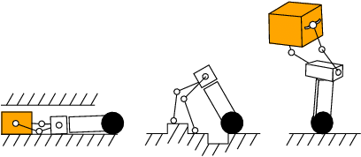
To accommodate unstructured environments, we will study techniques that exploit a highly structured, closed-loop basis for grasping actions. These grasp prototypes reflect the capabilities of the motor system and, therefore, capture the character of versatile, under-actuated hands, bimanual manipulation resources, and multi-robot grasping and manipulation resources.
We propose to exploit generative models represented in the form of closed-loop controllers that form a compositional basis for grasping and manipulation tasks [Grupen08, Saxena08]. These approaches represent independent objectives including pregrasp postures, path planning, and kinematic conditioning for force, velocity, power production, and force closure. The resulting policies are more general because they are based on sequences of co-articulated objective functions that reject bounded disturbances and can be tuned to account for run-time events.
Figure 3.4.2.3-1: Multimodal manipulation and mobility
- Control primitives will be combined formally in a manner that eliminates inadvertent destructive interference.
- Discrete-event abstractions of continuous control behavior will be used to support model-based performance guarantees even during learning.
- Control knowledge will be used to recognize intentions and support learning from demonstration and imitation.
- Control sequence representations will be developed to facilitate generalization and transfer, providing a common strategy for fingertip, bimanual, and multi-robot manipulation tasks thus addressing an unprecedented range of geometric scales using a single abstract policy.

3.4.2.4 Basic Research: Learning for Manipulation in Unstructured Environments (MMB-LEARN)
SUMMARY: We will use learning to improve manipulation performance based on depth images. (PI Andrew Ng, Stanford)
Learning has been used with some success in some basic manipulation tasks such as grasping novel objects [Saxena08]. In our work, we will focus our study on developing learning algorithms to other more sophisticated manipulation actions and to work more efficiently with human subjects. For example, we would like the robot to manipulate and collaborate with humans in battlefield or to carry a human away from the battlefield or to build some barriers. Such actions require more complex output learning (i.e. learning to perform a sequence of actions). The future direction is to apply recent advances such as apprenticeship reinforcement learning and max margin planning for the above complex control problems.
Many manipulation and mobility tasks require object recognition, and especially in our contexts, human and human activity recognition. Although many recognition algorithms exist for intensity images, very few algorithms have been designed for other sensors. The question is how to combine cues from different sensors (infrared, depth, tactile, camera) for better recognition. In a pilot study [Quigley09], we showed that object detection can be improved using depth data. We will extend our study to make more intelligent use of such cues for more complex objects.
Combining multiple sensors for manipulation will lead to the problem that data is very high dimensional. As a consequence, algorithms become slower, prone to overfitting, and no longer real-time. The challenge is to design learning algorithms that are efficient and generalize well for these cases. One promising approach is to add more prior knowledge and constraints to improve the learning process. Another direction is to use special hardware (such as the highly parallelize-able graphics processing units) to make faster decisions.
Calibrating multiple sensors is another inherent problem for manipulation. Existing state-of-the-art calibration algorithms are only designed specifically for cameras and require substantial human supervision. There is a lack of research in calibrating many other sensors or actuators automatically. We will explore methods of calibrating these sensors. These methods can be nonparametric and unsupervised. This means the sensors learn the calibration parameters using prior knowledge (shared common features between modalities) in the external world. Using such algorithms, there is no need for human supervision in calibration and sensors will adaptively calibrate during their course of operation.

3.4.2.5 Applied Research: Forceful Dynamic Whole-Body Manipulation (MMA-FORCE)
SUMMARY: We will develop techniques to allow robots to perform tasks requiring large amounts of dynamically-applied force. (PI: Brian Yamauchi, iRobot)
The goal of this applied research topic is to provide robots with the ability to use the force of their mobile platforms to assist in demanding manipulation tasks (e.g. digging ditches, pushing heavy objects). This includes the ability to use dynamics and momentum to increase and control forces, such as taking a running start before breaching a door.
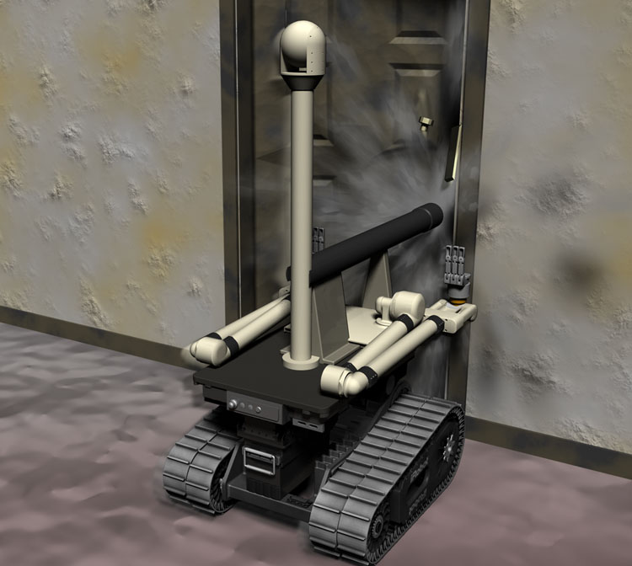
Force control is a well-established area within robotic manipulation [Siciliano00]. However, traditional force control deals with accurately controlling small forces at the end effector via a servo loop. In contrast, our work in forceful, dynamic, whole-body manipulation will focus on using the mobility platform in combination with manipulators and end effectors to maximize rather than minimize the forces between the robot and the environment.
The contact between the robot and the environment will often be ballistic rather than servo controlled. For example, a robot attempting to break down a door will need to pre-position its base, manipulator, and end effector (e.g. battering ram) and accelerate toward the door. The forces that result when the robot hits the door will be predetermined by the dynamic state of the robot and the relative position of the robot and the door. The impact will occur over a short period of time, meaning that the robot will only be able to make minor changes to the magnitude and direction of the force on impact. Despite the ballistic nature of individual “runs” at the door, this behavior can still use sensor data to adapt its actions over multiple ballistic impacts. For example, if the door does not appear to be yielding, the robot can increase its approach speed incrementally over multiple runs. Alternately, if a weak spot is detected where the door is starting to buckle, the robot may aim its end effector directly at that weak spot.
Figure 3.4.2.5-1: SSR breaching a locked door
In the area of forceful manipulation, some work has been done on applying high forces to soil for robotic earthmoving [Stentz99]. This work makes use of script-based motion plans that are modified based on perception of the current world state. However, as is the case with human-controlled excavation, the tracked vehicle base was motionless as the excavator arm was used to dig in the soil. Also, the focus was on continuous excavation as opposed to repeated ballistic impacts.

3.4.2.6 Applied Research: Cooperative Manipulation (MMA-COOP)
SUMMARY: We will develop techniques to allow robots and humans to work together to perform manipulation tasks. (PI: Ron Lumia, UNM)
While previous work has been done in the theory of multirobot manipulation and tested in laboratory experiments [Khatib96, Braun05, Zameroski08], no practical multirobot manipulation systems have been demonstrated for carrying large payloads in complex outdoor environments. The potential of robot/human manipulation teams is their potential for synergies between robot and human strengths. However, this approach also poses new challenges in dynamic interaction with humans and safe operation in close proximity to humans.
We will investigate these challenges for the task for barricade building. The goal of barricade building is to use a heterogeneous team of mobile robots and humans to construct a barricade from unpalletized materials. First, each robot must model the pose of each person in the workspace in real time to anticipate future movements so as to prevent collision. Second, the robot must have a clear understanding of what a barricade is and how to build one. The concept of a barricade, including how to build one, must be a part of the world model stored by each robot. We will apply the grasp techniques developed in MMB-GRASP topic, the learning techniques developed in the MMB-LEARN topic, and the tactile sensors developed in MMB-BIO to enable robust manipulation of building materials. Each step of building the barricade may be performed by a combination of one or more robots and/or one or more humans. Finally, robots may watch humans perform a barricade building task, understand via Perception that the intent of the humans is to build the barricade, and then join into the task to accelerate its completion.

3.4.3 Lightweight and Inherently Safe Actuators

3.4.3.1 Functional Capabilities Needed
If robots are to become commonplace, working with each other and with personnel in teams, they need to be safer, more responsive and more versatile [Bicchi08, Braun05]. These requirements cannot be met using new software with conventional hardware. New actuators, structures and even new fabrication methods are ultimately required.
Robots have traditionally relied on electromagnetic actuators, which offer excellent controllability but poor power/weight ratios compared to human muscle. Even more limiting is their inability to exert large sustained forces without high transmission ratios between the motor and load. The use of such transmissions results in arms with high mechanical impedance, which are inherently less safe than their biological counterparts whenever unexpected physical contacts occur. The danger is compounded by a lack of tactile/force sensing and by the use of structures that lack energy absorbing characteristics.

3.4.3.2 Current State-of-the-Art
Bicchi et al. [Bicchi08] summarize current challenges and approaches in human-safe robots. Efforts to increase safety while maintaining performance have focused on reducing mechanical impedance and inertia, by relocating motors to the robot base and powering arms with cables [Salisbury88], designing low-inertia links with composites, and employing series elastic actuators [Pratt95, Wolf08]. Other work has employed variable compliance mechanisms, artificial muscles [Schiavi08, Tondu06] and hybrid macro-mini approaches in which small motors at the joints augment large, low-impedance actuators for a combination of high power, low stiffness and fast response [Shin08]. In controlled tests, such methods can provide a tenfold reduction in arm inertia for the same overall power and force capability. However, these approaches significantly increase complexity, particularly when a large angular range of motion is required. Moreover, without a sensing, energy-absorbing skin, the immediate response to accidental contact is still poor compared to that of animals or humans.
Other work has focused on the need for versatile hands that can grasp a wide range of objects without being impractically fragile and complex. Compliant, under-actuated hands show promise for handling a large subset of the tools, fixtures and objects that humans use in daily activities [Dollar06, Carrozza04]. However, they currently lack sufficient sensitivity and robustness for human-equivalent manipulation in realistic scenarios.

3.4.3.3 Basic Research: Bioinspired Technologies (MMB-BIO)
SUMMARY: We will develop new bioinspired actuators, structures, and tactile sensors that will enable development of inherently safe manipulators. (PI: Mark Cutkosky, Stanford)
The emerging possibilities of hybrid macro-mini actuation, artificial muscle actuators, under-actuated compliant systems and artificial skin will require a sustained research effort in the following areas: dynamic modeling and nonlinear control, design and fabrication of advanced multi-material structures with integrated actuation and sensing, and signal processing. Many artificial muscle actuators (such as shape memory alloys and ionic polymers) are too slow for human-equivalent manipulation, and those that are fast, such as EPAMS (electroactive polymer artificial muscles), typically suffer from unreliability and fatigue. New materials and processing methods, however, have the potential to reduce defects and increase life. Therefore, one research task will focus on investigating new classes of materials, and new fabrication methods, which will yield actuators with increased reliability and life cycle performance. One material to be investigated will be silicones doped with barium titanate to increase the dielectric constant. These materials have fast response and good fatigue life, avoiding some of the failure modes of acrylic EPAMS. The initial fabrication method to be studied will be pre-strained layers with embedded carbon fiber “battens”. The application of such methods promises to yield fundamental improvements in EPAM maximum power, bandwidth and reliability.
Additional challenges in this task include practical considerations related to developing and integrating a compact, energy-efficient, high-voltage, low-current power system. EPAM actuators also require mechanical preloading (or an antagonistic configuration) for best performance. Therefore, initial studies will employ artificial muscles in applications that take advantage of their properties as dynamically adjustable suspensions and energy storage elements. Promising applications include knee joints for a jumping marsupial robot, and landing systems for perching UAVs (see MMB-LOCO).
Fundamental advances in the control of macro-mini actuators will be pursued. Initial work will focus on modeling and empirical validation of nonlinear macro-mini system dynamics. This will lead to the development of optimal complementary control schemes of the overall system. Later work will draw upon recent findings from biomechanics on how humans and animals control their musculoskeletal systems for fast, graceful motion with minimum effort [Khatib08]. Mappings will be developed between computational neuromuscular models describing skilled human movement and the acceleration, force, torque, and activation patterns of robotic systems.
Another basic research thrust will focus on the development of novel design and fabrication techniques for human-safe bioinspired mechanisms. Two novel design and fabrication approaches will be pursued. The first uses shape deposition manufacturing (SDM) to fabricate multi-material composite structures that integrate actuators, sensors, and their supporting electronics into the mechanical structure. This yields increased robustness and reduced mass, and allows for distributed processing while minimizing practical problems related to wiring [Lanzetta08, Cutkosky09]. SDM-based manufacturing approaches will first be developed for systems with 3-4 actuated degrees of freedom. Later phases will extend these approaches to fully articulated arms and hands that will be mounted on mobile platforms.
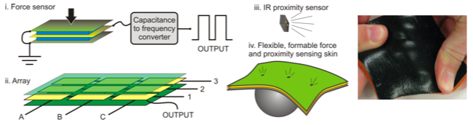
Figure 3.4.3.3-1: Example of accurate, robust, artificial skin with dynamic force and proximity sensing. Immediate conversion to digital format reduces noise sensitivity and simplifies communications [Cutkosky09].
A second design and fabrication approach will focus on developing energy absorbent robotic structures with tunable compliance structures arising from anisotropic active foams. These foams can be 3D printed with tunable compliance due their void geometry, which can be optimized given classical design functional requirements. This property allows monolithic materials to replicate motion characteristics of complex mechanisms. The foams’ cells can be filled with active fluids (MR, ER, etc) to further modulate stiffness properties in a closed-loop manner as a function of environmental conditions. The foams are lightweight and possess good energy absorption properties, making them highly suitable for tasks that involve human interaction. For tasks requiring high stiffness, they can be used in concert with traditional materials as a “skin,” to create stiff, but operator-safe, systems.
Another fundamental technological advance needed for inherently safe manipulators is the ability for robots to detect physical contact using tactile sensors. For this topic, we will be leveraging recent advances in nontraditional MEMS and Shape Deposition Manufacturing, allowing arrays of sensors to be embedded into robot structures. Initial efforts will focus on embedded flexible circuits with surface-mounted devices for sensing and signal processing. Figure xx shows an example of a tactile and proximity sensing array fabricated into a tough, compliant artificial skin. Local processing immediately converts the sensed quantities to digital format, for noise reduction and simplified communication with reduced wiring. Embedded optical fibers represent another attractive technology for precise, high-bandwidth sensing with high-bandwidth optical multiplexing [Par08].

3.4.3.4 Applied Research: Safe Mobile Manipulators (MMA-SAFE)
SUMMARY: We will apply the techniques from MMB-BIO to build the suspension for a perching UAV and to build lightweight manipulator arms. (PI: Mark Cutkosky, Stanford)
This applied research topic will integrate the basic findings and technologies from the MMB-BIO basic research topic onto mobile robotic platforms at various scales. We will initially apply basic research results to focused applications, including the development of an active suspension system for marsupial platforms. An example of particular interest is the suspension for perching UAVs, which needs to ensure a stable bounce-free landing. Such systems place a premium on controllable energy storage and damping with very low weight, and thus the application of novel EPAM actuators promises to yield breakthrough performance.
Other tasks will include iterative testing and design improvement to increase reliability and robustness of EPAM actuation and control. This will require improvements in manufacturing technology. Today, artificial muscles are crafted by hand. We will work with vendors of materials (e.g. 3M) and startup companies (e.g. Artificial Muscle Inc.) to develop robust, large-scale actuation systems suitable for robotic platforms. iRobot Corporation’s expertise in high-volume manufacturing (e.g. Roomba) will be exploited to help achieve low-cost, high-reliability solutions that will ultimately be needed for human-safe robots to become ubiquitous. Other integration tasks will focus on integration of unified control systems for articulated arms and mobile platform. The goal is to exploit dynamically coordinated mobility and manipulation to increase arm performance.

3.4.4 Autonomous Mobility in Difficult Terrain

3.4.4.1 Desired Capability
Robots today can walk, run, and climb, but these locomotion capabilities are typically confined to predetermined gaits in structured, known environments. In order for next-generation robots to go wherever the Army needs them, they will need to adapt to changing and novel environments. This adaptation must occur at multiple levels – at the servo level, to account for small time-varying environmental changes or disturbances; at the gait level, to allow a robot to run through an open field, then slow to a careful walking gait to navigate a slippery mud hazard; and at the task level, to allow a robot to adapt its fundamental mode of locomotion, to allow a system to climb a tree then glide through the canopy.
We aim to study methods for flexible locomotion in unstructured environments through a combination of techniques from the learning subtopic, with particular emphasis on adaptive control and machine learning for feedback control modifications, and techniques from the motion planning subtopic, for gait and transition planning. We will also study and develop novel mechanical designs for multi-modal robots.
We aim to demonstrate aggressive transitions between terrestrial modes of locomotion, such as from flight to climbing/running and back again, or from rolling to jumping. We envision a small marsupial platform that can run on flat terrain, leap onto a tree and climb to a high branch, then take off into a gliding or soaring flight. The robot can return to terrestrial or arboreal locomotion by landing aggressively on a tree or perch.

3.4.4.2 Current State-of-the-Art
Our team has a strong foundation of expertise in these areas, which has led to significant results for wheeled vehicles with articulated suspension in steeply sloped terrain [Iagnemma03], legged robots that walk dynamically on rough terrain (e.g. LittleDog, MIT biped), legged robots that can climbing vertical surfaces (e.g. Stickybot, RiSe), as well as fixed-, rotary- and flapping-wing UAVs. We have developed near real-time multi-gait locomotion planning capabilities for known environments with the LittleDog platform [Byl08c] and machine learning-based control of locomotion for a series of bipeds [Collins05, Tedrake05]. The RiSe platform has demonstrated transitions between multiple gait postures depending on the environmental conditions. We have also obtained initial results for aggressive “perch” landings on UAVs [Cory08]. We aim to combine and extend these capabilities to operate robustly and adaptively at high speeds in unstructured environments.

3.4.4.3 Basic Research: Adaptive Multimodal Locomotion (MMB-LOCO)
SUMMARY: We will explore learning-based control of a flying/perching robot and proprioceptive control of a compliant climbing robot. (PIs: Russ Tedrake and Daniela Rus, MIT)
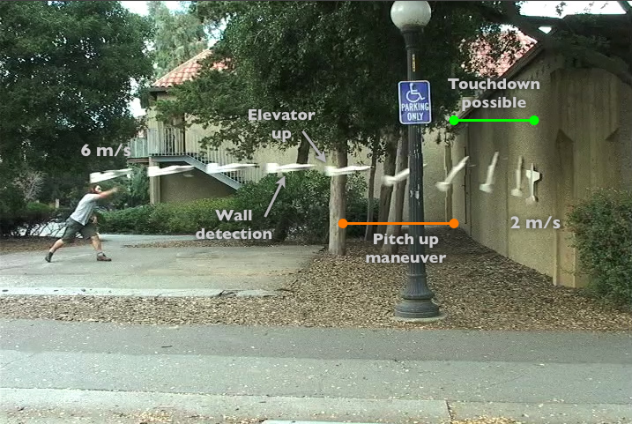
Locomotion in varied terrains is difficult because robots must operate with limited perceptual information and with challenging kinodynamic constraints (e.g. friction constraints at the contact points, actuator amplitude and rate limits, complex geometric constraints arising from obstacles). Rather than focusing on hand-tuned solutions for particular locomotion capabilities in specific scenarios, we will develop robust, general solutions for feedback controller designs through a tight coupling with motion planning and machine learning approaches to feedback control.
Basic research will address fundamental challenges in control system development for robust multi-modal locomotion. We will fuse our terrestrial legged locomotion technology with our climbing robot technology, and focus on aggressive transitions. We will produce a ~1m wingspan autonomous fixed-wing vehicle with a tuned suspension and spiny toes that can fly towards a building, execute an aggressive post-stall maneuver to rapidly decelerate before contact, then “perch” on the wall. Through refined modeling of the post-stall aerodynamics of the vehicle and refined feedback control, we will improve the robustness of this capability to handle 5 knots gusts of wind, and improve the accuracy of this maneuver to allow the vehicle to land on a window sill.
Figure3.4.4.3-1: Multimodal UAV transitioning from flying to perching
We will also explore the use of mechanical compliances in the design of robots via spring-mounted actuation and sensors for measuring the motion of the system at all compliances. The sensors will give the robot a proprioceptive sense whereby it can measure the compliant motion at its own joints induced by the robot's interaction with the environment. The compliances allow the robot to move as needed to conform to the actual local geometry, and the sensing then enables the robot to know how it moved so that it may actively adjust itself to fit that geometry with minimal internal strain. We propose to develop a theory of proprioception with mechanical compliances and demonstrate it in the context of building climbing robots. In the first phase of the project we will build robots that can climb on man-made linkage structures such as trusses and bridges. In the second phase of the project we will develop robots that can climb trees.

3.4.4.4 Applied Research: Marsupial Robot Teams (MMA-MARSUPIAL)
SUMMARY: We will develop techniques to allow robots to deploy and recover other robots. (PIs: Brian Yamauchi, iRobot and Russ Tedrake, MIT)
Marsupial robot teams can combine mobility at multiple scales and using multiple modes to provide unprecedented capabilities to explore complex environments [Murphy99, Carroll02]. An innovative feature of our approach is the use of multi-layer marsupial hierarchies to extend the range of robot teams. In the SPARTA concept, a large RCV provides long-range autonomous transport over road networks in urban and rural environments and deploys man-sized SRRs. Each SRR provides mobility equal to or greater than a human in both indoor and outdoor environments, including the ability to open doors, climb stairs, and drive cross-country over rough terrain. Each SRR also deploys small (man-portable) XMRs that provide unique and specialized mobility capabilities, such as climbing trees and perching on window sills and power lines [Cory08]. For this topic, we will be using the climber and flyer XMRs developed for the MMB-LOCO basic research task and ducted-fan micro-air vehicles being developed by the Droid Works.
Autonomous marsupial robot teams raise challenges in both deployment and recovery [Minten01]. Either the smaller robot will need to deploy and dock autonomously from the larger robot, or the larger robot will need to autonomously deploy and recover the smaller robot. If the smaller robot has sophisticated sensors and powerful computing capacity, the deployment and docking problem can be simplified by locating the autonomy with the smaller robot. For example, it would be easier for an SRR to drive down a ramp to deploy from an RCV than for the RCV to eject the SRR using an additional mechanism. Likewise it will be much easier for the SRR to drive back up the ramp to the RCV than for the RCV to attempt to pick up the SRR.
However, very small robots, such as XMRs may not have sufficient power and payload capacity to support a wide variety of sensors and a powerful CPU. In this case, it may be necessary to put the autonomy on the larger robot, in this case, the SRR. In order for an SRR to deploy a climber XMR, it will need grasping behaviors that will allow it to safely pick up the XMR and then place it on a suitable surface (e.g. ground, wall, tree trunk). For this task, we will apply the grasp behaviors from MMB-GRASP and the sensor-driven learning approaches from MMB-LEARN. In order for an SRR to recover a climber XMR, it will need to be able to locate the XMR and then pick it up and return it to the SRR’s payload bay. This perception problem will be particularly challenging in cluttered natural environments such as forests, at night, and in adverse weather. We will work closely with the Perception Team to develop robust solutions to this problem.
The most challenging case is when the dynamics of marsupial locomotion requires that the autonomy be placed on a very small robot. In the case of a flying XMR, both takeoff and landing will need to be controlled by the XMR. For this task, we will apply the learning-based methods developed in MMB-LOCO to learn control strategies for autonomous takeoff from and landing on a perch mounted on the SRR.

3.4.4.5 Applied Research: High-Speed Dynamic Mobility over Rough Terrain (MMA-DYNAMIC)
SUMMARY: We will develop techniques to allow robots to drive at high speeds over rough terrain and jump over hazards. (PI: Brian Yamauchi, iRobot)
Any robot moving at sufficiently high speed will need to consider the dynamics of its motion, especially if it is moving over rough terrain. It is unrealistic to assume that a robot will have a perfect map of the environment or a perfect model of the interactions between itself and the environment. Any feasible solution will require that the robot combine incomplete prior knowledge about itself and the world with imperfect perception of current state of the world using robust, sensor-driven behaviors that can compensate for uncertainty in robot/world interactions.
For this topic, we will build upon previous research in online measurement of vehicle handling characteristics [Karlsen04], trajectory space planning for dynamic vehicle control [Spenko06], and dynamic modification of vehicle handling characteristics [Yamauchi08]. In previous work, MIT demonstrated the use of trajectory space planning to allow a roughly man-sized UGV to dynamically react to unexpected obstacles while staying within the dynamic limits of vehicle at speeds up of 3-9 m/s (7-20 mph), even on steep inclines (up to 18º) and rough terrain [Spenko06]. As part of the TARDEC-funded Stingray Project, iRobot is currently developing semi-autonomous driver-assist behaviors that will allow an operator to control a modified Warrior UGVs at speeds of over 9 m/s (20 mph) [Yamauchi08]. These behaviors will include active shifting of the Warrior’s articulated payload platform to dynamically change the vehicle’s handling characteristics, and dynamically adjusting the flipper angle to allow the vehicle to drive over large obstacles at high speeds. For Team SPARTA we will combine trajectory space planning with dynamic handling behaviors and extend both to deal with a far wider range of mobility modes. Using these techniques, we will enable robots to drive at high speeds over rough terrain even when contact with the ground is frequently interrupted.
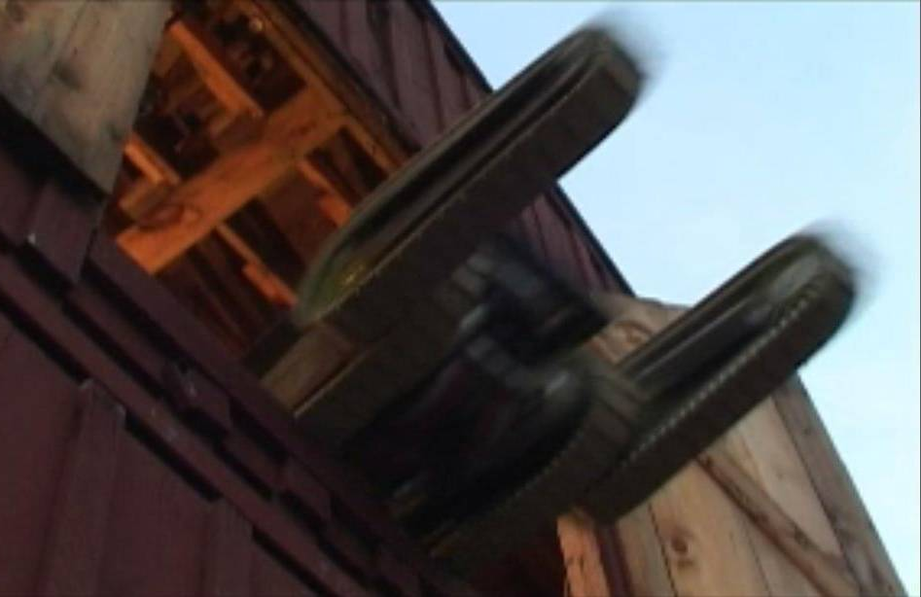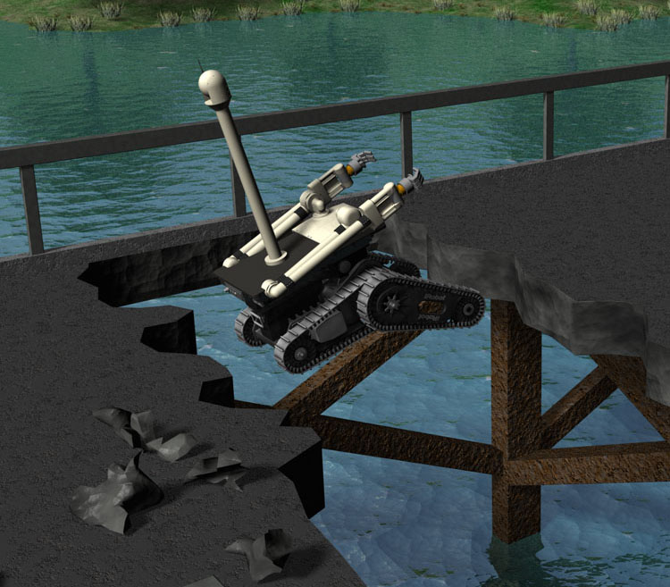
Figure 3.4.4.5-1: Warrior jumping out of a second-story barn door (left), SSR jumping over river (right)
We will also demonstrate the use of dynamics to avoid trajectory-dependent hazards [Spenko06]. These are hazards that only represent obstacles for certain speeds and directions. For example, consider a bridge that has been damaged by bombs, leaving a gap between the two ends of the bridge. This gap is only an obstacle if approached too slowly. If a vehicle approaches the gap at a sufficiently high speed, it can jump across the gap. In addition, if the vehicle has flippers (like the Warrior), it can push down on the bridge surface just ahead of the gap, providing additional upward velocity and allowing it to cross wider gaps. As part of our unique mobility program, we will demonstrate an SRR autonomously jumping across gaps simulating rivers, ravines, and damaged bridges.
As an alternate method for gaining vertical velocity, one robot can act as a ramp for another. The first robot carries a ramp that it positions for the optimal jump trajectory over the gap, and the second robot hits that ramp at speed and jumps over the gap. On impact, the momentum of the first robot should provide sufficient force to propel the second robot into the air. In order to use these techniques, the robots must be sufficiently rugged to deal with high speed impacts. The Warrior meets this criterion. In testing, a Warrior prototype was driven off a ramp through a second-story barn door, slamming onto the solid ground below, and driving off immediately.

References [note: to be moved to Ref volume]

[AMI08] Artificial Muscle Inc., Menlo Park, CA http://www.artificialmuscle.com
[Bicchi08] A. Bicchi, M. Peshkin, E. Colgate, Safety for Physical Human-Robot Interaction, Ch. 57 in Springer Handbook of Robotics, B. Siciliano, O. Khatib, eds., Springer (2008).
[Bowling07] D. Bowling, G. Starr, R. Lumia, and J. Wood, ``Wideband Suppression of Motion-Induced Vibration,'' IEEE Int'l. Conf. on Robotics & Automation,'' Rome, 2007.
[Braun05] Braun, B. M., G. P. Starr, J. E. Wood, and R. Lumia, ``A Framework for Implementing Cooperative Motion on Industrial Controllers,'' IEEE Transactions on Robotics and Automation, June 2004
[Breazeal08] C. Breazeal, A. Takanishi, T. Kobayashi, Social Robots that Interact with People, Ch. 58 in Springer Handbook of Robotics, B. Siciliano, O. Khatib, eds., Springer (2008).
[Brock2005] O. Brock and R. Grupen. NSF/NASA workshop on autonomous mobile manipulation. final report, March 2005.
[Byl09] K. Byl and R. Tedrake, “Dynamically diverse legged locomotion for rough terrain, ” Proc. of the IEEE/RAS International Conference on Robotics and Automation, May 2009.
[Carroll02] Daniel Carroll, H. R. Everett, Gary Gilbreath, Katherine Mullens, “Extending Mobile Security Robots to Force Protection Missions,” Proceedings of the Association for Unmanned Vehicles Systems International (AUVSI), Orlando, FL, July 2002.
[Carrozza04] M.C. Carrozza, C. Suppo, F. Sebastiani, B. Massa, F. Vecchi, R. Lazzarini, M.R. Cutkosky and P. Dario, “The SPRING Hand: Development of a Self-Adaptive Prosthesis for Restoring Natural Grasping,” Autonomous Robots, Vol. 16, No. 2, pp. 125-141, 2004.
[Ciocarlie2007] Ciocarlie, M., Goldfeder, C. and Allen, P, “Dexterous Grasping via Eigengrasps: A Low-dimensional Approach to a High-complexity Problem,” Proceedings of the Robotics: Science & Systems 2007 Manipulation Workshop - Sensing and Adapting to the Real World, June 30, Atlanta, GA.
[Colter08] J. Koltler, M. Rodgers and A.Y. Ng, “A control architecture for quadruped locomotion over rough terrain,” Proc. IEEE ICRA 2008.
[Cory08] Rick Cory and Russ Tedrake. Experiments in ﬁxed-wing uav perching. Proceedings of the AIAA Guidance, Navigation, and Control Conference, Aug 2008.
[Cortez08] R. Cortez, X. Papageorgiou, H. Tanner, A. Klimenko, K. Borozdin, R. Lumia, and W. Priedhorsky, "Smart Radiation Sensor Management," IEEE Robotics & Automation Magazine, 15: 85-93, 2008.
[Cutkosky09] M.R. Cutkosky and S. Kim, “Design and Fabrication of Multi-Material Structures for Bio-Inspired Robots,” accepted for publication in Philosophical Transactions of the Royal Society A, special issue on Biomimetics, 2009.
[DeSapio07] De Sapio, V., Khatib, O., Delp, S.L., Least action principles and their application to constrained and task-level problems in robotics and biomechanics. Multibody System Dynamics, 2007.
[Dollar06] A.M. Dollar and R. D. Howe, A Robust Compliant Grasper via Shape Deposition Manufacturing, IEEE/ASME Transactions on Mechatronics, vol. 11(2), pp.154-161, 2006.
[Grupen08] Grupen, R., The Developmental Organization of Dexterous Robot Behavior. MIT Press, Boston, MA, Spring 2008.
[Jenkins2004] Jenkins, O. and Mataric, M., “A Spatio-temporal Extension to Isomap Nonlinear Dimension Reduction,” Proc. 21st Intl. Conf. on Machine learning, ACM, Banff, 2004.
[Kaneko2008] M. Kaneko, et al., Motion for Manipulation Tasks: (Cha. 26), Contact Modeling and Manipulation (Cha. 27), Grasping (Cha. 28), in Part D, Manipulation and Interfaces, Springer Handbook of Robotics, B. Siciliano and O. Khatib, eds., 2008.
[Karlsen04] Robert Karlsen, Gary Witus, and James Overholt, “On-the-Fly Assessment of Terrain Effects on UGV Handling,” Proceedings of SPIE Vol. 5422: Unmanned Ground Vehicle Technology VI, Orlando, FL, April 2004, pp. 484-492.
[Khatib08] Khatib, O., Sentis, L., and Park, J., A Unified Framework for Whole-Body Humanoid Robot Control With Multiple Constraints and Contacts, Springer Tracts in Advanced Robotics - STAR Series, European Robotics Symposium, March 2008.
[Khatib96] O. Khatib, K. Yokoi, K. Chang, D. Ruspini, R. Holmberg, and A. Casal, "Vehicle/Arm Coordination and Multiple Mobile Manipulator Decentralized Cooperation," Proceedings of IEEE/RSJ International Conference on Intelligent Robots and Systems (IROS 96), Osaka, Japan, 1996, pp. 546-553.
[Kim08] S. Kim, M. Spenko, S. Trujillo, B. Heynman, D. Santos and M.R. Cutkosky, “Smooth Vertical Surface Climbing with Directional Adhesion,” IEEE Transactions on Robotics, vol. 24, no. 1, 2008.
[Lanzetta08] M. Lanzetta M. and M.R. Cutkosky, Shape deposition manufacturing of biologically inspired hierarchical microstructures, CIRP Annals: Manufacturing Technology, Volume 57, Issue 1, 2008, Pages 231-234.
[Liu05] Y. Liu, G. Starr, J. Wood, and R. Lumia, ``Spatial Grasp Synthesis of Complex Objects using Model-Based Simulation,'' Industrial Robot, v. 32, no. 1, January 2005.
[Minten01] Brian Minten, Robin Murphy, Jeff Hyams, Mark Micire, “Low-Order Complexity Vision-Based Docking,” IEEE Transactions on Robotics and Automation, 17(6):922-930, December 2001.
[Montemerlo08] M. Montemerlo, et al., Junior: The Stanford entry in the Urban Challenge, Journal of Field Robotics, Vol. 25, No. 9, Sept. 2008.
[Murphy08] R. Murphy, et al., Search and Rescue Robotics, Chapter 51 in Springer Handbook of Robotics, B. Siciliano and O. Khatib, eds., 2008.
[Murphy99] Robin Murphy, Michelle Ausmus, Magda Bugaska, Tanya Ellis, Tonia Johnson, Nia Kelley, Jodi Kiefer, Lisa Pollock, “Marsupial-like Mobile Robot Societies,” Proc. Third International Conference on Autonomous Agents (Agents 99), Seattle, WA, May 1999.
[Platt05] R. Platt, A. Fagg, and R. Grupen, “Reusing schematic grasping policies,” In Proc. IEEERAS, Intl. Conf. on Humanoid Robots, Tsukuba, Japan, 2005.
[Pratt95] G. Pratt and Williamson M. Series elastic actuators. Proc. of the 1995 IEEE/RSJ International Conference on Intelligent Robots and Systems, 1:399–406, 1995.
[Quigley09] High-Accuracy 3D Sensing for Mobile Manipulation: Improving Object Detection and Door Opening, Morgan Quigley, Siddharth Batra, Stephen Gould, Ellen Klingbeil, Quoc Le, Ashley Wellman and Andrew Y. Ng, to appear in Proceedings of the 2009 IEEE International Conference on Robotics and Automation,” Kobe, Japan, May 2009.
[Salisbury88] Salisbury, K., W. Townsend, B. Ebrman, and D. DiPietro. Preliminary design of a whole-arm manipulation system (WAMS). in Robotics and Automation, 1988. Proceedings., 1988 IEEE International Conference on. 1988.
[Saxena08] Saxena, A., J. Driemeyer, and A.Y. Ng, Robotic Grasping of Novel Objects using Vision. The International Journal of Robotics Research, 2008. 27(2): p. 157-173.
[Schiavi08] R. Schiavi, G. Grioli, S. Sen, and A. Bicchi. Vsa–ii: A novel prototype of variable stiffness actuator for safe and performing robots interacting with humans. IEEE International Conference on Robotics and Automation, 2008.
[Shin08] D. Shin, I. Sardellitti, Y-L Park, O. Khatib, M. Cutkosky, “Design and Control of a Bio-Inspired Human-Safe Robotic Arm,” Proceedings of 11th ISER, Athens, Greece, July 2008.
[Silciliano00] Bruno Siciliano and Luigi Villani, Robot Force Control, New York: Springer, 2000.
[Spenko06] Matthew Spenko, Yoji Kuroda, Steven Dubowsky, and Karl Iagnemma, “Hazard Avoidance for High-Speed Mobile Robots in Rough Terrain,” Journal of Field Robotics, 23(5):311-332, May 2006.
[Spenko08] M. Spenko, G.C. Haynes, J.A. Saunders, M.R. Cutkosky, A.A. Rizzi, R.J. Full, D.E. Koditschek, “Biologically Inspired Climbing with a Hexapedal Robot,” Journal of Field Robotics, Volume 25, Issue 4-5, April 2008, pages 223-242.
[Stentz99] A. Stentz, J. Bares, S. Singh and P. Rowe, “A Robotic Excavator for Autonomous Truck Loading,” Autonomous Robots, 7(2):175-186, September 1999.
[Tondu06] B. Tondu and S.D. Zagal. Mckibben artiﬁcial muscle can be adapted to be in accordance with the hill skeletal muscle model. IEEE Internation Conference on Biomedical Robotics and Biomechatronics, 2006
[Wolf08] S. Wolf and G. Hirzinger. A new variable stiffness design: matching requirements of the next robot generation. IEEE ICRA, 2008.
[Yamauchi05] Brian Yamauchi, “Wayfarer: An Autonomous Navigation Payload for the PackBot,” Proceedings of the Association for Unmanned Vehicles Systems International (AUVSI), Baltimore, MD, June 2005.
[Yamauchi08] Brian Yamauchi and Kent Massey, “Stingray: High-speed Teleoperation of UGVs in Urban Terrain Using Driver-Assist Behaviors and Immersive Telepresence,” Proceedings of the 26th Army Science Conference, Orlando, FL, December.
[Zameroski08] D. Zameroski, G. Starr, J. Wood, and R. Lumia, ``Rapid Swing-Free Transport of Nonlinear Payloads Using Dynamic Programming,'' ASME Journal of Dynamic Systems, Measurement, and Control, v. 130, July 2008.
[Zico07] J. Zico Kolter, Pieter Abbeel, and Andrew Y. Ng, “Hierarchical Apprenticeship Learning with Application to Quadruped Locomotion,” Neural Information Processing Systems, 2007. Guidance, Navigation, and Control Conference, Aug 2008.

