Using a Catheter-like Probe to Distinguish Tissue Stiffness between RF Ablated and Un-ablated Cardiac Tissue

Samson Phan and Yong-Lae Park
Stanford University

1. Prototype Design

A catheter-like probe was designed and fabricated to distinguish tissue stiffness between un-ablated (raw) and RF-ablated cardiac tissue. Previous prototypes could not reliably differentiate between treated and untreated tissue due to the catheter’s flexible body’s influence on the system’s resonant frequency. Figure 1 shows the current prototype design. A probe strip was made of stiffer steel of increased thickness, and a flexure was made on a certain location by selectively thinning a section. A piezo-electric unimorph actuator and an FBG were attached to the flexure part to provide actuation and sensing, respectively.

The flexure introduction section is expected to provide higher sensitivity to tissue resonant frequency changes by increasing the vibration amplitude

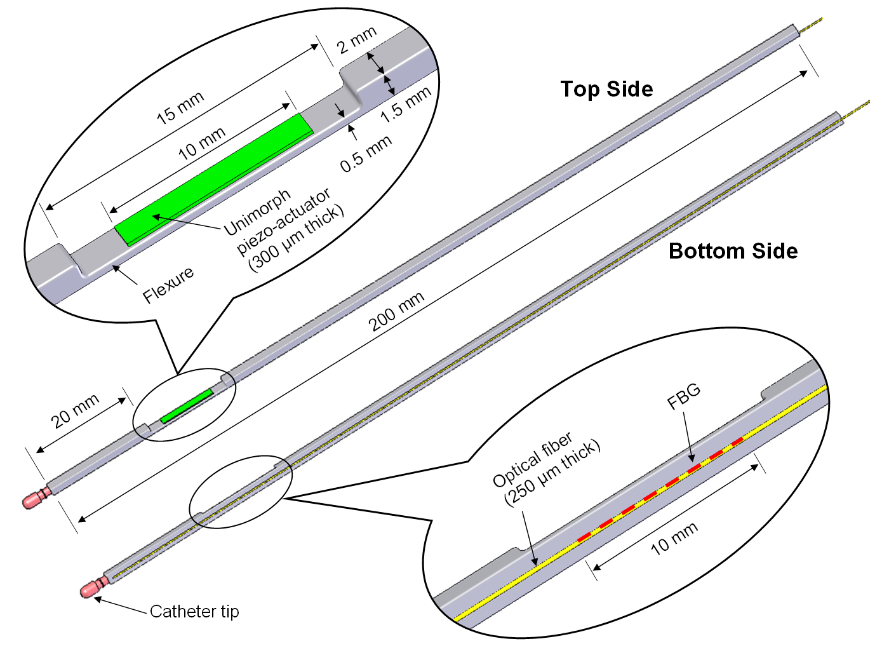
Figure 1. Prototype design with a unimorph piezo-electric actuator and a single FBG bonded to the flexure part

2. Experimental Setup

During the experiments, a swine heart tissue was pressed by the catheter tip with a consistent force level since resonant frequency can change for different pressure levels even with the same tissue, as shown by previous tests. The angle between the catheter strip and the surface of the tissue was approximately 15º~20º, and the catheter body was fixed with a clamp, as shown in Figure 2.

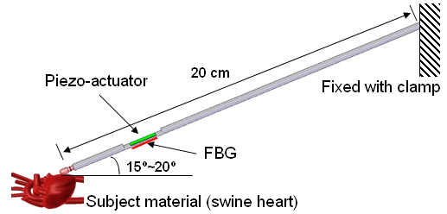
Figure 2. Experimental setup

Two different locations of the heart were selected for the experiments. The piezo-actuator vibrated with a chirped sine wave. Frequency responses were obtained by the strain signals from the bonded FBG sensor for before and after burning the target tissue on each location. To simulate the RF-ablation, the heart tissue was burned with microwave energy.

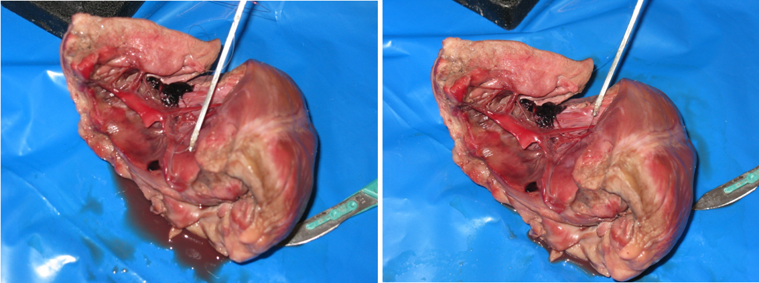
Figure 3. The swine heart prepared as a subject material and two selected locations for tissue distinguishment experiments

3. Experimental Results

As described in Section 2, two different tissue locations were selected for the experiments. In the first experiment shown in Figure 4, the resonant frequencies appeared at 1.7 kHz before burning and at 1.85 kHz after burning. In the second experiment (Figure 5), the resonant frequencies are shown at approximately 1.75 kHz before burning and moved to 1.8 kHz after burning. In both experiments, the resonant frequencies were increased after burning the tissue and the amplitude of the signal at the resonant frequencies significantly decreased.

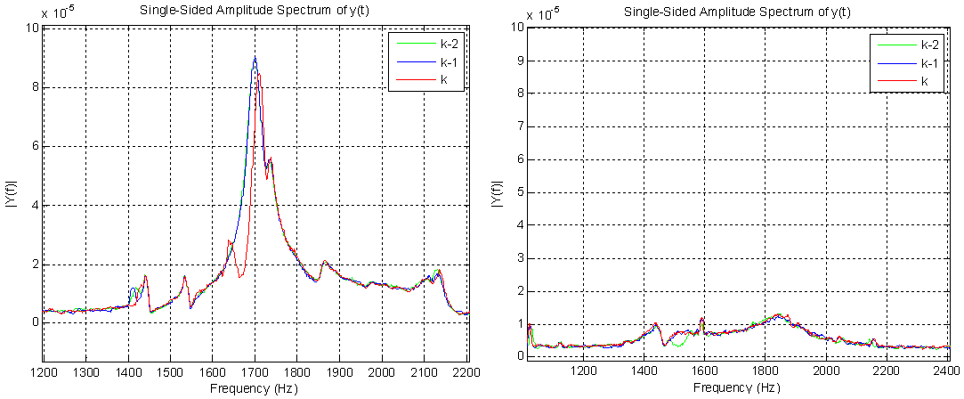
Resonant frequency = 1.7 kHz
Resonant frequency = 1.85 kHz
Figure 4. Frequency responses for tissue location 1 before (left) and after (right) burning

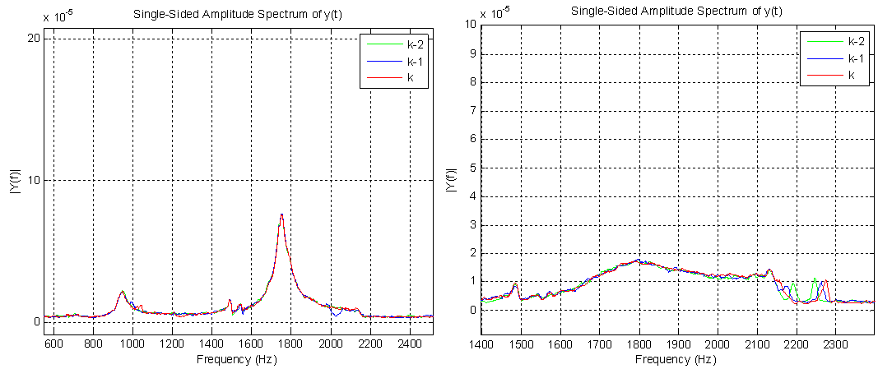
Resonant frequency = 1.75 kHz
Resonant frequency = 1.8 kHz
Figure 5. Frequency responses for tissue location 2 before (left) and after (right) burning

4. Conclusions

The experimental results show that the resonant frequencies increases when the heart tissue is subjected to RF energy. As expected, tissue increases in stiffness after ablation. The resonant frequency differences between ablated and unablated were 150 Hz and 50 Hz for the two tissue locations.

In addition, signal amplitude at resonant frequency decreased significantly after ablation in both experiments. This suggests damping in the tissue was increased after the ablation.

In summary, the current prototype with flexure design was able to distinguish a change in tissue properties as a result of ablation.

