Reducing Error Rates with Low-Cost Haptic Feedback
in Virtual Reality-Based Training Applications

Li Jiang*, Rohit Girotra*, Mark R. Cutkosky*, Chris Ullrich‡
(*)Department of Mechanical Engineering, Stanford University, USA
(‡) Immersion Corporation, San Jose, USA
Email: lijiang, rgirotra, cutkosky@stanford.edu, cullrich@immersion.com

Abstract

This paper reports on the effectiveness of haptic feedback in a low-cost virtual-reality training environment for military and emergency personnel. Subjects participated in simulated exercises for clearing a damaged building, implemented using a modified commercial videogame engine and USB-compatible force and vibration feedback devices. With the addition of haptic feedback, subjects made fewer procedural errors and completed some tasks more rapidly. Initially, best results were obtained with vibration feedback. After some modifications to the collision detection and display algorithm, force feedback produced equivalent results and was preferred by a majority of the subjects.

1. Introduction

There has been an increasing interest in virtual reality-based training of procedures for military, police and emergency personnel [1-6]. An encouraging result of several early studies [7,8] is that virtual reality environments need not be entirely realistic in order to provide useful training that carries over to real situations. Most of the virtual reality-based training has focused on visual and auditory feedback. Haptic feedback has been explored in a few cases [9-11] with promising results.
High-end “immersive” virtual reality systems may include wearable head-mounted displays or “cave” video projection systems, three-dimensional motion tracking and perhaps treadmills or harnesses for imparting resistance to the motion of the subject. These systems are capable of kinesthetic as well as visual and audio feedback [12-22]. Unfortunately, such systems are expensive and can only train one or a few people at a time. This is particularly a drawback when substantial groups of people should be trained together. Consequently there has been an interest in low-cost VR environments, as found in multi-user videogames for desktop computers. The hope is that with steady improvements in desktop technology, these low-cost VR trainers will be responsive and realistic enough to help subjects learn important procedures. In these applications, subjects view the scenes using either the computer monitors or inexpensive head-mounted displays and impart motions and commands using joysticks, keyboards and other commercial gaming devices. The availability of selection USB-compatible gaming devices with haptic feedback is steadily growing, which leads to the following questions:
- What roles can haptic feedback play in low-cost VR training for military and emergency personnel?
- Can performance or learning rates be improved with haptic feedback?
To shed light on these questions we undertook experiments involving the addition of haptic feedback in a low-cost VR training scenario. We were particularly interested in “building clearing” operations as practiced by military personnel in close-quarters combat and emergency personnel to evacuate hostages or earthquake victims. The challenges in such environments often include poor visibility, distracting noises (e.g. explosions) and a severe time pressure for planning and executing procedures. Haptic feedback provides a useful additional channel for information and communication. For example, in some procedures personnel are trained to tap the shoulder of a team-mate as part of the communication protocol for Close Quarter Battles (CQB) [23]. This paper is organized as follows, in section 2 we present our first experiment, a simulated hostage rescue scenario. In section 3 we present our 2nd experiment, navigation of a dark, unfamiliar environment. In section 4 we discuss conclusions and future work.

2. Experiment one

The aim of this experiment was to investigate the effects of haptic feedback on a subject’s ability to remember and accurately execute procedures while negotiating a virtual environment.

2.1. Experiment one setup

The experiments were conducted using a dual-processor Windows desktop running a modified version of the Half-Life (v42/1.1.0.1) game engine that could generate kinesthetic and tactile feedback as a result of the players’ actions in the virtual environment. A screenshot of the running application is shown in Figure 1. In addition to producing cues for haptic feedback, the modification logged the player’s position, velocity, collision state and clip fraction, a variable ranging from 0 if the player’s motion is unclipped to 1 if fully clipped, every 16ms. For example, if a player moves at a rate of 300 units/frame at frame N toward a wall or obstacle located 150 units from his current position, the ‘clip fraction’ is 150/300=0.5 for frame N+1. After the initial collision frame the clip fraction returns to 0 because the player cannot accelerate into an obstacle. Unfortunately, like many game engines, Half-Life does not produce more detailed collision information such as penetration depth or geometric location. Because of this limitation, the magnitudes of haptic feedback effects were made proportional to the ‘clip fraction’ at the initial collision. For kinesthetic effects, the direction of the effect was updated based on player orientation every 16ms. In addition to collision feedback, two special textures were implemented to allow the system to display different tactile effects during player walkover. This addition allowed effects to be played through different feedback devices depending on the texture. Thus, a texture associated with low-lying obstacles could be routed through different devices than a texture applied to shoulder-height obstacles.
To achieve haptic effects, we modified commercial force feedback joysticks and vibration devices with USB drivers from Immersion Corporation.
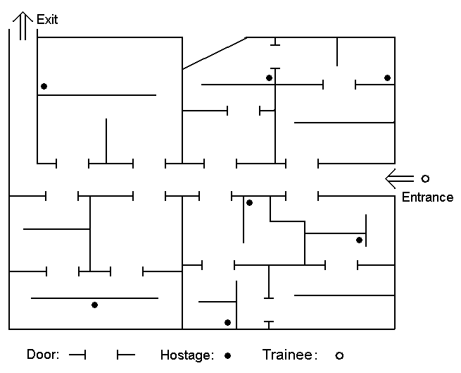
Figure 2. Map of a typical building layout
Preliminary tests were first conducted to determine under what conditions haptic feedback could give meaningful cues. In many cases, the initial results were disappointing: experienced videogame players performed so well using visual cues that haptic feedback was of little consequence. However, it gradually became clear that under certain conditions players could learn an environment faster and make fewer errors with appropriate haptic cues. Accordingly, the scenarios at experiment 1&2 were developed.
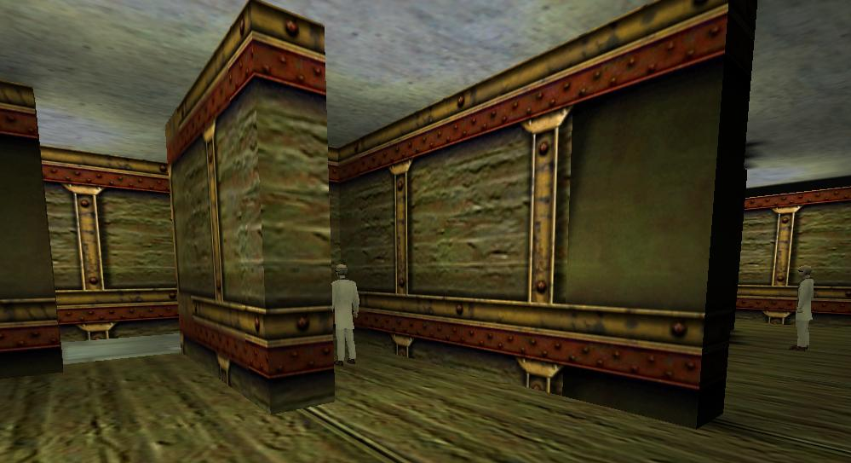
Figure 1. Screenshot of actual Half Life Environment

2.1.1 Scenario. Imagine a training session in a simulated environment for rescue missions. A trainee has to rescue hostages, or perhaps survivors of an explosion, from inside a dark and dangerous building. The building must be cleared and the hostages must be recovered quickly. However, it is important to check each room for safety before entering. To indicate that a room has been checked the user must briefly stop against a wall at either side of the entryway [24]. The task is considered to be complete when users complete a sweep of the building and proceed through an exit at the far end from the starting point.
When haptic feedback (joystick force or vibration) is turned on, contacts with any walls or obstacles are registered, including the walls just outside the room to be cleared.
The measured variables included the total time to complete the mission and the number of failures to properly check rooms before entering.
2.1.2 Protocol. A set of twelve diverse subjects, (eight male and four female, with ages ranging from 20 to 30 years) six having prior experience in 3D gaming and six having little or no experience, were chosen for the experiment. Three feedback modes were selected: (A) No haptic feedback, (B) Vibration feedback using vibration joystick, (C) force feedback using force feedback joystick.
Each subject was assigned a sequence of haptic feedback modes, such that all six combinations of A, B and C were covered. This was done for both groups (experienced and inexperienced). The order of presentation was randomized and balanced. Each subject carried out twelve trials in total, i.e., four runs with three trials each. There were twelve different maps of identical complexity level obtained by making permutations of a configuration consisting of 12 rooms and a central hallway (see Fig 2). The choice of maps was randomized and balanced.

2.1.3 Metrics. The primary metric was the subjects’ ability to complete the mission without failing to register a safety check by touching a wall just outside a room before entering. The number of hostages rescued was not a reliable statistic because it relied mainly on the user’s ability to see hostages, despite having a narrow field of view and a darkened environment.
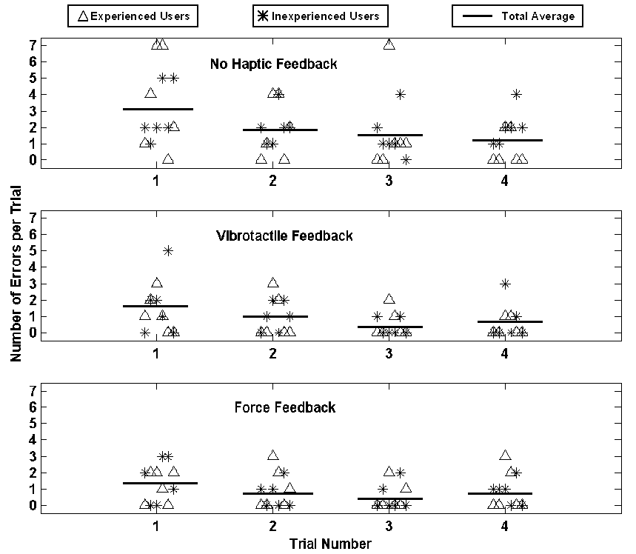
Figure 4. Error statistics for subjects as a function of trail number. There is a slight reduction in the average number of errors between trial 1 and trial 4.

2.2 Data Analysis and Results
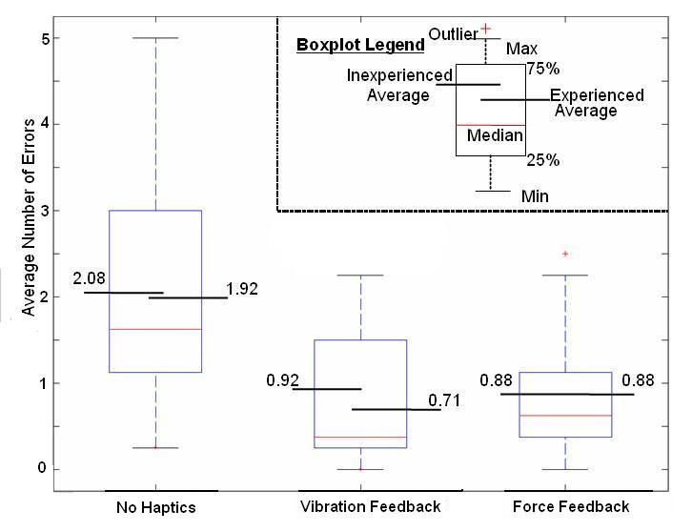Figure 3: Box plots showing the error statistics for experienced and inexperienced subjects in Exp 1.
As seen in Fig 3, there is a significant difference in the number of errors made when using either vibration or force feedback as compared to the no-haptics case. The results of paired T-tests show that the probability of a significant difference is 99.7% for vibration versus no-haptics and 99.9% for force feedback versus no haptics.
Because early testing revealed differences in the strategies used by experienced and inexperienced video game players, the results were divided into pools of 6 experienced and 6 inexperienced users. The average for each pool are labeled in Fig.3

2.2.1 Learning Rates. The errors produced by experienced and inexperienced subjects are plotted (Fig 4) as a function of the trial number (each subject had four trials with each condition: force feedback, vibration feedback, no feedback). The results show that despite substantial subject-to-subject variability, there is a slight reduction in the average number of errors when progressing from trial 1 to 4.
Conducting a paired-T test for all subjects between trial 4 and trial 1 reveals that the probability of a statistically significant difference in the means is 98.5% for condition A (no haptics), 95.8% for condition B (vibration feedback) and 76.4% for condition C (force feedback).

2.3. Conclusions

As Figure 3 indicates, there is a clear reduction in the average number of errors made with either vibration or force feedback.
From Figure 4, there is some evidence of learning over the four trials, however the learning is actually more evident without haptics than with. One way to interpret these results is that the addition of haptics immediately improved performance to an extent that little further improvement was obtained over four trials. (Recall that the presentation order was randomized to guard against bias.)
Anecdotally, all subjects reported a greater sense of immersion with haptic feedback. The case with force feedback was slightly preferred. However, it should be noted this result was only obtained after considerable experimentation and modification of the force computation in preliminary tests. Initially, the limitations of the video game engine (which provides no information about the details of collisions with objects) and a commercial force feedback joystick produced results that users found more distracting than helpful. Useful force feedback was obtained only after implementing an algorithm in which the initial force is made proportional to the user’s velocity in the direction normal to the collision surface (e.g. a wall) and then latched at the value until the user departs from the surface. The resulting force, while not exactly realistic, is smooth and provides useful information about the direction and magnitude of a collision.
More generally, the results of this experiment lead us to believe that haptic feedback in a virtual environment helps a subject to remember to perform a critical sequence of actions during a procedure such as a simulated building-clearing task.

3. Experiment Two

The focus of Experiment 2 was to evaluate the effects of distributed vibration feedback on a user’s body during a virtual reality training exercise. The task given to users was to guide an avatar through a very dark, cluttered and potentially hazardous environment – perhaps a building or tunnel in the aftermath of an explosion.
In real application, it is often valuable for personnel to retain an accurate memory of the condition and obstacles for future reference. In our virtual environment, the user must go through a dim corridor. There are two main kinds of obstacles: low ones that must be jumped or stepped over; the high obstacles that must be ducked under to prevent head injuries (Fig 5). The total number of obstacles in the corridor is 15, and they are in random order. A dim red light indicates the direction of the exit.
A standard mouse and keyboard video game interface is provided for input. The questions being addressed included whether haptic feedback allows users to complete the task in less time and whether they can better remember the details of the environment that they have negotiated.

3.1. Experiment two setup

As in Experiment 1, the Half Life, (v42/1.1.0.1 commercial video game engine was used to develop the virtual environment. The vibration feedback units were adapted from commercial USB port mice to velcro straps that could be fastened to various parts of the users’ bodies. After some experimentation, the best results were obtained using four vibration devices, with two attached to the users head (these could also be attached to a helmet if using a head-mounted display) and two attached to the user’s lower legs (Fig 6)
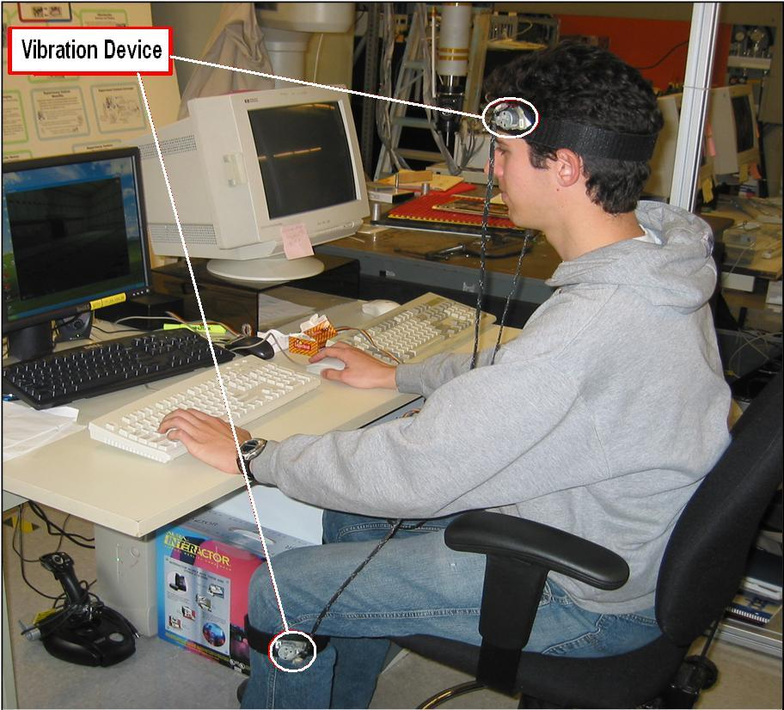
Figure 6. Distributed vibration feedback device for experiment 2
Although Half Life does not provide any detailed information about collisions, it is possible to flag obstacles with a unique texture that flagged obstacles is distinguished from collisions with other obstacles. When users hit a low obstacle, a flag was generated to trigger lower leg vibration devices. Similarly, collisions with high obstacles triggered the vibration devices attached to the user’s head.
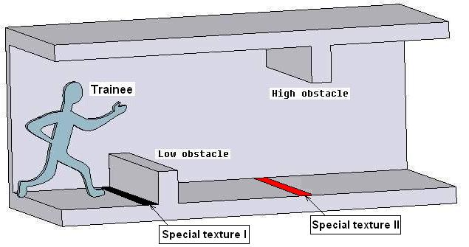
Figure 5. Layout of the corridor in experiment 2

3.1.1. Protocol. A diverse set of eight subjects, (5 male and 3 female, with ages ranging from 20 to 30 years and with varying degrees of video game experience) were chosen for the experiment. Four variations on the corridor were used with the sequences of 15 obstacles.
Each subject carried out 8 trials in total, two trials in each of the four corridors. The order of presentation was varied and balanced between subjects. For the first four trials, subjects were asked to go as fast as possible. For the second four trials, the subjects were informed that they had one minute (ample time to negotiate the corridor) and that they would be asked afterward to try to recall the of obstacles that they had encountered along the way.

3.1.2. Metrics. The measured variables included:
1. The total time required.
2. The number of obstacles of each type (high or low) correctly remembered after completing a trial (memory trials).

3.2. Data Analysis and Results
Figure 7 shows the total numbers of obstacles that users reported and the numbers of obstacles correctly identified as high or low in the sequence. The box plots show the median and upper and lower quartiles, as well as the maximum and minimum values found across all subjects. The average numbers of obstacles are also shown for each box.
The maximum possible number of correctly identified obstacles is 15. Interestingly, the presence of haptic feedback causes users to both to report more objects and to recall more objects correctly. Conducting a paired T-test between the case of haptics versus no-haptics for the number of obstacles identified correctly results in probability of 98% for a statistically significant difference in the averages (t = 2.96, DOF = 7, pnull = 0.021).
There were also significant differences in the amount of time that people took to negotiate the corridor with and without haptics. Recall that for the first two trials, speed was emphasized and that for the second two trials memory was emphasized, rather than speed. Nonetheless, most users completed the trials more rapidly with haptic feedback. Figure 8 shows a histogram of the relative amount of time required by each subject to complete a speed trial with haptics versus without: R = t_{haptic} /t _{no-haptic.} We see that four of the eight subjects required between 90% and 100% as long to complete the task with haptics as without, three required less than 90% as long and one took slightly longer with haptics.
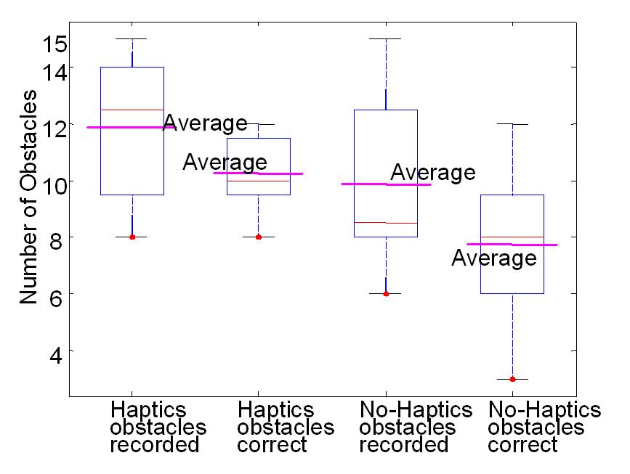
Figure 7. Obstacles (total reported) and number of obstacles correctly recorded, with or without haptic feedback.
Performing a paired T-test on the average amounts of time for the speed trials, with and without haptics, results in a value of p_{null} = 0.053 or 94.7% confidence in a different average time.
Although speed was not a goal in the memory trials, most subjects again completed the task faster when haptic feedback was present.

3.3. Experiment two conclusions

The provision of vibrational haptic feedback to user’s heads and lower legs helped users to identify high and low obstacles more quickly and more accurately. The numbers of obstacles correctly identified and the total task times were superior when haptic feedback was present.
While watching users, it was clear that they recovered from collisions more rapidly with haptic feedback. Although there was some spatial information associated with different feedback devices at the head and lower limbs, we hypothesize that this is still primarily an example of “temporal” or “event” feedback, which other investigators have also found to be effectively conveyed via haptic feedback. Thus, users detected “head events” or “foot events” more quickly and more memorably with haptic feedback.
A comment should also be made about the approaches taken by experienced versus novice video game players. Indeed, the original scenarios developed during some preliminary tests proved too easy for accomplished gamers. They proceeded extremely rapidly through the corridor and made virtually no mistakes with only visual feedback. By darkening the environment, the task became sufficiently challenging that all users benefited from the extra feedback that haptics provided.
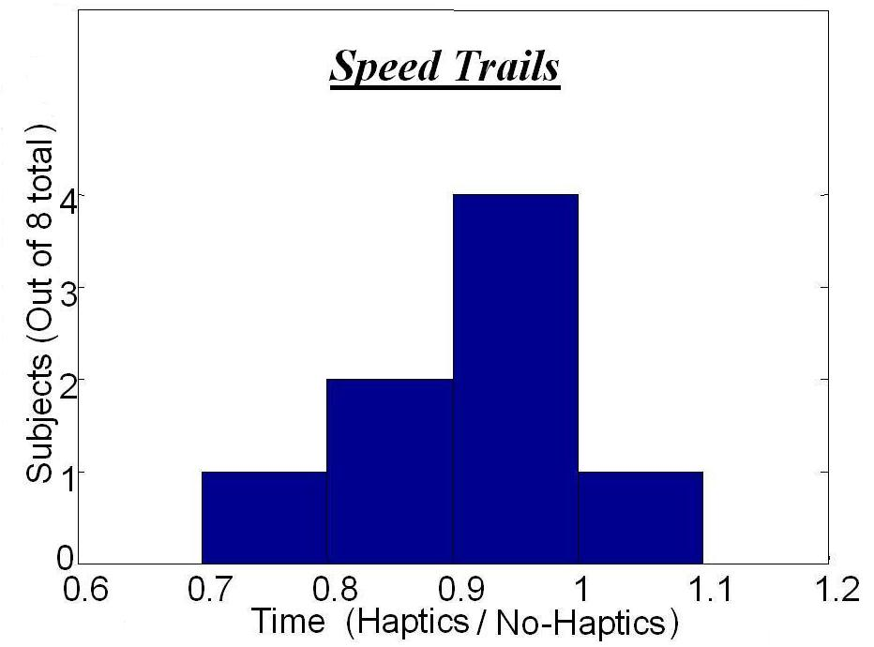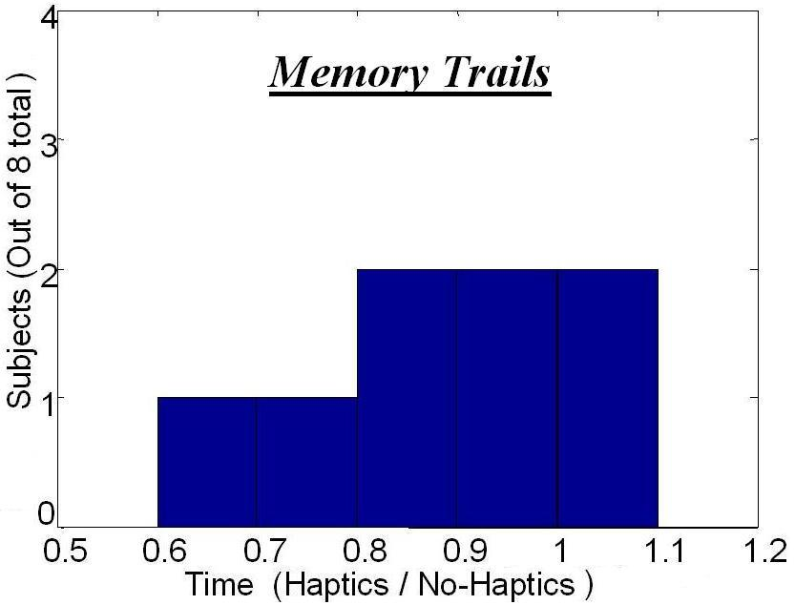
Figure 8. Relative time required to complete a trial with haptics versus without haptics for the two Speed trails and two Memory trails separately.

4. Conclusions

The results from the two experiments lead us to believe that haptic feedback can play an important role in low-cost VR training of military and emergency personnel. Experiment 1 shows significantly fewer errors by subjects performing a task with either vibration or force feedback, implying higher levels of immersion. Experiment 2 showed an improvement in speed of performance and in accuracy of recall, in darkened environment with haptic feedback.

5. Acknowledgements

This research was sponsored by Immersion Corporation, San Jose, CA, with support from US Navy grant N0014-03-M-0264.

References

- Parsons, James., et al., "Fully Immersive Team Training: A Networked Testbed for Ground-Based Training Missions." Interservice/Industry Training Systems and Education Conference (I/ITSEC), December 1998.
- Rose, F. D., et al., “Training in virtual environments: Transfer to real world tasks and equivalence to real task training”, Ergonomics, 43, 2000, pp 494-511.
- Zeltzer, D., et al., “Validation and verification of virtual environment training systems”, Virtual Reality Annual Intel Symposium, IEEE 1996 March, pp.123 – 130.
- Moshell, J.M., et al., “A research testbed for virtual environment training applications”, Virtual Reality Annual Intel Symposium, IEEE, Sept.1993, pp.83–89.
- Darken, R.P., Banker, W.P., “Navigating in natural environments: a virtual environment training transfer study”, Virtual Reality Annual Intel Symposium, IEEE, March 1998, pp.12 – 19.
- Garant, E., et al., “A virtual reality training system for power-utility personnel”, Communications, Computers, and Signal Processing, IEEE Pacific Rim Conference, May 1995, pp.296 – 299.
- Bell, John T., Fogler, H. Scott., “Low Cost Virtual Reality and its Application to Chemical Engineering - Part One”, Computing and Systems Technology Division Communications, American Institute of Chemical Engineers, 18(1), 1995.
- Chia, ChienWei., “Low Cost Virtual Cockpits for Air Combat Experimentation” Interservice/Industry Training, Simulation, and Education Conference, 2004.
- Kuang, Alex B., et al., “Assembling Virtual Fixtures for Guidance in Training Environments”, Haptic Interfaces for Virtual Environment and Teleoperator Systems, 2004. HAPTICS '04. 12th Intel Symposium March 2004, pp.367 – 374.
- Choi, Kup-Sze., et al., “Interactive deformation of soft tissues with haptic feedback for medical learning”, Information Technology in Biomedicine, IEEE Transactions, Volume: 7, Issue: 4, 2003,pp.358 – 363.
- Solis, J., et al., “Validating a skill transfer system based on reactive robots technology”, Robot and Human Interactive Communication, ROMAN 2003. The 12th IEEE International Workshop, Oct 2003.
- Darken, Rudolph P., Cockayne,William R., “The Omni-Directional Treadmill: A Locomotion Device for Virtual Worlds”, UIST ‘97, Banff, Canada, October 1997, pp. 213-221.
- Wallace, A., “Object-oriented methodology in a virtual-reality training system.”, Electrotechnology; Dec. 1997-Jan. 1998; vol.8, no.6, pp.16-18.
- Hollerbach, J.M., et al., ”The convergence of robotics, vision, and computer graphics for user information,'' IJRR, 18, 1999, pp. 1088-1100.
- Hollerbach, J.M., “Locomotion interfaces”, Handbook of Virtual Environments Technology, K.M. Stanney, ed., Lawrence Erlbaum Associates, Inc., 2002, pp. 239-254.
- Christensen, R., et al., “Inertial force feedback for the Treadport locomotion interface”, Presence: Teleoperators and Virtual Environments, 2000, pp.1-14.
- Durlach, N.I., et al., “Virtual Reality: Scientific and Technological Challenges”, National Academy Press, Washington, D.C., 1994.
- Witmer, B.G., et al., “Judging perceived and traversed distance in virtual environments”, Teleoperators and Virtual Environments, 7, 1998, pp.144–167.
- Ward, M., et al., “A demonstrated optical tracker with scalable work area for head-mounted display system” Symp. Interactive 3-D Graphics, 1992, pp. 43–52.
- Cruz-Neira, C., et al., “Surround-screen projection-based virtual reality: The design and implementation of the CAVE”, ACM SIGGRAPH’93, pp.135–142
- Slater, M., et al., “The virtual treadmill: A naturalistic metaphor for navigation in immersive virtual environments” M.Gobel (Ed.), Virtual Environments’ 95, pp.135–148. .
- Peterson, B., el al., “The effects of the interface on navigation in virtual environment” Proc. Human Factors and Ergonomics Society. 1998
- Reece, Jordan., “Virtual Close Quarter Battle(CQB) Graphic Decision trainer”, Master thesis, Naval Postgraduate School, Monterey, CA, 2002
- Holifield, Leonard., “Close-Quarter Combat: A Soldier's Guide to Hand-To-Hand Fighting”, Paladin Press, May 1997

